# 9. Assessment of the Pacific ocean perch stock in the Gulf of Alaska

Peter-John F. Hulson, Benjamin C. Williams, Benjamin E. Fissel, Bridget E. Ferriss, Madison Hall, Ellen M. Yasumiishi, and Darin T. Jones

November 2021

## Executive Summary

Pacific ocean perch in the Gulf of Alaska are assessed on a biennial stock assessment schedule to coincide with the availability of new survey data. Consequently, we present a full stock assessment using a statistical age-structured model. Survey and fishery data are used to estimate population trends and projected future population estimates are used to recommend catch limits.

### Summary of Changes in Assessment Inputs

*Changes in the input data*: We updated the catch for 2020 and used preliminary catch estimates for 2021-2023 (see *Specified catch estimation* section), along with 2021 bottom trawl survey biomass, and 2020 fishery age composition.

*Changes in the assessment methodology*: The assessment methodology is the same as the 2020 assessment.

### Summary of Results

For the 2022 fishery, we recommend the maximum allowable ABC of **38,268** t. This ABC is a 6% increase from the 2021 ABC of 36,177 t. The increase is attributed to the model continuing to react to five consecutive survey biomass estimates larger than 1 million tons as well as an increase in survey biomass in 2021 compared to 2019. This also resulted in an 11% higher ABC than the 2022 ABC projected last year. The corresponding reference values for Pacific ocean perch are summarized in the following table, with the recommended ABC and OFL values in bold. The stock is not being subject to overfishing, is not currently overfished, nor is it approaching a condition of being overfished.

|  |  |  |  |  |
| --- | --- | --- | --- | --- |
|  | As estimated or  specified *last* year for: | | As estimated or  recommended *this* year for: | |
| **Quantity** | 2021 | 2022 | 2022 | 20231 |
| *M* (natural mortality) | 0.076 | 0.076 | 0.075 | 0.075 |
| Tier | 3a | 3a | 3a | 3a |
| Projected total (age 2+ ) biomass (t) | 613,522 | 597,732 | 650,832 | 634,907 |
| Projected Female spawning biomass | 207,096 | 198,179 | 216,635 | 210,257 |
| *B100%* | 317,035 | 317,035 | 331,917 | 331,917 |
| *B40%* | 126,814 | 126,814 | 132,767 | 132,767 |
| *B35%­* | 110,962 | 110,962 | 116,171 | 116,171 |
| *FOFL* | 0.120 | 0.120 | 0.120 | 0.120 |
| *maxFABC* | 0.100 | 0.100 | 0.100 | 0.100 |
| *FABC* | 0.100 | 0.100 | 0.100 | 0.100 |
| OFL (t) | 42,977 | 41,110 | **45,580** | 44,196 |
| maxABC (t) | 36,177 | 34,602 | 38,268 | 37,104 |
| ABC (t) | 36,177 | 34,602 | **38,268** | 37,104 |
| **Status** | As determined *last* year for: | | As determined *this* year for: | |
|  | 2019 | 2020 | 2020 | 2021 |
| Overfishing | No | n/a | No | n/a |
| Overfished | n/a | No | n/a | No |
| Approaching overfished | n/a | No | n/a | No |

1Projected ABCs and OFLs for 2022 and 2023 are derived using estimated catch of 28,187 for 2021, and projected catches of 32,458 t and 31,105 t for 2022 and 2023 based on realized catches from 2018-2020. This calculation is in response to management requests to obtain more accurate projections.

### Area Apportionment

The following table shows the recommended apportionment for 2022 and 2023 from the random effects model.

|  |  |  |  |  |
| --- | --- | --- | --- | --- |
| Area Apportionment | Western | Central | Eastern | Total |
| 6.8% | 80.5% | 12.7% | 100% |
| 2022 Area ABC (t) | **2,602** | **30,806** | **4,860** | **38,268** |
| 2023 Area ABC (t) | **2,523** | **29,869** | **4,712** | **37,104** |

Amendment 41 prohibited trawling in the Eastern area east of 140° W longitude. The ratio of biomass still obtainable in the W. Yakutat area (between 147° W and 140° W) is larger than the 2019 assessment at 0.29, an increase from 0.24. The random effects model was not applied for the WYAK and EYAK/SEO split and the weighting method of using upper 95% confidence of the ratio in biomass between these two areas used in previous assessments was continued. This results in the following apportionment of the Eastern Gulf area:

|  |  |  |  |
| --- | --- | --- | --- |
|  | W. Yakutat | E. Yakutat/Southeast | Total |
| 2022 Area ABC (t) | **1,409** | **3,451** | **4,860** |
| 2023 Area ABC (t) | **1,366** | **3,346** | **4,712** |

In 2012, the Plan Team and SSC recommended combined OFLs for the Western, Central, and West Yakutat areas (W/C/WYK) because the original rationale of an overfished stock no longer applied. However, because of concerns over stock structure, the OFL for SEO remained separate to ensure this unharvested OFL was not utilized in another area. The Council adopted these recommendations. This results in the following apportionment for the W/C/WYK area:

|  |  |  |  |
| --- | --- | --- | --- |
|  | Western/Central/W. Yakutat | E. Yakutat/Southeast | Total |
| 2022 Area OFL (t) | **41,470** | **4,110** | **45,580** |
| 2023 Area OFL (t) | **40,211** | **3,985** | **44,196** |

### Summaries for Plan Team

|  |  |  |  |  |  |  |
| --- | --- | --- | --- | --- | --- | --- |
| **Species** | **Year** | **Biomass1** | **OFL** | **ABC** | **TAC** | **Catch2** |
| Pacific ocean perch | 2020 | 544,569 | 37,092 | 31,238 | 31,238 | 25,191 |
| 2021 | 613,522 | 42,977 | 36,177 | 36,177 | 25,149 |
| 2022 | 650,832 | 45,580 | 38,268 |  |  |
| 2023 | 634,907 | 44,196 | 37,104 |  |  |

1Total biomass from the age-structured model

|  |  |  |  |  |  |  |  |  |  |
| --- | --- | --- | --- | --- | --- | --- | --- | --- | --- |
| **Stock** |  | **2021** | | | | **2022** | | **2023** | |
| **Area** | **OFL** | **ABC** | **TAC** | **Catch2** | **OFL** | **ABC** | **OFL** | **ABC** |
| Pacific ocean perch | W |  | 1,643 | 1,643 | 1,515 |  | 2,602 |  | 2,523 |
| C |  | 27,429 | 27,429 | 21,972 |  | 30,806 |  | 29,869 |
| WYAK |  | 1,705 | 1,705 | 1,662 |  | 1,409 |  | 1,366 |
| SEO | 6,414 | 5,400 | 5,400 | 0 | 4,110 | 3,451 | 3,985 | 3,346 |
| W/C/WYK | 36,563 |  |  |  | 41,470 |  | 40,211 |  |
| Total | 42,977 | 36,177 | 36,177 | 25,149 | 45,580 | 38,268 | 44,196 | 37,104 |

2Current as of September 25, 2021, Source: NMFS Alaska Regional Office via the Alaska Fisheries Information Network (AKFIN).

### SSC and Plan Team Comments on Assessments in General

“*The SSC revised and clarified the recommendation to maintain the status quo and only produce risk tables for full assessments (rather than all assessments, as indicated in the subgroup recommendation).*” (SSC, June 2021)

As requested, we provide a risk table in the *Harvest Recommendations* section. After completing this exercise, we do not recommend ABC be reduced below maximum permissible ABC.

### SSC and Plan Team Comments Specific to this Assessment

*“The Plan Team supports these future research topics, and additionally recommends:*

1. *investigation of natural mortality, as the current estimate of 0.066 is higher than the expected value from the prior distribution (0.05) and may be constraining the model*
2. *re-evaluation of the age-plus group, as changes to the model and input data have occurred since this was previously evaluated*
3. *continued evaluation of methods for weighting for the compositional data as new models are developed and/or changes are made to input data.”*

(Plan Team, November 2018)

*“The SSC supports the author’s and PT’s suggestions to investigate the following topics in the next CIE review for GOA rockfish (scheduled for spring 2019):*

* *incorporating hydroacoustic information into the assessment as the species are regularly found throughout the water column*
* *examining fishery-dependent information, e.g., how age samples are being collected*
* *examining catchability, which has been an ongoing issue for POP and other rockfish species, coupled with selectivity (a manuscript is currently in preparation to inform priors)*
* *examining the VAST model for POP, and possibly dusky and northern rockfish”*

(SSC, December 2018)

*“The Team discussed the acoustic survey selectivity and recommends further exploration of using the raw acoustic survey lengths, the acoustic abundance weighted length compositions, or using the bottom trawl survey selectivity as a proxy.”* (September 2019)

*The Team endorses the author considerations for the CIE review’s terms of reference:*

* *incorporating hydroacoustic information into the assessment as the species are regularly found throughout the water column,*
* *examining catchability, which has been an ongoing issue for POP and other rockfish species, coupled with selectivity (a manuscript is currently in preparation to inform priors)*
* *examining the VAST model for POP abundance and apportionment.*

(Plan Team, November 2019)

*The SSC supports the GOA GPT recommendation to explore incorporating hydroacoustic information into the assessment, examining catchability and selectivity, and examining the VAST model for POP abundance and apportionment. The SSC agrees that the formation of an internal assessment review team prior to the CIE review would be beneficial.* (SSC, December 2019)

*The Team recommended that assessment authors work with the MACE group to examine acoustic survey data to see if there are vertical shifts for POP related to water temperature.* (Plan Team, November 2020)

*Pete indicted that future work includes continuing to work with internal review team to further examine: 1) selectivity; 2) the VAST model; 3) data weighting for compositional data; 4) using the hydroacoustic index; 5) re-evaluate the plus age group; and 6) examine how fishery dependent ages are being collected (i.e., the degree to which spatial discretion of fishery otolith samples are consistent with the spatial distribution of the catch). The Team supports research into these topics.* (Plan Team, November 2020)

*The SSC recommends the author examine if the new natural mortality prior is still constraining*. (SSC, December 2020)

*The SSC supports the GOA GPT’s and the authors’ recommendation to explore 1) incorporating hydroacoustic information into the assessment, 2) examining catchability and selectivity, 3) examining the VAST model for POP abundance and apportionment, 4) examining data weighting for compositional data, 5) re-evaluating the plus age group; and 6) examining how fishery-dependent ages are being collected.* (SSC, December 2020)

In the spring of 2021 a CIE review was conducted for GOA POP, the recommendations from this review are summarized in Appendix 9B. A recommendation from the CIE panel was to investigate the differences in biomass estimates from VAST and design-based methods (i.e., see figure below). They noted that until these differences are well understood, the assessment should continue fitting to the design based estimates.

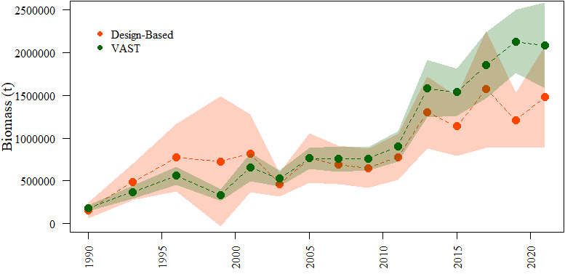

Over the course of the last several years, and in anticipation of the CIE review, a number of the above recommendations made by the Plan Team and SSC have been investigated. A primary finding of these investigations was the sensitivity of the results to the biomass index that was used. The AFSC’s Groundfish Assessment Program (GAP) has formed a technical working group to resolve model based estimates of trawl surveys. These differences will be evaluated in more detail in 2022 and our plan is to follow their findings and their advice, in addition to the advice of the Plan Team and SSC.

## Introduction

### Biology and distribution

Pacific ocean perch (*Sebastes alutus,* POP) have a wide distribution in the North Pacific from southern California around the Pacific rim to northern Honshu Is., Japan, including the Bering Sea. The species appears to be most abundant in northern British Columbia, the Gulf of Alaska (GOA), and the Aleutian Islands (Allen and Smith 1988). Adults are found primarily offshore on the outer continental shelf and the upper continental slope in depths of 150-420 m. Seasonal differences in depth distribution have been noted by many investigators. In the summer, adults inhabit shallower depths, especially those between 150 and 300 m. In the fall, the fish apparently migrate farther offshore to depths of ~300-420 m. They reside in these deeper depths until about May, when they return to their shallower summer distribution (Love et al. 2002). This seasonal pattern is probably related to summer feeding and winter spawning. Although small numbers of POP are dispersed throughout their preferred depth range on the continental shelf and slope, most of the population occurs in patchy, localized aggregations (Hanselman et al. 2001). POP are generally considered to be semi-demersal but there can at times be a significant pelagic component to their distribution. POP often move off-bottom during the day to feed, apparently following diel euphausiid migrations (Brodeur 2001). Commercial fishing data in the GOA since 1995 show that pelagic trawls fished off-bottom have accounted for as much as 31% of the annual harvest of this species.

There is much uncertainty about the life history of POP, although generally more is known than for other rockfish species (Kendall and Lenarz 1986). The species appears to be viviparous (the eggs develop internally and receive at least some nourishment from the mother), with internal fertilization and the release of live young. Insemination occurs in the fall, and sperm are retained within the female until fertilization takes place ~2 months later. The eggs hatch internally, and parturition (release of larvae) occurs in April-May. Information on early life history is very sparse, especially for the first year of life. POP larvae are thought to be pelagic and drift with the current, and oceanic conditions may sometimes cause advection to suboptimal areas (Ainley et al. 1993) resulting in high recruitment variability. However, larval studies of rockfish have been hindered by difficulties in species identification since many larval rockfish species share the same morphological characteristics (Kendall 2000). Genetic techniques using allozymes (Seeb and Kendall 1991) and mitochondrial DNA (Li 2004) are capable of identifying larvae and juveniles to species, but are expensive and time-consuming. Post-larval and early young-of-the-year POP have been positively identified in offshore, surface waters of the GOA (Gharrett et al. 2002), which suggests this may be the preferred habitat of this life stage. Transformation to a demersal existence may take place within the first year (Carlson and Haight 1976). Small juveniles probably reside inshore in very rocky, high relief areas, and by age 3 begin to migrate to deeper offshore waters of the continental shelf (Carlson and Straty 1981). As they grow, they continue to migrate deeper, eventually reaching the continental slope where they attain adulthood. Adult and juvenile populations are believed to be spatially separated (Carlson and Straty 1981; Rooper et al. 2007).

POP are mostly planktivorous (Carlson and Haight 1976; Yang 1993; Yang and Nelson 2000; Yang 2003; Yang et al. 2006). In a sample of 600 juvenile perch stomachs, Carlson and Haight (1976) found that juveniles fed on an equal mix of calanoid copepods and euphausiids. Larger juveniles and adults fed primarily on euphausiids, and to a lesser degree, copepods, amphipods and mysids (Yang and Nelson 2000). In the Aleutian Islands, myctophids have increasingly comprised a substantial portion of the POP diet, which also compete for euphausiid prey (Yang 2003). POP and walleye pollock (*Gadus chalcogrammus*) probably compete for the same euphausiid prey as euphausiids make up about 50% of the pollock diet (Yang and Nelson 2000). Consequently, the large removals of POP by foreign fishermen in the GOA in the 1960s may have allowed walleye pollock stocks to greatly expand in abundance.

Predators of adult POP are likely sablefish, Pacific halibut, and sperm whales (Major and Shippen 1970). Juveniles are consumed by seabirds (Ainley et al. 1993), other rockfish (Hobson et al. 2001), salmon, lingcod, and other large demersal fish.

POP is a slow growing species, with a low rate of natural mortality, a relatively old age at 50% maturity (8.4 - 10.5 years for females in the GOA), and a very old maximum age of 98 years in Alaska (84 years maximum age in the GOA) (Hanselman et al. 2003a). Age at 50% recruitment to the commercial fishery has been estimated to be between 7 and 8 years in the GOA. Despite their viviparous nature, they are relatively fecund with number of eggs/female in Alaska ranging from 10,000-300,000, depending upon size of the fish (Leaman 1991). Rockfish in general were found to be about half as fecund as warm water snappers with similar body shapes (Haldorson and Love 1991).

The evolutionary strategy of spreading reproductive output over many years is a way of ensuring some reproductive success through long periods of poor larval survival (Leaman and Beamish 1984). Fishing generally selectively removes the older and faster-growing portion of the population. If there is a distinct evolutionary advantage of retaining the oldest fish in the population, either because of higher fecundity or because of different spawning times, age-compression could be deleterious to a population with highly episodic recruitment like rockfish (Longhurst 2002). Research on black rockfish (*Sebastes melanops*) has shown that larval survival may be dramatically higher from older female spawners (Berkeley et al. 2004, Bobko and Berkeley 2004). The black rockfish population has shown a distinct downward trend in age-structure in recent fishery samples off the West Coast of North America, raising concerns about whether these are general results for most rockfish. de Bruin et al. (2004) examined POP (*S. alutus*) and rougheye rockfish (*S. aleutianus*) for senescence in reproductive activity of older fish and found that oogenesis continues at advanced ages. Leaman (1991) showed that older individuals have slightly higher egg dry weight than their middle-aged counterparts. Such relationships have not yet been determined to exist for POP or other rockfish in Alaska. Stock assessments for Alaska groundfish have assumed that the reproductive success of mature fish is independent of age. Spencer et al. (2007) showed that the effects of enhanced larval survival from older mothers decreased estimated *Fmsy* (the fishing rate that produces maximum sustainable yield) by 3% to 9%, and larger decreases in stock productivity were associated at higher fishing mortality rates that produced reduced age compositions. Preliminary work at Oregon State University examined POP of adult size by extruding larvae from harvested fish near Kodiak, and found no relationship between spawner age and larval quality (Heppell et al. 2009). However, older spawners tended to undergo parturition earlier in the spawning season than younger fish. A more recent study suggest that larval quality is both a function of spawner age and parturition timing.

### Evidence of stock structure

A few studies have been conducted on the stock structure of POP. Based on allozyme variation, Seeb and Gunderson (1988) concluded that POP are genetically quite similar throughout their range, and genetic exchange may be the result of dispersion at early life stages. In contrast, analysis using mitochondrial DNA techniques indicates that genetically distinct populations of POP exist (Palof 2008). Palof et al. (2011) report that there is low, but significant genetic divergence (FST = 0.0123) and there is a significant isolation by distance pattern. They also suggest that there is a population break near the Yakutat area from conducting a principle component analysis. Withler et al. (2001) found distinct genetic populations on a small scale in British Columbia. Kamin et al. (2013) examined genetic stock structure of young of the year POP. The geographic genetic pattern they found was nearly identical to that observed in the adults by Palof et al. (2011).

In a study on localized depletion of Alaskan rockfish, Hanselman et al. (2007) showed that POP are sometimes highly depleted in areas 5,000-10,000 km2 in size, but a similar amount of fish return in the following year. This result suggests that there is enough movement on an annual basis to prevent serial depletion and deleterious effects on stock structure.

In 2012, the POP assessment presented the completed stock structure template that summarized the body of knowledge on stock structure and spatial management (Hanselman et al. 2012a).

## Fishery

### Historical Background

A POP trawl fishery by the U.S.S.R. and Japan began in the GOA in the early 1960s. This fishery developed rapidly, with massive efforts by the Soviet and Japan­ese fleets. Catches peaked in 1965, when a total of nearly 350,000 metric tons (t) was caught. This apparent overfishing resulted in a precipitous decline in catches in the late 1960s. Catches continued to decline in the 1970s, and by 1978 catches were only 8,000 t (Figure 9-1). Foreign fishing dominated the fishery from 1977 to 1984, and catches generally declined during this period. Most of the catch was taken by Japan (Carlson et al. 1986). Catches reached a minimum in 1985, after foreign trawling in the GOA was prohibited.

The domestic fishery first became important in 1985 and expanded each year until 1991 (Figure 9-1). Much of the expansion of the domestic fishery was apparently related to increasing annual quotas; quotas increased from 3,702 t in 1986 to 20,000 t in 1989. In the years 1991-95, overall catches of slope rockfish diminished as a result of the more restrictive management policies enacted during this period. The restrictions included: (1) establishment of the management subgroups, which limited harvest of the more desired species; (2) reduction of total allowable catch (TAC) to promote rebuilding of POP stocks; and (3) conservative in-season management practices in which fisheries were sometimes closed even though substantial unharvested TAC remained. These closures were necessary because, given the large fishing power of the rockfish trawl fleet, there was substantial risk of exceeding the TAC if the fishery were to remain open. Since 1996, catches of POP have increased again, as good recruitment and increasing biomass for this species have resulted in larger TAC’s. In recent years, the TAC’s for POP have usually been fully taken (or nearly so) in each management area except Southeast Outside. (The prohibition of trawling in Southeast Outside during these years has resulted in almost no catch of POP in this area). In 2013, approximately 21% of the TAC was taken in the Western GOA. NMFS did not open directed fishing for POP in this area because the catch potential from the expected effort (15 catcher/processors) for a one day fishery (shortest allowed) exceeded the available TAC. The 2014 fishery in this area didn’t occur until October but nearly all of the TAC was harvested.

Detailed catch information for POP in the years since 1977 is listed in Table 9-1. The reader is cautioned that actual catches of POP in the commercial fishery are only shown for 1988-2019; for previous years, the catches listed are for the POP complex (a former management grouping consisting of POP and four other rockfish species), POP alone, or all *Sebastes* rock­fish, depending upon the year (see Table 9-1). POP make up the majority of catches from this complex. The acceptable biological catches and quotas in Table 9-1 are Gulf-wide values, but in actual practice the NPFMC has divided these into separate, annual apportionments for each of the three regulatory areas of the GOA.

Historically, bottom trawls have accounted for nearly all the commercial harvest of POP. In recent years, however, the portion of the POP catch taken by pelagic trawls has increased. The percentage of the POP Gulf-wide catch taken in pelagic trawls increased from an average of 7% during 1990-2005 to an average of 24% and up to 31% after 2006.

Before 1996, most of the POP trawl catch (>90%) was taken by large factory-trawlers that processed the fish at sea. A significant change occurred in 1996, however, when smaller shore-based trawlers began taking a sizeable portion of the catch in the Central area for delivery to processing plants in Kodiak. These vessels averaged about 50% of the catch in the Central Gulf area since 1998. By 2008, catcher vessels were taking 60% of the catch in the Central Gulf area and 35% in the West Yakutat area. Factory trawlers continue to take nearly all the catch in the Western Gulf area.

In 2007, the Central GOA Rockfish Program was implemented to enhance resource conservation and improve economic efficiency for harvesters and processors who participate in the Central GOA rockfish fishery. This rationalization program establishes cooperatives among trawl vessels and processors which receive exclusive harvest privileges for rockfish management groups. The primary rockfish management groups are northern rockfish, POP, and pelagic shelf rockfish.

### Management measures/units

In 1991, the NPFMC divided the slope assemblage in the GOA into three management subgroups: POP, shortraker/rougheye rockfish, and all other species of slope rockfish. In 1993, a fourth management subgroup, northern rockfish, was also created. In 2004, shortraker rockfish and rougheye rockfish were divided into separate subgroups. These subgroups were established to protect POP, shortraker rockfish, rougheye rockfish, and northern rockfish (the four most sought-after commercial species in the assemblage) from possible overfishing. Each subgroup is now assigned an individual ABC (acceptable biological catch) and TAC (total allowable catch), whereas prior to 1991, an ABC and TAC was assigned to the entire assemblage. Each subgroup ABC and TAC is apportioned to the three management areas of the GOA (Western, Central, and Eastern) based on distribution of survey biomass.

Amendment 32, which took effect in 1994, established a rebuilding plan for POP. The amendment stated that “*stocks will be considered to be rebuilt when the total biomass of mature females is equal to or greater than BMSY*” ([Federal Register: April 15, 1994](http://alaskafisheries.noaa.gov/prules/noa_18103.pdf)). Prior to Amendment 32, overfishing levels had been defined GOA-wide. Under Amendment 32, “*the overfishing level would be distributed among the eastern, central, and western areas in the same proportions as POP biomass occurs in those areas. This measure would avoid localized depletion of POP and would rebuild POP at equal rates in all regulatory areas of the GOA.*” This measure established management area OFLs for POP.

Amendment 41, which took effect in 2000, prohibited trawling in the Eastern area east of 140 degrees W. longitude. Since most slope rockfish, especially POP, are caught exclusively with trawl gear, this amendment could have concentrated fishing effort for slope rockfish in the Eastern area in the relatively small area between 140 degrees and 147 degrees W. longitude that remained open to trawling. To ensure that such a geographic over-concentration of harvest would not occur, since 1999 the NPFMC divided the Eastern area into two smaller management areas: West Yakutat (area between 147 and 140 degrees W. longitude) and East Yakutat/Southeast Outside (area east of 140 degrees W. longitude). Separate ABC’s and TAC’s are now assigned to each of these smaller areas for POP, while separate OFLs have remained for the Western, Central, and Eastern GOA management areas.

In November, 2006, NMFS issued a final rule to implement Amendment 68 of the GOA groundfish Fishery Management Plan for 2007 through 2011. This action implemented the Central GOA Rockfish Program (formerly the Rockfish Pilot Program or RPP). The intention of this program is to enhance resource conservation and improve economic efficiency for harvesters and processors in the rockfish fishery. This should spread out the fishery in time and space, allowing for better prices for product and reducing the pressure of what was an approximately two week fishery in July. The authors will pay close attention to the benefits and consequences of this action.

Since the original establishment of separate OFLs by management areas for POP in the rebuilding plan (Amendment 32) in 1994, the spawning stock biomass has tripled. The rebuilding plan required that female spawning biomass be greater than *Bmsy* and the stock is now 53% higher than *Bmsy* (using *B40%* as a proxy for *Bmsy*). Management has prosecuted harvest accurately within major management areas using ABC apportionments. While evidence of stock structure exists in the GOA, it does appear to be along an isolation by distance cline, not sympatric groups (Palof et al. 2011; Kamin et al. 2013). Palof et al. (2011) also suggest that the Eastern GOA might be distinct genetically, but this area is already its own management unit, and has additional protection with the no trawl zone. Hanselman et al. (2007) showed that POP are reasonably resilient to serial localized depletions (areas replenish on an annual basis). The NPFMC stock structure template was completed for GOA POP in 2012 (Hanselman et al. 2012a). Recommendations from this exercise were to continue to allocate ABCs by management area or smaller. However, the original rationale for area-specific OFLs from the rebuilding plan no longer exists because the overall population is above target levels and is less vulnerable to occasional overages. Therefore, in terms of rebuilding the stock, management area OFLs are no longer a necessity for the GOA POP stock.

Management measures since the break out of POP from slope rockfish are summarized in Table 9-2.

### Bycatch and discards

Gulf-wide discard rates(% discarded, current as of October 24, 2021) for POP in the commercial fishery are listed as follows:

|  |  |  |  |  |  |  |  |  |  |  |  |
| --- | --- | --- | --- | --- | --- | --- | --- | --- | --- | --- | --- |
| Year | 2000 | 2001 | 2002 | 2003 | 2004 | 2005 | 2006 | 2007 | 2008 | 2009 | 2010 |
| % Discard | 11.3 | 8.6 | 7.3 | 15.1 | 8.2 | 5.7 | 7.8 | 3.7 | 4.1 | 6.8 | 4.1 |

|  |  |  |  |  |  |  |  |  |  |  |  |  |  |  |  |  |  |  |
| --- | --- | --- | --- | --- | --- | --- | --- | --- | --- | --- | --- | --- | --- | --- | --- | --- | --- | --- |
| Year | 2011 | 2012 | 2013 | 2014 | 2015 | 2016 | 2017 | 2018 | 2019 | 2020 | 2021 |  |  |  |  |  |  |  |
| % Discard | 6.6 | 4.8 | 7.6 | 9.5 | 3.8 | 6.8 | 14.8 | 4.7 | 7.4 | 4.5 | 2.2 |  |  |  |  |  |  |  |

Total FMP groundfish catch estimates in the GOA rockfish targeted fisheries are shown in Table 9-3. For the GOA rockfish fishery, the largest non-rockfish bycatch groups are arrowtooth flounder, Atka mackerel, walleye pollock, Pacific cod, and sablefish. Catch of POP in other GOA fisheries is mainly in arrowtooth flounder, walleye pollock-midwater, and rex sole targeted fishing (Table 9-4). Non-FMP species catch in the rockfish target fisheries is dominated by giant grenadier and miscellaneous fish (Table 9-5). The increase in POP discards in 2017 can likely be attributed to an extremely high bycatch of POP in the arrowtooth flounder directed fishery (Table 9-4). Hulson et al. (2014) compared bycatch for the combined rockfish fisheries in the Central GOA from before and during the Rockfish Program to determine the impacts of the Rockfish Program and found the bycatch of the majority of FMP groundfish species in the Central GOA was reduced following implementation of the Rockfish Program.

Prohibited species catch in the GOA rockfish fishery is generally low (Table 9-6). Catch of prohibited and non-target species generally decreased with implementation of the Central GOA Rockfish Program (Hulson et al. 2014).

## Data

The following table summarizes the data used for this assessment (bold font denotes new data to this year’s assessment):

|  |  |  |
| --- | --- | --- |
| Source | Data | Years |
| NMFS Groundfish survey | Survey biomass | 1984-1999 (triennial), 2001-**2021** (biennial) |
|  | Age Composition | 1984, 1987, 1990, 1993, 1996, 1999, 2003, 2005, 2007, 2009, 2011, 2013, 2015, 2017, 2019 |
| U.S. trawl fisheries | Catch | 1961-**2021** |
| Age Composition | 1990,1998-2002, 2004, 2005, 2006, 2008, 2010, 2012, 2014, 2016, 2018, **2020** |
| Length Composition | 1963-1977, 1991-1997 |

### Fishery

#### Catch

Catches ranged from 2,500 t to 350,000 t since 1961. The detailed catch information for POP is listed in Table 9-1 and annual summaries shown graphically in Figure 9-1 (these annual values are used in the assessment model). Additional research and non-commercial catches (excluded from the directed fishery analysis) have been generally less than 100 t annually and are presented (as required) in Appendix 9-A.

#### Age and Size composition

Observers aboard fishing vessels and at onshore processing facilities have provided data on size and age composition of the commercial catch of POP. Ages were determined from the break-and-burn method (Chilton and Beamish 1982). Table 9-7 summarizes the fishery length compositions from the most recent 10 years, Table 9-8 summarizes age compositions for the fishery, and Figures 9-2 and 9-3 show the distributions graphically for fishery age and length composition data fit by the assessment. The age compositions for the fishery prior to 2004 show strong 1986 and 1987 year classes. After 2004 the fishery age composition data show the presence of several relatively strong year classes including the 1993, 1994, and 1998 year classes. Each of these year classes, with the exception of the 1993 and 1994 year classes, have also been identified in the trawl survey age composition data.

Fishery length composition is available from the early 1960s to present (Figure 9-3 and Table 9-7). Due to the availability of age data from both the fishery and trawl survey we do not fit the recent fishery length composition, but rather use the historical fishery length composition data shown in Figure 9-3. We note that the fishery length samples are used to determine the fishery age composition through the use of an age-length key, which weights the age samples from the fishery by the length samples. Fishery length composition data prior to the mid-1970s indicates that the mean length of POP was smaller than after the mid-1970s. We hypothesize that rather than year classes moving into the population in these years (and thus reducing the mean length) that there were differences in growth, thus, we use a different size age transition matrix in these years (as described in the *Parameters Estimated Outside the Assessment Model* section below). In general, because of the selectivity of the fishery at older ages, there is no strong recruitment signal in the fishery length composition data.

### Survey

#### Biomass Estimates from Trawl Surveys

Bottom trawl surveys were conducted on a triennial basis in the GOA in 1984, 1987, 1990, 1993, 1996, and a biennial survey schedule has been used since the 1999 survey. The surveys provide much information on POP, including an abundance index, age composition, and growth characteristics. The surveys are theoretically an estimate of absolute biomass, but we treat them as a relative index in the stock assessment. The surveys covered typically cover all of the NMFS areas of the GOA out to a depth of 500 m. In some years the surveys extended to 1,000 m and in the 2001 the survey covered only the central and western GOA (budget limitations affected the ability to cover the Eastern GOA). Regional and Gulf-wide biomass estimates (with corresponding coefficients of variation in total biomass) for POP are shown in Table 9-9. Gulf-wide biomass estimates for with 95% confidence intervals are shown in Figure 9-4.

Biomass estimates of POP were relatively low in 1990, increased markedly in both 1993 and 1996, and remained around the 1996 value in 1999 and 2001 (Table 9-9 and Figure 9-4). These surveys were characterized with relatively larger uncertainty with coefficients of variation (CV) greater than 20% (reaching a maximum in 1999 of 53%). Large catches of an aggregated species like POP in just a few individual hauls can greatly influence biomass estimates and are a source of much variability. Biomass estimates of POP decreased in 2003, then increased in 2005 and remained relatively stable until 2011, indicating that the biomass in 2003 may have been anomalously small. In 2013 biomass estimates increased markedly and have remained above one million tons since. The largest biomass estimate of the time series occurred in 2017. Since the 2003 survey biomass estimates of POP have been associated with relatively small uncertainty, with CVs below 20% in all but one year (2017, with a CV of 22%). This reduced uncertainty is because POP continue to be more uniformly distributed than in the past, as indicated by increasing proportion of tows that catch POP in the survey as well as declining uncertainty in the trawl survey catch per unit effort (CPUE, Figure 9-5).

The 2021 survey biomass estimate is the second largest on record and is 22% larger than the 2019 biomass estimate. Regionally, both the Central and Western GOA increased while the estimate for the Eastern GOA declined from 2019 (Table 9-9). The general distribution of CPUE in the 2021 survey were comparable to 2017 and 2019 in the Central and Eastern GOA (Figure 9-5). The most notable difference in POP CPUE distribution in 2021 compared to 2019 and 2017 is in the far western part of the Western GOA.

#### Trawl Survey Age and Length Compositions

Ages were determined from the break-and-burn method (Chilton and Beamish 1982). The survey age compositions from 1990-2017 surveys showed that although the fish ranged in age up to 84 years, most of the population was relatively young; mean survey age has increased from 9.2 years in 1990 to 15.6 years in 2017 (Table 9-10). The first four surveys identified relatively strong year classes in the mid-1980s (1984-1988) and also showed a period of very weak year classes during the 1970s to mid-19080s (Figure 9-6). The weak year classes through this period of time may have delayed recovery of POP populations after they were depleted by the foreign fishery. Since the 1999 survey the age compositions have indicated several stronger than average year classes. Starting with the 2003 and through the 2009 survey the age composition data indicated relatively strong year classes in 1998, 2000, and 2002. Since the 2009 survey the age composition data has distinguished relatively strong year classes in 2006, 2008, and 2010. The 2017 survey age composition indicates that the 2007 year class could also be relatively strong and the plus age group of 25 and older has increased to 0.15 (from an average of 0.04 prior to 2011). The 2019 survey age composition indicates the possible emergence of a strong 2016 year class. These relatively strong year classes since 1998 may be contributing to the increase in survey biomass observed since 2013.

Gulf-wide population size compositions for POP are shown in Figure 9-7. These size composition data identify several year classes that have moved through the population since 2001. The 2001 and 2009 survey length compositions indicated relatively strong year classes in 1998 and 2006 (which were ~17-21 cm in these surveys). The 2006 year class was again relatively strong in the 2011 data (which would have been ~24-28 cm) and both the 1998 and 2006 year classes were corroborated with the survey age composition data. The 2019 survey length compositions indicated a mode at ~17-21 cm (age-3), which would be the 2016 year class. The most recent length composition data from the 2021 survey detects this mode but it is not as strong as that seen in 2019. Survey size data are used in constructing the age-length transition matrix, but not used as data to be fitted in the stock assessment model.

#### Summer Acoustic-Trawl Survey

Acoustic-trawl (AT) surveys designed to evaluate walleye pollock abundance in the Gulf of Alaska have been conducted by the Alaska Fisheries Science Center (AFSC) in summer months (June – August) on odd years from 2013 to 2021 aboard the NOAA ship *Oscar Dyson* (Jones et al. 2014, Jones et al. 2017, Jones et al. 2019). POP are routinely encountered during these surveys and abundance estimates for POP are available for the surveyed area. The surveys cover the Gulf of Alaska continental shelf and shelfbreak from depths of 50 to 1000 m, including associated bays and troughs, and extend from the continental shelf south of the Islands of Four Mountains in the Aleutian Islands eastward to Yakutat Bay. The surveys consist of widely-spaced (25 nmi) parallel transects along the shelf, and more closely spaced transects (1-15 nmi) in troughs, bays, and Shelikof Strait. Mid-water and bottom trawls are used to identify species and size of acoustic targets.

Surveys prior to 2019 used a single length distribution of POP caught in combined hauls to scale the acoustic data to abundance and biomass. Starting in 2019, the length distribution from the haul nearest to the acoustic signal was used for scaling. A generalized physoclist target strength (TS) to length (L) relationship (TS = 20Log10(L)-67.5; Foote 1987) was used to scale acoustic signal to length. More specific computational details of the AT methods for abundance estimation can be found in Jones et al. 2019.

The summer Gulf AT survey data is not currently used in the assessment model, but biomass estimates are available since the 2013 survey. We will continue to report these estimates in the POP SAFE as current research is exploring the potential for including this information into the assessment model. The following table includes the biomass estimates provided by the AT survey:

|  |  |  |  |  |  |
| --- | --- | --- | --- | --- | --- |
| Year | 2013 | 2015 | 2017 | 2019 | 2021 |
| Biomass (mt) | 262,889 | 438,545 | 172,388 | 144,045 | 277,941 |

Figure 9-8 shows the distribution of POP within the AT survey for the most recent three surveys. Compared to 2019, the biomass of POP was more spread out across the transects, with a large estimate south of Kodiak Island (Figure 9-8).

## Analytic Approach

### General Model Structure

Prior to 2001, the stock assessment was based on an age-structured model using an early FORTRAN version of the stock synthesis framework (Methot 1990). Since then it was modified and written in to AD Model Builder software (see Fournier et al. 2012 for recent reference) as described in Courtney et al. (2007). The population dynamics, with parameter descriptions and notation are shown in Table 9-11. The formulae to estimate the observed data by the POP assessment are shown in Table 9-12. Finally, the likelihood and penalty functions used to optimize the POP assessment are shown in Table 9-13.

Since its initial adaptation in 2001, the models’ attributes have been explored and changes have been made to the template to adapt to POP and other species. The following changes have been adopted within the POP assessment since the initial model in 2001:

* 2003: Size to age matrix added for the 1960s and 1970s to adjust for density-dependent growth, natural mortality and bottom trawl survey catchability estimated within model
* 2009: Fishery selectivity estimated for three time periods describing the transition from a foreign to domestic fishery, MCMC projections used with a pre-specified proportion of ABC for annual catch
* 2014: Maturity at age estimated conditionally with addition of new maturity data
* 2015: Extended ageing error matrix adopted to improve fit to plus age group and adjacent age classes
* 2017: Length bins for fishery length composition data set at 1cm, removed 1984 and 1987 trawl survey data, time block added to fishery selectivity starting in 2007 to coincide with the Central GOA rockfish program
* 2020: Fishery age composition data constructed with age-length key, prior for bottom trawl catchability set at 1.15 (Jones et al. 2021), and prior for natural mortality set at 0.0614 (Hamel 2015)

### Description of Alternative Models

Given recent developments and the results of the CIE review, we only present one model configuration which matches the one accepted in 2020 (but with updated data).

### Parameters Estimated Outside the Assessment Model

Growth of POP is estimated using length-stratified methods to estimate mean length and weight at age from the bottom trawl survey that are then modeled with the von Bertlanffy growth curve (Hulson et al. 2015). Two size to age transition models are employed in the POP assessment, the first for data from the 1960s and 1970s, the second for data after the 1980s. The additional size to age transition matrix is used to represent a lower density-dependent growth rate in the 1960s and 1970s (Hanselman et al. 2003a). The von Bertlanffy parameters used for the 1960s and 1970s size to age transition matrix are:

*L∞* = 41.6 cm *κ* = 0.15 *t0* = -1.08

The von Bertlanffy parameters used for the post 1980s size to age transition matrix are:

*L∞* = 41.1 cm *κ* = 0.18 *t0* = -0.49

The size to age conversion matrices are constructed by adding normal error with a standard deviation equal to the bottom trawl survey data for the probability of different ages for each size class. This is estimated with a linear relationship between the standard deviation in length with age. The linear parameters used for the 1960s and 1970s size to age transition matrix are (*a*-intercept, *b*-slope):

*a* = 0.42 *b* = 1.38

The linear parameters used for the post 1980s size to age transition matrix are (*a*-intercept, *b*-slope):

*a* = -0.02 *b* = 2.18

Weight-at-age was estimated with weight at age data from the same data set as the length at age. The estimated growth parameters are shown below. A correction of (W∞-W25)/2 was used for the weight of the pooled ages (Schnute et al. 2001).

*W∞* = 901 g *κ* = 0.20 *t0* = -0.37 *β* = 3.04

The above growth parameters are updated for each assessment with the addition of new age, length, and weight data from the trawl survey. The average percent change in spawning biomass estimated from the current assessment with previous growth parameters compared to using the updated growth information above was less than 0.5%.

Aging error matrices were constructed by assuming that the break-and-burn ages were unbiased but had a given amount of normal error around each age based on percent agreement tests conducted at the AFSC Age and Growth lab. In 2015 an extended ageing error matrix was implemented into the POP assessment in order to improve the fit to the plus age group and adjacent age classes (Hulson et al. 2015). For a data plus age group of 25, the resulting model plus age group was 29 so that 99.9% of the fish greater than age 29 were within the 25 plus age group of the data.

### Parameters Estimated Inside the Assessment Model

Natural mortality (*M*), catchability (*q*) and recruitment deviations (**r) are estimated with the use of prior distributions as penalties. The prior mean for *M* is based on maximum age from Hamel (2015). Natural mortality is a notoriously difficult parameter to estimate within the model so we assign a relatively precise prior CV of 10%. Catchability is a parameter that is somewhat unknown for rockfish, so while we assign it a prior mean of 1 (assuming all fish in the area swept are captured and there is no herding of fish from outside the area swept, and that there is no effect of untrawlable grounds), we assign it a less precise CV of 45%. This allows the parameter more freedom than that allowed to natural mortality. Recruitment deviation is the amount of variability that the model allows for recruitment estimates. Rockfish are thought to have highly variable recruitment, so we assign a high prior mean to this parameter of 1.7 with a CV of 20%.

Fishery selectivity is estimated within four time periods that coincide with the transition from a foreign to domestic fishery. These time periods are:

1. 1961-1976: This period represented the massive catches and overexploitation by the foreign fisheries which slowed considerably by 1976. We do not have age data from this period to examine, but we can assume the near pristine age-structure was much older than now, and that at the high rate of exploitation, all vulnerable age-classes were being harvested. For these reasons we chose to only consider asymptotic (logistic) selectivity.
2. 1977-1995: This period represents the change-over from the foreign fleet to a domestic fleet, but was still dominated by large factory trawlers, which generally would tow deeper and further from port.
3. 1996-2006: During this period we have noted the emergence of smaller catcher-boats, semi-pelagic trawling and fishing cooperatives. The length of the fishing season has also been recently greatly expanded.
4. 2007-Present: This period coincides with the start of the Rockfish Program in the Central Gulf, a fishing cooperative that has influenced the behavior and composition (catcher versus factory trawlers) of the fishery.

Fishery selectivity across these time periods transitions from an asymptotic selectivity from 1961-1976 into dome-shaped fishery selectivity after 1977. We fitted a logistic curve for the first block, an averaged logistic-gamma in the 2nd block, and a gamma function for the 3rd  and 4th blocks. Bottom trawl survey selectivity is estimated to be asymptotic with the logistic curve.

Maturity-at-age is modeled with the logistic function conditionally within the assessment following the method presented in Hulson et al. (2011). Parameter estimates for maturity-at-age are obtained by fitting two datasets collected on female POP maturity from Lunsford (1999) and Conrath and Knoth (2013). Parameters for the logistic function describing maturity-at-age are estimated conditionally in the model so that uncertainty in model results (e.g., ABC) can be linked to uncertainty in maturity parameter estimates.

Other parameters estimated conditionally include, but are not limited to: mean recruitment, fishing mortality, and spawners per recruit levels. The numbers of estimated parameters for the recommended model are shown below. Other derived parameters are described in Box 1.

|  |  |  |
| --- | --- | --- |
| Parameter name | Symbol | Number |
| Natural mortality | $$M$$ | 1 |
| Catchability | $$q$$ | 1 |
| Log-mean-recruitment | $$μ_{r}$$ | 1 |
| Recruitment variability | $$σ_{r}$$ | 1 |
| Spawners-per-recruit levels | $$F_{35\%},F_{40\%},F_{100\%}$$ | 3 |
| Recruitment deviations | $$ε_{y}^{r}$$ | 87 |
| Average fishing mortality | $$μ_{f}$$ | 1 |
| Fishing mortality deviations | $$ε_{y}^{f}$$ | 61 |
| Fishery selectivity coefficients | $$s_{a}^{f}$$ | 6 |
| Survey selectivity coefficients | $$s_{a}^{t}$$ | 2 |
| Maturity-at-age coefficients | $${\hat{m}}_{a}$$ | 2 |
| Total |  | 166 |

#### Uncertainty approach

Evaluation of model uncertainty is obtained through a Markov Chain Monte Carlo (MCMC) algorithm (Gelman et al. 1995). The chain length of the MCMC was 10,000,000 and was thinned to one iteration out of every 2,000. We omit the first 1,000,000 iterations to allow for a burn-in period. We use these MCMC methods to provide further evaluation of uncertainty in the results below including 95% credible intervals for some parameters (computed as the 5th and 95th percentiles of the MCMC samples).

## Results

### Model Evaluation

The model used in this assessment is the same as the model accepted in 2020 with updated data and parameter priors. When we present alternative model configurations, our usual criteria for choosing a superior model are: (1) the best overall fit to the data (in terms of negative log-likelihood), (2) biologically reasonable patterns of estimated recruitment, catchabilities, and selectivities, (3) a good visual fit to length and age compositions, and (4) parsimony. Because the current assessment model is the same as 2020 we will evaluate the 2021 assessment based on differences in results compared to the 2020 assessment.

Model 20.1 with data updated through 2021 generally results in reasonable fits to the data, estimates biologically plausible parameters, and produces consistent patterns in abundance compared to previous assessments. The assessment model continues to underestimate the trawl biomass since the 2013 survey, although, the retrospective pattern indicates that the model fit is continuing to improve to the trawl survey with additional assessments.

### Time Series Results

Key results have been summarized in Tables 9-14 to 9-18. Model predictions generally fit the data well (Figures 9-1, 9-2, 9-3, 9-4, and 9-6) and most parameter estimates and likelihood functions have remained similar to the last several years using this model (Table 9-14).

#### Definitions

Spawning biomass is the biomass estimate of mature females. Total biomass is the biomass estimate of all POP age two and greater. Recruitment is measured as the number of age two POP. Fishing mortality is the mortality at the age the fishery has fully selected the fish.

#### Biomass and exploitation trends

Estimated total biomass gradually increased from a low near 85,000 t in 1980 to over 596,000 t at the peak in 2015 (Figure 9-9). MCMC credible intervals indicate that the historic low is reasonably certain while recent increases are not quite as certain. Spawning biomass shows a similar trend (Figure 9-9). These estimates show a rapid increase since 1992, which coincides with an increase in uncertainty. The recent estimates of spawning biomass are nearly at historical levels prior to the 1970s. Age of 50% selection is 5 for the survey and between 7 and 9 years for the fishery (Figure 9-10). Fish are fully selected by both fishery and survey between 10 and 15. Current fishery selectivity is dome-shaped and with the addition of the recent time block after 2007 matches well with the ages caught by the fishery. Catchability is slightly larger (1.82) than that estimated in 2020 (1.8). The high catchability for POP is supported by several empirical studies using line transect densities counted from a submersible compared to trawl survey densities (Krieger 1993 [*q=*2.1], Krieger and Sigler 1996 [*q=*1.3], Jones et al. 2021 [*q*=1.15]). Compared to the last full assessment, spawning biomass and age-6+ total biomass has increased in response to fitting the large trawl survey biomass estimates since 2013 (Table 9-15, Figure 9-9).

Fully-selected fishing mortality shows that fishing mortality has decreased dramatically from historic rates and has leveled out in the last decade (Figure 9-11). Goodman et al. (2002) suggested that stock assessment authors use a “management path” graph as a way to evaluate management and assessment performance over time. We chose to plot a phase plane plot of fishing mortality to *FOFL* (*F35%*) and the estimated spawning biomass relative to unfished spawning biomass (*B100%*). Harvest control rules based on *F35%* and *F40%* and the tier 3b adjustment are provided for reference. The management path for POP has been above the *F35%* adjusted limit for most of the historical time series (Figure 9-12). In addition, since 2004, POP SSB has been above *B40%* and fishing mortality has been below *F40%* since 1983.

#### Recruitment

Recruitment (as measured by age 2 fish) for POP is highly variable and large recruitments comprise much of the biomass for future years (Figure 9-13). Recruitment has increased since the early 1970s, starting with the 1986 year class. Since the 1990s there have been several larger than average year classes, with the largest resulting in 2006. The largest differences in estimated recruitment between the current assessment and the 2020 assessment resulted at the end of the time series (Table 9-15 and Figures 9-13 and 9-14), which should not be unexpected given the influence of additional age composition data on recent recruitment estimates. The survey age data and the large 2013-2019 survey biomass suggests that the 2006-2009, 2010, 2012, and 2016 year classes may be above average (Figure 9-14). However, these recent recruitments are still highly uncertain as indicated by the MCMC credible intervals in Figure 9-13. POP do not seem to exhibit much of a stock-recruitment relationship because large recruitments have occurred during periods of high and low biomass (Figure 9-13).

#### Uncertainty results

From the MCMC chains described in *Uncertainty approach*, we summarize the posterior densities of key parameters for the recommended model using histograms (Figure 9-15) and credible intervals (Table 9-16 and 9-17). We also use these posterior distributions to show uncertainty around time series estimates of survey biomass (Figure 9-4), total and spawning biomass (Figure 9-9), fully selected fishing mortality (Figure 9-11) and recruitment (Figure 9-13).

Table 9-16 shows the maximum likelihood estimate (MLE) of key parameters with their corresponding standard deviation derived from the Hessian matrix. Also shown are the MCMC, mean, median, standard deviation and the corresponding Bayesian 95% credible intervals (BCI). The Hessian and MCMC standard deviations are similar for *q, M,* and *F40*%, but the MCMC standard deviations are larger for the estimates of female spawning biomass and ABC.These larger standard deviations indicate that these parameters are more uncertain than indicated by the Hessian approximation. The distributions of these parameters with the exception of natural mortality are slightly skewed with higher means than medians for current spawning biomass and ABC, indicating possibilities of higher biomass estimates (Figure 9-15). Uncertainty estimates in the time series of spawning biomass also result in a skewed distribution towards higher values, particularly at the end of the time series and into the 15 year projected times series (Figure 9-16).

#### Retrospective analysis

A within-model retrospective analysis of the recommended model was conducted for the last 10 years of the time-series by dropping data one year at a time. The revised Mohn’s “rho” statistic (Hanselman et al. 2013) in female spawning biomass was -0.16 (slightly larger than the 2020 value of -0.15), indicating that the model increases the estimate of female spawning biomass in recent years as data is added to the assessment. The retrospective female spawning biomass and the relative difference in female spawning biomass from the model in the terminal year are shown in Figure 9-17 (with 95% credible intervals from MCMC). In general the relative difference in female spawning biomass early in the time series is low, in recent years the increases in spawning biomass have been up to 30% compared to the terminal year. This result is not unexpected as given the large trawl survey biomass estimates since 2013; the model is responding to this data by increasing the estimates of biomass in each subsequent year.

### Harvest Recommendations

#### Amendment 56 Reference Points

Amendment 56 to the GOA Groundfish Fishery Management Plan defines the “overfishing level”

(OFL), the fishing mortality rate used to set OFL (*FOFL*), the maximum permissible ABC, and the fishing mortality rate used to set the maximum permissible ABC. The fishing mortality rate used to set ABC (*FABC*) may be less than this maximum permissible level, but not greater. Because reliable estimates of reference points related to maximum sustainable yield (MSY) are currently not available but reliable estimates of reference points related to spawning per recruit are available, POP in the GOA are managed under Tier 3 of Amendment 56. Tier 3 uses the following reference points: *B40%*, equal to 40% of the equilibrium spawning biomass that would be obtained in the absence of fishing; *F35%,,*equal to the fishing mortality rate that reduces the equilibrium level of spawning per recruit to 35% of the level that would be obtained in the absence of fishing; and *F40%*, equal to the fishing mortality rate that reduces the equilibrium level of spawning per recruit to 40% of the level that would be obtained in the absence of fishing.

Estimation of the *B40%* reference point requires an assumption regarding the equilibrium level of recruitment. In this assessment, it is assumed that the equilibrium level of recruitment is equal to the average of age-2 recruitments between 1979 and 2019 (i.e., the 1977 – 2017 year classes). Because of uncertainty in very recent recruitment estimates, we lag 2 years behind model estimates in our projection. Other useful biomass reference points which can be calculated using this assumption are *B100%* and *B35%*, defined analogously to *B40%*. The 2022 estimates of these reference points are:

|  |  |
| --- | --- |
| *B100%* | 331,917 |
| *B40%* | 132,767 |
| *B35%* | 116,171 |
| *F40%* | 0.10 |
| *F35%* | 0.12 |

#### Specification of OFL and Maximum Permissible ABC

Female spawning biomass for 2022 is estimated at 216,635 t. This is above the *B40%* value of 132,767 t. Under Amendment 56, Tier 3, the maximum permissible fishing mortality for ABC is *F40%* andfishing mortality for OFL is *F35%.*Applying these fishing mortality rates for 2022, yields the following ABC and OFL:

|  |  |
| --- | --- |
| *F40%* | 0.10 |
| ABC | 38,268 |
| *F35%* | 0.12 |
| OFL | **45,580** |

A standard set of projections is required for each stock managed under Tiers 1, 2, or 3 of Amendment 56. This set of projections encompasses seven harvest scenarios designed to satisfy the requirements of Amendment 56, the National Environmental Policy Act, and the Magnuson-Stevens Fishery Conservation and Management Act (MSFCMA).

For each scenario, the projections begin with the vector of 2021 numbers at age as estimated in the assessment (Table 9-18). This vector is then projected forward to the beginning of 2022 using the schedules of natural mortality and selectivity described in the assessment and the best available estimate of total (year-end) catch for 2021. In each subsequent year, the fishing mortality rate is prescribed on the basis of the spawning biomass in that year and the respective harvest scenario. In each year, recruitment is drawn from an inverse Gaussian distribution whose parameters consist of maximum likelihood estimates determined from recruitments estimated in the assessment. Spawning biomass is computed in each year based on the time of peak spawning and the maturity and weight schedules described in the assessment. Total catch after 2021 is assumed to equal the catch associated with the respective harvest scenario in all years. This projection scheme is run 1,000 times to obtain distributions of possible future stock sizes, fishing mortality rates, and catches.

In response to GOA Plan Team minutes in 2010, we have established a consistent methodology for estimating current-year and future year catches in order to provide more accurate two-year projections of ABC and OFL to management. In the past, two standard approaches in rockfish models have been employed; assume the full TAC will be taken, or use a certain date prior to publication of assessments as a final estimate of catch for that year. Both methods have disadvantages. If the author assumes the full TAC is taken every year, but it rarely is, the ABC will consistently be underestimated. Conversely, if the author assumes that the catch taken by around October is the final catch, and substantial catch is taken thereafter, ABC will consistently be overestimated. Therefore, going forward in the GOA rockfish assessments, for current year catch, we are applying an expansion factor to the official catch on or near October 1 by the 3-year average of catch taken between October 1 and December 31 in the last three complete catch years (e.g. 2018-2020 for this year). For POP, the expansion factor for 2021 catch is 1.12.

For catch projections into the next two years, we are using the ratio of the last three official catches to the last three TACs multiplied against the future two years’ ABCs (if TAC is normally the same as ABC). This method results in slightly higher ABCs in each of the future two years of the projection, based on both the lower catch in the first year out, and based on the amount of catch taken before spawning in the projection two years out. To estimate future catches, we updated the yield ratio (0.85), which was the average of the ratio of catch to ABC for the last three complete catch years (2018-2020). This yield ratio was multiplied by the projected ABCs for 2022 and 2023 from the assessment model to generate catches for those years.

Five of the seven standard scenarios will be used in an Environmental Assessment prepared in conjunction with the final SAFE. These five scenarios, which are designed to provide a range of harvest alternatives that are likely to bracket the final TAC for 2022, are as follow (“*max* *FABC*” refers to the maximum permissible value of *FABC* under Amendment 56):

*Scenario 1*: In all future years, *F* is set equal to *max* *FABC*. (Rationale: Historically, TAC has been constrained by ABC, so this scenario provides a likely upper limit on future TACs.)

*Scenario 2*: In 2022 and 2023, *F* is set equal to a constant fraction of *max* *FABC*, where this fraction is equal to the ratio of the realized catches in 2018-2020 to the ABC recommended in the assessment for each of those years. For the remainder of the future years, maximum permissible ABC is used. (Rationale: In many fisheries the ABC is routinely not fully utilized, so assuming an average ratio catch to ABC will yield more realistic projections.)

*Scenario 3*: In all future years, *F* is set equal to 50% of max *FABC*. (Rationale: This scenario provides a likely lower bound on *FABC* that still allows future harvest rates to be adjusted downward when stocks fall below reference levels.)

*Scenario 4*: In all future years, *F* is set equal to the 2015-2019 average *F*. (Rationale: For some stocks, TAC can be well below ABC, and recent average *F* may provide a better indicator of *FTAC* than *FABC*.)

*Scenario 5*: In all future years, *F* is set equal to zero. (Rationale: In extreme cases, TAC may be set at a level close to zero.)

Two other scenarios are needed to satisfy the MSFCMA’s requirement to determine whether a stock is currently in an overfished condition or is approaching an overfished condition. These two scenarios are as follow (for Tier 3 stocks, the MSY level is defined as *B35%*):

*Scenario 6*: In all future years, *F* is set equal to *FOFL*. (Rationale: This scenario determines whether a stock is overfished. If the stock is expected to be above 1) above its MSY level in 2021 or 2) above ½ of its MSY level in 2021 and above its MSY level in 2031 under this scenario, then the stock is not overfished.)

*Scenario 7*: In 2022 and 2023, *F* is set equal to *max* *FABC*, and in all subsequent years *F* is set equal to *FOFL*. (Rationale: This scenario determines whether a stock is approaching an overfished condition. If the stock is 1) above its MSY level in 2023 or 2) above 1/2 of its MSY level in 2023 and expected to be above its MSY level in 2033 under this scenario, then the stock is not approaching an overfished condition.)

Spawning biomass, fishing mortality, and yield are tabulated for the seven standard projection scenarios (Table 9-19). The difference for this assessment for projections is in Scenario 2 (Author’s F); we use pre-specified catches to increase accuracy of short-term projections in fisheries (such as POP) where the catch is usually less than the ABC. This was suggested to help management with setting preliminary ABCs and OFLs for two year ahead specifications. The methodology for determining these pre-specified catches is described below in *Specified catch estimation.*

In addition to the seven standard harvest scenarios, Amendments 48/48 to the BSAI and GOA Groundfish Fishery Management Plans require projections of the likely OFL two years into the future. While Scenario 6 gives the best estimate of OFL for 2021, it does not provide the best estimate of OFL for 2022, because the mean 2021 catch under Scenario 6 is predicated on the 2021 catch being equal to the 2021 OFL, whereas the actual 2021 catch will likely be less than the 2021 OFL. The executive summary contains the appropriate one- and two-year ahead projections for both ABC and OFL.

During the 2006 CIE review, it was suggested that projections should account for uncertainty in the entire assessment, not just recruitment from the endpoint of the assessment. We continue to present an alternative projection scenario using the uncertainty of the full assessment model, harvesting at the same estimated yield ratio as Scenario 2, except for all years instead of the next two. This projection propagates uncertainty throughout the entire assessment procedure based on MCMC. The projection shows wide credibility intervals on future spawning biomass (Figure 9-17). The *B35%* and *B40%* reference points and future recruitments are based on the 1979-2019 age-2 recruitments, and this projection predicts that the median spawning biomass will eventually tend toward these reference points while at harvesting at *F40%*.

#### Risk Table and ABC Recommendation

The SSC in its December 2018 minutes recommended that all assessment authors use the risk table when determining whether to recommend an ABC lower than the maximum permissible. The following template is used to complete the risk table:

|  |  |  |  |  |
| --- | --- | --- | --- | --- |
|  | *Considerations* | | | |
|  | *Assessment-related* | *Population dynamics* | *Environmental / ecosystem* | *Fishery Performance* |
| Level 1: Normal | Typical to moderately increased uncertainty/minor unresolved issues in assessment. | Stock trends are typical for the stock; recent recruitment is within normal range. | No apparent environmental/ecosystem concerns | No apparent fishery/resource-use performance and/or behavior concerns |
| Level 2: Substantially increased concerns | Substantially increased assessment uncertainty/ unresolved issues. | Stock trends are unusual; abundance increasing or decreasing faster than has been seen recently, or recruitment pattern is atypical. | Some indicators showing an adverse signals relevant to the stock but the pattern is not consistent across all indicators. | Some indicators showing adverse signals but the pattern is not consistent across all indicators |
| Level 3: Major Concern | Major problems with the stock assessment; very poor fits to data; high level of uncertainty; strong retrospective bias. | Stock trends are highly unusual; very rapid changes in stock abundance, or highly atypical recruitment patterns. | Multiple indicators showing consistent adverse signals a) across the same trophic level as the stock, and/or b) up or down trophic levels (i.e., predators and prey of the stock) | Multiple indicators showing consistent adverse signals a) across different sectors, and/or b) different gear types |
| Level 4: Extreme concern | Severe problems with the stock assessment; severe retrospective bias. Assessment considered unreliable. | Stock trends are unprecedented; More rapid changes in stock abundance than have ever been seen previously, or a very long stretch of poor recruitment compared to previous patterns. | Extreme anomalies in multiple ecosystem indicators that are highly likely to impact the stock; Potential for cascading effects on other ecosystem components | Extreme anomalies in multiple performance indicators that are highly likely to impact the stock |

The table is applied by evaluating the severity of four types of considerations that could be used to support a scientific recommendation to reduce the ABC from the maximum permissible. These considerations are stock assessment considerations, population dynamics considerations, environmental/ecosystem considerations, and fishery performance. Examples of the types of concerns that might be relevant include the following:

1. Assessment considerations—data-inputs: biased ages, skipped surveys, lack of fishery-independent trend data; model fits: poor fits to fits to fishery or survey data, inability to simultaneously fit multiple data inputs; model performance: poor model convergence, multiple minima in the likelihood surface, parameters hitting bounds; estimation uncertainty: poorly-estimated but influential year classes; retrospective bias in biomass estimates.
2. Population dynamics considerations—decreasing biomass trend, poor recent recruitment, inability of the stock to rebuild, abrupt increase or decrease in stock abundance.
3. Environmental/ecosystem considerations—adverse trends in environmental/ecosystem indicators, ecosystem model results, decreases in ecosystem productivity, decreases in prey abundance or availability, increases or increases in predator abundance or productivity.
4. Fishery performance—fishery CPUE is showing a contrasting pattern from the stock biomass trend, unusual spatial pattern of fishing, changes in the percent of TAC taken, changes in the duration of fishery openings.

#### Assessment considerations

In recent assessments the GOA POP assessment model has resulted in a negative retrospective pattern, which is interpreted as the model continually increasing spawning biomass as new data are added (-0.16 in the current assessment, Figure 9-17). While the assessment fits to composition data from the survey (age) and fishery (age and length) are generally adequate (Figures 9-2, 9-3, and 9-6), the retrospective pattern is driven by increases in the trawl survey biomass estimates since 2013. The assessment model has underestimated each survey biomass estimate since 2013, resulting in five consecutive years of negative residuals (Figure 9-4). This consistent retrospective pattern across recent assessments could indicate misspecification in the model, and thus, we continue to rank the assessment considerations as level 2, a substantially increased concern.

#### Population dynamics considerations

As discussed in the *Assessment considerations* section above, the recent increase in POP biomass since 2011 is an unusual increase that has not been seen in the time series of biomass prior. In order to fit these large bottom trawl survey biomass estimates the assessment model has indicated several above average recruitment events in recent years (Figures 9-13 and 9-14), most notably in the mid-1980s, mid- and late-1990s, and since 2000. However, even with these above average recruitments the model is still not able to fit the increase bottom trawl survey biomass satisfactorily. In comparison to many stocks in the North Pacific, this increase in biomass coinciding with warmer temperatures is atypical (with the exception of sablefish). This stock trend is unusual because both the stock trend and recruitment estimates have been increasing faster than seen recently, and as such, we continue to rate the population-dynamics concern as level 2, a substantially increased concern.

#### Environmental/Ecosystem considerations

We scored this category as level 1 (normal concern) for Pacific ocean perch (POP) given moderate thermal conditions for adults and moderate to below average thermal conditions for larvae, mixed trends for zooplankton abundance, and potential but unknown levels of competition with juvenile sablefish and pink salmon.

POP are benthic, continental slope (150-300 m depths) dwellers as adults, with a pelagic then inshore benthic juvenile stage (age 1 to 3) in the Gulf of Alaska (GOA) (Carlson and Haight 1976, Love et al. 2002, Rooper and Bolt 2005, Rooper et al. 2007, NPFMC 2010). Spawning occurs during winter and early spring , larvae settle to the benthos within 3-6 months (Love et al. 2002). It is reasonable to expect that the 2021 and predicted 2022 average deeper ocean temperatures will provide good spawning habitat. Average to cooler surface temperatures will contribute to average to below average pelagic conditions for larval rockfish, as warm spring surface waters are conducive to larval survival and positive rockfish recruitment (Moss 2016, Morgan 2019). Ocean temperatures at the surface and at depth on the shelf were around the long-term average in 2021 (AFSC Bottom Trawl Survey, Laman 2021; AFSC EcoFOCI survey, Rogers et al 2021; Seward Line Survey,  Danielson 2021), although western GOA started the year with warmer surface waters (satellite data; Watson 2021) and there was slightly above average warmth (5.2 °C) at 200m depth along the outer edge of the shelf during the summer (AFSC Longline Survey; Siwicke 2021). This is within the range of preferred ocean temperatures for adults (4.0-6.5 °C, Major and Shippen 1970). Numerous temperature time series showed signs of cooling from previous surveys (returning to average from recent marine heatwave years 2014-2016, 2019) at the surface and at depth, and 2022 surface temperatures are predicted to continue cooling, in alignment with La Niña conditions and a negative Pacific Decadal Oscillation.

Planktivorous foraging conditions were moderate and regionally variable across the GOA in 2021. The primary prey of the adult Pacific Ocean Perch include calanoid copepods, euphausiids, myctophids, and miscellaneous prey in the GOA (Byerly 2001, Yang and Nelson 2000, Yang 2003). While zooplankton trends were variable, an important observation shows continued decline in POP body condition (i.e. lower weights at length) since 2015 (Bottom Trawl Survey, O’Leary, 2021). Declines are especially pronounced in SEAK and Yakutat regions since the previous survey in 2019. The timing of this declining trend matches the time frame of increasing POP population since the 2014-2016 marine heatwave. Regionally, zooplankton trends varied from the western to eastern GOA. The western GOA had lower spring biomass of large copepods and approximately average biomass of smaller copepods was around Kodiak, characteristics of previous warm, less productive years (e.g., 2019). Planktivorous seabird reproductive success, an indicator of zooplankton availability and nutritional quality, was below average just north of Kodiak (E. Amatuli Island; Drummond and Renner 2021). Around the eastern edge of WGOA (Seward Line, Middleton Island) the biomass of large copepods was average to above-average (Seward Line Survey, Hopcroft 2021) and planktivorous seabirds had better reproductive success (Middleton Island, Hatch et al. 2021), indicating improved forage conditions. The eastern GOA inside waters of Icy Strait, northern southeast Alaska, had higher than average large copepods and euphausiids (AFSC SECM Survey, Icy Strait, Fergusson 2021), however planktivorous seabirds had mixed reproductive success. Potential competitors are large year classes of juvenile sablefish (2016, 2018) and a pink salmon which are returning in very high numbers this year (Murphy et al. 2021, Shaul et al. 2021).

Predators of juvenile POP include Pacific halibut, arrowtooth flounder, seabirds, rockfish, salmon, and lingcod (Moss 2016, Hulson et al. 2020). Predators of adults include Pacific halibut, sablefish, and sperm whales (Moss 2016, Hulson et al. 2020). Halibut and arrowtooth flounder populations remain low relative to previous levels, and, in general, there is no cause to suspect increased predation pressure on larval or adult demersal shelf rockfish.

#### Fishery performance

In general, fishery CPUE shows consistent patterns in abundance similar to the bottom trawl survey and there have been no recent changes to spatial distribution of catch, percent of TAC taken, or fishing duration. Overall, there are no indications of adverse signals or concerns about the fishery in terms of resource-use, performance, or behavior and thus we scored the fishery-performance concern as level 1, no apparent concern. We will continue to monitor the fishery performance as it pertains to the COVID-19 pandemic.

#### Summary and ABC recommendation

The following is a summary of the risk table:

|  |  |  |  |
| --- | --- | --- | --- |
| *Assessment-related considerations* | *Population dynamics considerations* | *Environmental/ ecosystem considerations* | *Fishery Performance considerations* |
| Level 2: Substantially increased concerns | Level 2: Substantially increased concerns | Level 1: No apparent concern | Level 1: No apparent concern |

Bottom trawl survey estimates of POP biomass in the GOA indicate an unprecedented increase in abundance, which has not been properly explained by the population dynamics defined in the current assessment model. Even though we rate the assessment-related and population dynamics considerations at a level 2, we do not, however, recommend a reduction in ABC as the retrospective pattern in this assessment continues to indicate increasing population abundance.

#### Area Allocation of Harvests

Apportionment of ABC and OFL among regulatory areas has been based on the random effects model developed by the survey averaging working group. The random effects model was fit to the survey biomass estimates (with associated variance) for the Western, Central, and Eastern GOA. The random effects model estimates a process error parameter (constraining the variability of the modeled estimates among years) and random effects parameters in each year modeled. The fit of the random effects model to survey biomass in each area is shown in Figure 9-18.

In general the random effects model fits the area-specific survey biomass reasonably well. The random effects model estimates increases in biomass in the Western and Central Gulf in 2021 compared to 2019, and decrease in the Eastern Gulf. Using the random effects model estimates of survey biomass for the apportionment results in 6.8% for the Western area (up from 4.6% in 2019), 80.5% for the Central area (up from 75.8% in 2019), and 12.7% for the Eastern area (down from 19.6% in 2019).

Using the results of the random effects model results in recommended ABC’s of **2,602** t for the Western area, **30,806** t for the Central area, and **4,860** t for the Eastern area.

Amendment 41 prohibited trawling in the Eastern area east of 140° W longitude. In the past, the Plan Team has calculated an apportionment for the West Yakutat area that is still open to trawling (between 147oW and 140oW). We calculated this apportionment using the ratio of estimated biomass in the closed area and open area. This calculation was based on the team’s previous recommendation that we use the weighted average of the upper 95% confidence interval for the W. Yakutat. We computed this interval this year using the weighted average of the ratio for 2017, 2019, and 2021. We calculated the approximate upper 95% confidence interval using the variance of a weighted mean for the 2017-2021 weighed mean ratio. This resulted in a ratio of 0.29, up from 0.24 in 2019. This results in an ABC apportionment of **1,409** t to the W. Yakutat area which would leave **3,451** t unharvested in the Southeast/Outside area.

Based on the definitions for overfishing in Amendment 44 in tier 3a (i.e., *FOFL* = *F35%*=0.12), overfishing is set equal to 45,580 t for POP. The overfishing level is apportioned by area for POP and historically used the apportionment described above for setting area specific OFLs. However, in 2012, area OFLs were combined for the Western, Central, and West Yakutat (W/C/WYK) areas, while East Yakutat/Southeast (SEO) was separated to allow for concerns over stock structure. This results in overfishing levels for W/C/WYK area of **41,470** t and **4,110** t in the SEO area.

#### Status Determination

Under the MSFCMA, the Secretary of Commerce is required to report on the status of each U.S. fishery with respect to overfishing. This report involves the answers to three questions: 1) Is the stock being subjected to overfishing? 2) Is the stock currently overfished? 3) Is the stock approaching an overfished condition?

*1) Is the stock being subjected to overfishing?* The official catch estimate for the most recent complete year (2020) is 25,191 t. This is less than the 2020 OFL of 37,092 t. Therefore, the stock is not being subjected to overfishing.

Harvest Scenarios #6 and #7 are intended to permit determination of the status of a stock with respect to its minimum stock size threshold (MSST). Any stock that is below its MSST is defined to be overfished. Any stock that is expected to fall below its MSST in the next two years is defined to be approaching an overfished condition. Harvest Scenarios #6 and #7 are used in these determinations as follows:

*2) Is the stock currently overfished?* This depends on the stock’s estimated spawning biomass in 2021:

a. If spawning biomass for 2021 is estimated to be below ½ *B35%*, the stock is below its MSST.

b. If spawning biomass for 2021 is estimated to be above *B35%* the stock is above its MSST.

c. If spawning biomass for 2021 is estimated to be above ½ *B35%* but below *B35%*, the stock’s status relative to MSST is determined by referring to harvest Scenario #6 (Table 9-19). If the mean spawning biomass for 2031 is below *B35%*, the stock is below its MSST. Otherwise, the stock is above its MSST.

*3) Is the stock approaching an overfished condition?* This is determined by referring to harvest Scenario #7:

a. If the mean spawning biomass for 2023 is below 1/2 *B35%*, the stock is approaching an overfished condition.

b. If the mean spawning biomass for 2023 is above *B35%*, the stock is not approaching an overfished condition.

c. If the mean spawning biomass for 2023 is above 1/2 *B35%* but below *B35%*, the determination depends on the mean spawning biomass for 2033. If the mean spawning biomass for 2033 is below *B35%*, the stock is approaching an overfished condition. Otherwise, the stock is not approaching an overfished condition.

Based on the above criteria and Table 9-19, the stock is not overfished and is not approaching an overfished condition. The *F* that would have produced a catch for 2020 equal to the OFL of 2020 was 0.09.

## Ecosystem Considerations

In general, a determination of ecosystem considerations for POP is hampered by the lack of biological and habitat information. A summary of the ecosystem considerations presented in this section is listed in Table 9-20.

### Ecosystem Effects on the Stock

*Prey availability/abundance trends*: Similar to many other rockfish species, stock condition of POP appears to be influenced by periodic abundant year classes. Availability of suitable zooplankton prey items in sufficient quantity for larval or post-larval POP may be an important determining factor of year class strength. Unfortunately, there is no information on the food habits of larval or post-larval rockfish to help determine possible relationships between prey availability and year class strength; moreover, identification to the species level for field collected larval slope rockfish is difficult. Visual identification is not possible though genetic techniques allow identification to species level for larval slope rockfish (Gharrett et. al 2001). Some juvenile rockfish found in inshore habitat feed on shrimp, amphipods, and other crustaceans, as well as some mollusk and fish (Byerly 2001). Adult POP feed primarily on euphausiids. Little if anything is known about abundance trends of likely rockfish prey items. Euphausiids are also a major item in the diet of walleye pollock. Recent declines in the biomass of walleye pollock, could lead to a corollary change in the availability of euphausiids, which would then have a positive impact on POP abundance.

*Predator population trends*: POP are preyed upon by a variety of other fish at all life stages, and to some extent marine mammals during late juvenile and adult stages. Whether the impact of any particular predator is significant or dominant is unknown. Predator effects would likely be more important on larval, post-larval, and small juvenile slope rockfish, but information on these life stages and their predators is scarce.

*Changes in physical environment*: Stronger year classes corresponding to the period around 1977 have been reported for many species of groundfish in the GOA, including POP, northern rockfish, sablefish, and Pacific cod. Therefore, it appears that environmental conditions may have changed during this period in such a way that survival of young-of-the-year fish increased for many groundfish species, including slope rockfish. POP appeared to have strong 1986-88 year classes, and there may be other years when environmental conditions were especially favorable for rockfish species. The environmental mechanism for this increased survival remains unknown. Changes in water temperature and currents could affect prey abundance and the survival of rockfish from the pelagic to demersal stage. Rockfish in early juvenile stage have been found in floating kelp patches which would be subject to ocean currents. Changes in bottom habitat due to natural or anthropogenic causes could alter survival rates by altering available shelter, prey, or other functions. Carlson and Straty (1981), Pearcy et al (1989), and Love et al (1991) have noted associations of juvenile rockfish with biotic and abiotic structure. Research by Rooper and Boldt (2005) found juvenile POP abundance was positively correlated with sponge and coral.

The Essential Fish Habitat Environmental Impact Statement (EFH EIS) (NMFS 2005) concluded that the effects of commercial fishing on the habitat of groundfish is minimal or temporary. The continuing upward trend in abundance of POP suggests that at current abundance and exploitation levels, habitat effects from fishing are not limiting this stock.

### Effects of POP Fishery on the Ecosystem

*Fishery-specific contribution to bycatch of HAPC biota*: In the GOA, bottom trawl fisheries for pollock, deepwater flatfish, and POP account for most of the observed bycatch of coral, while rockfish fisheries account for little of the bycatch of sea anemones or of sea whips and sea pens. The bottom trawl fisheries for POP and Pacific cod and the pot fishery for Pacific cod account for most of the observed bycatch of sponges (Table 9-5).

*Fishery-specific concentration of target catch in space and time relative to predator needs in space and time (if known) and relative to spawning components*: The directed slope rockfish trawl fisheries used to begin in July, were concentrated in known areas of abundance, and typically lasted only a few weeks. The Rockfish Pilot project has spread the harvest throughout the year in the Central GOA. The recent annual exploitation rates on rockfish are thought to be quite low. Insemination is likely in the fall or winter, and parturition is likely mostly in the spring. Hence, reproductive activities are probably not directly affected by the commercial fishery. There is momentum for extending the rockfish fishery over a longer period, which could have minor effects on reproductive output.

*Fishery-specific effects on amount of large size target fish*: The proportion of older fish has increased in the trawl survey and the estimated selectivity for the fishery in recent years in dome-shaped, thus, the fishery seems to be having negligible impact on the amount of older fish in the population.

*Fishery contribution to discards and offal production*: Fishery discard rates for the whole rockfish trawl fishery since 2000 are on average 33% and have ranged from 27% to 43%. Arrowtooth flounder comprised 7-44% of these discards since 2000, and have been less than 20% since 2008. Non-target discards are summarized in Table 9-5, with grenadiers (*Macrouridae sp.*) dominating the non-target discards.

*Fishery-specific effects on age-at-maturity and fecundity of the target fishery*: Research is under way to examine whether the loss of older fish is detrimental to spawning potential.

*Fishery-specific effects on EFH non-living substrate*: Effects on non-living substrate are unknown, but the heavy-duty “rockhopper” trawl gear commonly used in the fishery is suspected to move around rocks and boulders on the bottom. Table 9-5 shows the estimated bycatch of living structure such as benthic urochordates, corals, sponges, sea pens, and sea anemones by the GOA rockfish fisheries. The average bycatch of corals/bryozoans and sponges by rockfish fisheries are a large proportion of the catch of those species taken by all Gulf-wide fisheries.

## GOA Rockfish Economic Performance Report for 2020

Rockfish total catch in the Gulf of Alaska decreased 6% to 34 thousand t in 2020 relative to 2019 and retained catch decreased to 30.3 thousand t (Table 9-21). Catch remains near the recent highs over the last decade. Rockfish are an important component of the catch portfolio of GOA fisheries. Ex-vessel value in the GOA rockfish fisheries in 2020 was $9.5 million down 35% from 2019. The change in ex-vessel value was combined effect of marginal decreases in catch and 37% decrease in prices to $0.15 per pound (Table 9-21). First-wholesale value was down 13% in 2020 to $29.2 million with a significant decrease in the first-wholesale price (Table 9-22).

COVID-19 had an unprecedented impact on fisheries in Alaska. Undoubtedly, one of the significant economic impacts experienced by the industry were the mitigation costs experienced by the fishing and processing industries to continue to supply national and global markets for seafood. Existing data collections do not adequately capture these costs, and as such, this report focuses on catch, revenues, and effort and changes occurring during the most recent year. GOA rockfish catch levels relative to TAC were within a typical range suggesting that COVID-19 did not have a significant impact on catch levels. In contrast to changes in landings, however, there was a notable decrease in prices for many of the products with significant exports to China for reprocessing and Japan, which ultimately go to food service sectors. This includes GOA rockfish, which has significant end markets in Asia and North America in both foodservice and retail. The downward pressure on these prices is likely the result of COVID-19 related logistical difficulties in international shipping and inspections, as well as foodservice closures, and compounded the downward pressure on prices from tariffs. This downward pressure on fish product prices in the first-wholesale market coupled with cost pressure from COVID-19 mitigation efforts likely had upstream impacts on ex-vessel prices that decreased significantly.

The most significant species in terms of market volume and value is Pacific ocean perch which has accounted for upwards of 70% of the retained catch since 2017 (Table 9-21). Harvest levels of Pacific ocean perch are near the total allowable catch (TAC) and has been strong in recent years reflecting the underlying health of the stock. The GOA rockfish fisheries catch a diverse set of rockfish species and the other major species caught are northern and dusky (Table 9-21). Typically, 75%-90% of the northern rockfish TAC is harvested, and since 2017 this has dropped to roughly 60%. In 2019 retained catch of northern rockfish decreased to 2.4, and retained catch of Dusky rockfish decreased to 2.1 thousand t. Other rockfish caught in the GOA include rougheye, shortraker, and thornyhead. In recent years, approximately 85% of the retained rockfish catch has occurred in the Central Gulf. The Western Gulf’s share of retained catch was 12%. In the Central Gulf, where the majority of rockfish are caught, rockfish comprised 18% of the retained catch and 14% of the ex-vessel value, which is up relative to the years prior to 2017 in part because of reduced catch and value in other fisheries, in particular Pacific cod. Catch in the GOA is distributed approximately evenly between catcher vessels and catcher processors, although there are a far greater number of catch vessels. The number of catcher vessels harvesting rockfish has increase from an average of 178 in 2011-2015 to 182 in 2019, then dropped off to 157 in 2020. Rockfish are primarily targeted using trawl gear.

The Central Gulf of Alaska rockfish fisheries are managed under a catch share program designed to reduce bycatch and discards and to improve quality and value. The Rockfish Program began in 2012 and followed a pilot program from 2007-2011. Quota is allocated to catcher vessel and catcher processor cooperatives. Catch shares have had the effect of spreading the production out over the year which enabled delivered product to be processed more strategically thereby increasing the quality of the product.

The 13% decrease in 2020 first-wholesale value to $29 million was largely the result of a decrease in the first wholesale price (Table 9-22). The average price of rockfish products decreased 17% to $0.75 per pound. Prices for Pacific ocean perch, Northern, and Dusky decreased 16%, 24%, and 7%, respectively. Approximately 70% of the rockfish produced are processed as headed and gutted (H&G) which is lower than in most recent years as whole fish production increased whole fish.

The majority of rockfish produced in the U.S. are exported, primarily to Asian markets. Pacific ocean perch is the only rockfish species with specific information in the U.S. trade data. Other species are aggregated into a non-specific category. While export volumes were relatively stable, increasing 5%, there was a minor shift in product flow in 2020 relative to 2019. Approximately 53% of the Pacific ocean perch export value from the U.S. went to China in 2020 which was a decrease relative 2019, but not inconsistent with recent trade levels (e.g., 2015, 2017) (Table 9-23). Japan is the second largest export destination for Pacific ocean perch. Exported H&G rockfish to China is re-processed (e.g., as fillets) and re-exported to domestic and international markets. Rockfish are also sold to Chinese consumers, as whole fish. The U.S. has accounted for just over 15% of global Pacific ocean perch production in recent years and 85-95% of global production. Global production of rockfish has increased 16% from the 2011-2015 average to 329 thousand t in 2019 and global production of Pacific ocean perch has increased 37%. Global production of Atlantic redfish, a market competitor to Pacific ocean perch, has been stable at 52 thousand t since 2017. The U.S. dollar weakened somewhat against the Chinese Yuan in 2020 but was within its historical range, which mitigates its potential impact on market price. Because of China’s significance as a re-processor of rockfish products, the tariffs between the U.S. and China, which begun in 2018, have put downward pressure on rockfish prices which has inhibited value growth in rockfish markets. Pacific ocean Perch was among the species to receive relief under the USDA Seafood Tariff Relief Program in 2019-2020. Industry lacks immediate alternative reprocessing options to China on a large scale. Export quantities of Pacific ocean perch increased in 2020 from 2019 and the share of exports to China decreased (Table 9-23). The COVID-19 pandemic created supply chain logistical difficulties, particularly in China, which put downward pressure on prices. The share of exports to Japan increased which mitigated the impact on value. In addition, foodservice closures in major markets for rockfish finished goods, also likely impacted prices negatively.

## Data Gaps and Research Priorities

There is little information on early life history of POP and recruitment processes. A better understanding of juvenile distribution, habitat utilization, and species interactions would improve understanding of the processes that determine the productivity of the stock. In the SSC and Plan Team comments, as well as Appendix 9B, we outline and prioritize a number of model investigations that will be conducted over the course of the next few years to improve this assessment.

## Literature Cited

Ainley, D.G., Sydeman, W.J., Parrish, R.H., and Lenarz, W.H. 1993. Oceanic factors influencing distribution of young rockfish (Sebastes) in central California: A predator's perspective. CalCOFI Report 34: 133-139.

Allen, M .J., and G. B. Smith. 1988. Atlas and zoogeography of common fishes in the Bering Sea and northeastern Pacific. U.S. Dep. Commer., NOAA Tech. Rept. NMFS 66, 151 p.

Archibald, C. P., W. Shaw, and B. M. Leaman. 1981. Growth and mortality estimates of rockfishes (Scorpaenidae) from B.C. coastal waters, 1977-1979. Can. Tech. Rep. Fish. Aquat. Sci. 1048: iv +57 p.

Baker, M., W. Palsson, M. Zimmermann, C. Rooper. 2019. Model of trawlable area using benthic terrain and oceanographic variables - Informing survey design and habitat maps in the Gulf of Alaska. Fisheries Oceanography. 28: 629-657.

Berkeley, S. A., C. Chapman, and S. M. Sogard. 2004. Maternal age as a determinant of larval growth and survival in a marine fish, Sebastes melanops. Ecology 85(5):1258-1264.

Bobko, S.J. and S.A. Berkeley. 2004. [Maturity, ovarian cycle, fecundity, and age-specific parturition of black rockfish (Sebastes melanops)](http://www.dfg.ca.gov/mrd/mlpa/science2.html#bobko). Fisheries Bulletin 102:418-429.

Brodeur, R. D. 2001. Habitat-specific distribution of Pacific ocean perch (Sebastes alutus) in Pribilof Canyon, Bering Sea. Continent. Shelf Res., 21:207-224.

Byerly, Michael M. 2001. The ecology of age-1 Copper Rockfish (Sebastes caurinus) in vegetated habitats of Sitka sound, Alaska. M.S. thesis. University of Alaska, Fairbanks. Fisheries Division, 11120 Glacier Hwy, Juneau, AK 99801.

Carlson, H. R., and R. E. Haight. 1976. Juvenile life of Pacific ocean perch, *Sebastes alutus*, in coastal fiords of southeastern Alaska: their environment, growth, food habits, and schooling behavior. Trans. Am. Fish. Soc. 105:191-201.

Carlson, H. R., and R. R. Straty. 1981. Habitat and nursery grounds of Pacific rockfish, *Sebastes* spp., in rocky coastal areas of Southeastern Alaska. Mar. Fish. Rev. 43: 13-19.

Carlson, H.R., D.H. Ito, R.E. Haight, T.L. Rutecki, and J.F. Karinen. 1986. Pacific ocean perch. In R.L. Major (editor), Condition of groundfish resources of the Gulf of Alaska region as assessed in 1985, p. 155-209. U.S. Dept. Commer., NOAA Tech. Memo. NMFS F/NWC-106.

Chilton, D.E. and R.J. Beamish. 1982. Age determination methods for fishes studied by the groundfish program at the Pacific Biological Station. Can. Spec. Pub. Fish. Aquat. Sci. 60.

Conrath, C. L. and B. Knoth. 2013. Reproductive biology of Pacific ocean perch in the Gulf of Alaska. Marine and Coastal Fisheries: Dynamics, Management, and Ecosystem Science 5: 21-27.

Courtney, D.L., J. N. Ianelli, D. Hanselman, and J. Heifetz. 2007. Extending statistical age-structured assessment approaches to Gulf of Alaska rockfish (Sebastes spp.). In: Heifetz, J., DiCosimo J., Gharrett, A.J., Love, M.S, O'Connell, V.M, and Stanley, R.D. (eds.). Biology, Assessment, and Management of North Pacific Rockfishes. Alaska Sea Grant, University of Alaska Fairbanks. pp 429–449.

Danielson, S., and R. Hopcroft. 2021. Ocean temperature synthesis: Seward line may survey. In Ferriss, B., and Zador, S., 2021. Ecosystem Status Report 2021: Gulf of Alaska, Stock Assessment and Fishery Evaluation Report, North Pacific Fishery Management Council, 1007 West Third, Suite 400, Anchorage, Alaska 99501.de Bruin, J., R. Gosden, C. Finch, and B. Leaman. 2004. Ovarian aging in two species of long-lived rockfish, sebastes aleutianus and S. alutus. Biol. Reprod. 71: 1036-1042.

Drummond, B. and Renner, H. 2021. Seabird synthesis: Alaska Maritime National Wildlife Refuge data. In Ferriss, B., and Zador, S., 2021. Ecosystem Status Report 2021: Gulf of Alaska, Stock Assessment and Fishery Evaluation Report, North Pacific Fishery Management Council, 1007 West Third, Suite 400, Anchorage, Alaska 99501.

Fergusson, E. 2021. Long-term trends in zooplankton densities in Icy Strait, Southeast Alaska. In Ferriss, B., and Zador, S., 2021. Ecosystem Status Report 2021: Gulf of Alaska, Stock Assessment and Fishery Evaluation Report, North Pacific Fishery Management Council, 1007 West Third, Suite 400, Anchorage, Alaska 99501.

Foote, K. G. 1987. Fish target strengths for use in echo integrator surveys. J. Acoust. Soc. Am. 82:981-987.

[Fournier, D.A., H.J. Skaug, J. Ancheta, J. Ianelli, A. Magnusson, M.N. Maunder, A. Nielsen, and J. Sibert. 2012. AD Model Builder: using automatic differentiation for statistical inference of highly parameterized complex nonlinear models. Optim. Methods Softw. 27:233-249.](http://tandfonline.com/doi/abs/10.1080/10556788.2011.597854)

Gelman, A., J.B. Carlin, H.S. Stern, and D.B. Rubin. 1995. Bayesian data analysis. Chapman and Hall, London. 526 pp.

Gharrett, A. J., A.K. Gray, and J. Heifetz. 2001. Identification of rockfish (*Sebastes* spp.) from restriction site analysis of the mitochondrial NM-3/ND-4 and 12S/16S rRNA gene regions. Fish. Bull. 99:49-62.

Gharrett, A. J., Z. Li, C. M. Kondzela, and A. W. Kendall. 2002. Final report: species of rockfish (*Sebastes* spp.) collected during ABL-OCC cruises in the Gulf of Alaska in 1998-2002. (Unpubl. manuscr. available from the NMFS Auke Bay Laboratory, 11305 Glacier Hwy., Juneau AK 99801.)

Goodman, D., M. Mangel, G. Parkes, T.J. Quinn II, V. Restrepo, T. Smith, and K. Stokes. 2002. Scientific Review of the Harvest Strategy Currently Used in the BSAI and GOA Groundfish Fishery Management Plans. Draft report. North Pacific Fishery Management Council, 605 W 4th Ave, Suite 306 Anchorage, AK 99501.

Haldorson, L, and M. Love. 1991. Maturity and fecundity in the rockfishes, Sebastes spp., a review. Mar. Fish. Rev. 53(2):25–31.

Hamel, O.S. 2015. A method for calculating a meta-analytical prior for the natural mortality rate using multiple life history correlates. ICES J. Marine Science 72: 62-69.

Hanselman, D.H., B. Clark, and M. Sigler. 2013. Report of the groundfish plan team retrospective investigations group, part II: the compilation. Presented at September 2013 Plan Team, 12 pp. <http://www.afsc.noaa.gov/REFM/stocks/Plan_Team/2013/Sept/Retrospectives_2013_final3.pdf>

Hanselman, D.H., S.K. Shotwell, P.J.F. Hulson, J. Heifetz, and J.N. Ianelli. 2012a. Assessment of the Pacific ocean perch stock in the Gulf of Alaska. *In* Stock assessment and fishery evaluation report for the groundfish resources of the Gulf of Alaska. North Pacific Fishery Management Council, 605 W 4th Ave, Suite 306, Anchorage, AK 99501. pp. 563-592.

Hanselman, D., P. Spencer, K. Shotwell,and R. Reuter. 2007. Localized depletion of three Alaska rockfish species. In: Heifetz, J., DiCosimo J., Gharrett, A.J., Love, M.S, O'Connell, V.M, and Stanley, R.D. (eds.). Biology, Assessment, and Management of North Pacific Rockfishes. Alaska Sea Grant, University of Alaska Fairbanks. pp 493 – 511.

Hanselman, D. H., J. Heifetz, J. Fujioka, and J. N. Ianelli. 2003a. Gulf of Alaska Pacific ocean perch. In Stock assessment and fishery evaluation report for the groundfish resources of the Gulf of Alaska as projected for 2004. North Pacific Fishery Management Council, 605 W 4th Ave, Suite 306 Anchorage, AK 99501.

Hanselman, D.H., T.J. Quinn II, C. Lunsford, J. Heifetz and D.M. Clausen. 2001. Spatial implications of adaptive cluster sampling on Gulf of Alaska rockfish. In Proceedings of the 17th Lowell-Wakefield Symposium: Spatial Processes and Management of Marine Populations, pp. 303-325. Univ. Alaska Sea Grant Program, Fairbanks, AK.

Hartley, T., and R. Robinson. 2006. Emergence of multi-stakeholder-driven cooperative research in the Northwest Atlantic: The case of the Northeast Consortium. Marine Policy, 30: 580-592.

Hatch, S.A., Arimitsu, M., and Piatt, J.F. 2021. Seabird breeding performance on Middleton Island. In Ferriss, B., and Zador, S., 2021. Ecosystem Status Report 2021: Gulf of Alaska, Stock Assessment and Fishery Evaluation Report, North Pacific Fishery Management Council, 1007 West Third, Suite 400, Anchorage, Alaska 99501.

Heppell, S.S., S.A. Heppell, P. Spencer, W.D. Smith, and L. Arnold. 2009. Assessment of female reproductive effort and maternal effects in Pacific Ocean Perch *Sebastes alutus*: do big old females matter? Project 629 Final Report to the North Pacific Research Board.

Heifetz, J., D. M. Clausen, and J. N. Ianelli. 1994. Slope rockfish. In Stock assessment and fishery evaluation report for the 1995 Gulf of Alaska groundfish fishery, p. 5-1 - 5-24. North Pacific Fishery Management Council, 605 W 4th Ave, Suite 306 Anchorage, AK 99501.

Hobson, E.S., J.R. Chess, D.F. Howard. 2001. Interannual variation in predation on first-year Sebastes spp. by three northern California predators. Fish. Bull. 99: 292-302.

Hopcroft, R. 2021. Seward Line: Large Copepod & Euphausiid Biomass. In Ferriss, B., and Zador, S., 2021. Ecosystem Status Report 2021: Gulf of Alaska, Stock Assessment and Fishery Evaluation Report, North Pacific Fishery Management Council, 1007 West Third, Suite 400, Anchorage, Alaska 99501.

Hulson, P.-J.F., J. Hiefetz, D.H. Hanselman, S.K. Shotwell, and J.N. Ianelli. 2011. Assessment of the northern rockfish stock in the Gulf of Alaska. *In* Stock assessment and fishery evaluation report for the groundfish resources of the Gulf of Alaska. North Pacific Fishery Management Council, 605 W 4th Ave, Suite 306, Anchorage, AK 99501.

Hulson, P.-J.F., D.H. Hanselman, S.K. Shotwell, C.R. Lunsford, and J.N. Ianelli. 2014. Assessment of the Pacific ocean perch stock in the Gulf of Alaska. *In* Stock assessment and fishery evaluation report for the groundfish resources of the Gulf of Alaska. North Pacific Fishery Management Council, 605 W 4th Ave, Suite 306, Anchorage, AK 99501.

Hulson, P.-J.F., D.H. Hanselman, S.K. Shotwell, C.R. Lunsford, and J.N. Ianelli. 2015. Assessment of the Pacific ocean perch stock in the Gulf of Alaska. *In* Stock assessment and fishery evaluation report for the groundfish resources of the Gulf of Alaska. North Pacific Fishery Management Council, 605 W 4th Ave, Suite 306, Anchorage, AK 99501.

Hulson, Peter-John F., C.R. Lunsford, B. Fissel, and D. Jones. 2020. Assessment of Pacific ocean perch in the Gulf of Alaska. In Stock assessment and fishery evaluation report for the groundfish resources of the Gulf of Alaska, North Pacific Fishery Management Council, 1007 West Third, Suite 400, Anchorage, Alaska 99501.

Jones, D. T., P. H. Ressler, S. C. Stienessen, A. L. McCarthy, and K. A. Simonsen. 2014. Results of the acoustic-trawl survey of walleye pollock (*Gadus chalcogrammus*) in the Gulf of Alaska, June-August 2013 (DY2013-07). AFSC Processed Rep. 2014-06, 95 p. Alaska Fish. Sci. Cent., NOAA, Natl. Mar. Fish. Serv., 7600 Sand Point Way NE, Seattle WA 98115.

Jones, D. T., S. Stienessen, and N. Lauffenburger. 2017. Results of the acoustic-trawl survey of walleye pollock (*Gadus chalcogrammus*) in the Gulf of Alaska, June-August 2015 (DY2015-06). AFSC Processed Rep. 2017-03, 102 p. Alaska Fish. Sci. Cent., NOAA, Natl. Mar. Fish. Serv., 7600 Sand Point Way NE, Seattle WA 98115.

Jones, D. T., N. E. Lauffenburger, K. Williams, and A. De Robertis. 2019. Results of the acoustic trawl survey of walleye pollock (*Gadus chalcogrammus*) in the Gulf of Alaska, June August 2017 (DY2017-06), AFSC Processed Rep. 2019- 08, 110 p. Alaska Fish. Sci. Cent., NOAA, Natl. Mar. Fish. Serv., 7600 Sand Point Way NE Seattle, WA 98115.

Jones, D.T., C.N. Rooper, C.D. Wilson, P. Spencer, D.H. Hanselman, and R.E. Wilborn. 2021. Estimates of Availability to Bottom Trawls for Select Rockfish Speices from Acoustic-Optic Surveys in the Gulf of Alaska. Fish. Res. 236 (2021) 105848.

Kamin, L. M., K. J. Palof, J. Heifetz, and A.J. Gharrett, A. J. 2013. Interannual and spatial variation in the population genetic composition of young-of-the-year Pacific ocean perch (Sebastes alutus) in the Gulf of Alaska. Fisheries Oceanography. doi: 10.1111/fog.12038.

Karinen, J. F., and B. L. Wing. 1987. Pacific ocean perch. In R. L. Major (editor), Condition of groundfish resources of the Gulf of Alaska region as assessed in 1986, p. 149-157. U.S. Dep. Commer., NOAA Tech. Memo. NMFS F/NWC-1­19.

Kendall, A. W., and W. H. Lenarz. 1986. Status of early life history studies of northeast Pacific rockfishes. Proc. Int. Rockfish Symp. Oct. 1986, Anchorage Alaska; p. 99-117.

Kendall, A.W., Jr. 2000. An historical review of Sebastes taxonomy and systematics. Mar. Fish. Rev. 62: 1-16.

Krieger, K.J., 1993. Distribution and abundance of rockfish determined from a submersible and by bottom trawling. Fish. Bull. 91, 87-96.

Krieger, K.J., and M.F. Sigler. 1996. Catchability coefficient for rockfish estimated from trawl and submersible surveys. Fish. Bull. 94, 282-288.

Laman, N.  2021. Ocean temperature synthesis: Bottom trawl survey. In Ferriss, B. and Zador, S., 2021. Ecosystem Status Report 2021: Gulf of Alaska, Stock Assessment and Fishery Evaluation Report, North Pacific Fishery Management Council, 1007 West Third, Suite 400, Anchorage, Alaska 99501.

Leaman, B. M. 1991. Reproductive styles and life history variables relative to exploitation and management of Sebastes stocks. Environmental Biology of Fishes 30: 253-271.

Leaman, B.M. and R.J. Beamish. 1984. Ecological and management implications of longevity in some Northeast Pacific groundfishes. Int. North Pac. Fish. Comm. Bull. 42:85-97.

Li, Z. 2004. Phylogenetic relationships and identification of juveniles of the genus Sebastes. University of Alaska-Fairbanks, School of Fisheries and Ocean Sciences. M.S. thesis.

Longhurst, A., 2002. Murphy's law revisited: longevity as a factor in recruitment to fish populations.. Fish. Res. 56:125-131.

Love, M.S., M.H. Carr, and L.J. Haldorson. 1991. The ecology of substrate-associated juveniles of the genus Sebastes. Environmental Biology of Fishes 30:225-243.

Love M.S, M.M. Yoklavich, and L. Thorsteinson 2002. The Rockfishes of the Northeast Pacific. University of California Press, Los Angeles.

Lunsford, C. 1999. Distribution patterns and reproductive aspects of Pacific ocean perch (*Sebastes alutus*) in the Gulf of Alaska. M.S. thesis. University of Alaska Fairbanks, Juneau Center, School of Fisheries and Ocean Sciences.

Major, R. L., and H. H. Shippen. 1970. Synopsis of biological data on Pacific ocean perch, *Sebastodes alutus*. FAO Fisheries Synopsis No. 79, NOAA Circular 347, 38 p.

Maunder, M.N., Sibert, J.R. Fonteneau, A., Hampton, J., Kleiber, P., and Harley, S.J. 2006. Interpreting catch per unit effort data to assess the status of individual stocks and communities. ICES Journal of Marine Science, 63: 1373-1385

Methot, R.D. 1990. Synthesis model: An adaptable framework for analysis of diverse stock assessment data. INPFC Bull. 50: 259-289.

Morgan, C.A., B.R. Beckman, L.A. Weltkamp, and K.L. Fresh, 2019. Recent Ecosystem Disturbance in the Northern California Current. Fisheries 44(10):465-474.

Moss, J. H., et al. 2016. Surviving the Gauntlet: A comparative study of the pelagic, demersal, and spatial linkages that determine groundfish recruitment and diversity in the Gulf of Alaska ecosystem.  NPRB GOA Project G81 Upper Trophic Level Final Report). Anchorage, AK: North Pacific Research Board. NWAFC Processed Rep (2016): 88-21.

Murphy, J., Strasburger, W., Piston, A., Heinl, S., Moss, J., Fergusson, E. and Gray, A. Juvenile Salmon surface trawl catch rates in Icy Strait, Southeast Alaska. In Ferriss, B. and Zador, S., 2021. Ecosystem Status Report 2021: Gulf of Alaska, Stock Assessment and Fishery Evaluation Report, North Pacific Fishery Management Council, 1007 West Third, Suite 400, Anchorage, Alaska 99501.

NMFS (National Marine Fisheries Service). 2005. Final Environmental Impact Statement for Essential Fish Habitat Identification and Conservation in Alaska. <http://www.fakr.noaa.gov/habitat/seis/efheis.htm>.

NPFMC (North Pacific Fishery Management Council). 2010. Essential Fish Habitat (EFH): 5-year review for 2010, Summary Report. North Pacific Fishery Management Council, 605 W. 4th Ave, suite 306.  Anchorage, AK 99501.

O’Leary, C, N. Laman, and S. Rohan 2021. Gulf of Alaska groundfish condition. In Ferriss, B., and Zador, S., 2021. Ecosystem Status Report 2021: Gulf of Alaska, Stock Assessment and Fishery Evaluation Report, North Pacific Fishery Management Council, 1007 West Third, Suite 400, Anchorage, Alaska 99501.

Palof, K.J. 2008. Population genetic structure of Alaskan Pacific ocean perch (*Sebastes alutus*). M.S. thesis, University of Alaska Fairbanks, Fairbanks, Alaska. 65 pp.

Palof, K. J., J. Heifetz, and A. J. Gharrett. 2011. Geographic structure in Alaskan Pacific Ocean perch (*Sebastes alutus*) indicates limited life-time dispersal.Marine Biology 158:779–792.

Pearcy, W. G., D. L. Stein, M. A. Hixon, E. K. Pikitch, W. H. Barss, and R. M. Starr. 1989. Submersible observations of deep-reef fishes of Heceta Bank, Oregon. Fishery Bulletin 87:955-965.

Rogers, L., M. Wilson, and S. Porter. 2021. Ocean temperature synthesis: EcoFOCI spring survey. In Ferriss, B. and Zador, S., 2021. Ecosystem Status Report 2021: Gulf of Alaska, Stock Assessment and Fishery Evaluation Report, North Pacific Fishery Management Council, 1007 West Third, Suite 400, Anchorage, Alaska 99501.

Rooper, C., M. Martin. 2012. Comparison of habitat-based indices of abundance with fishery-independent biomass estimates from bottom trawl surveys. Fishery Bulletin 110: 21-35.

Rooper, C.N. and J.L. Boldt. 2005. Distribution of juvenile Pacific ocean perch *Sebastes alutus* in the Aleutian Islands in Relation to Benthic Habitat. Alaska Fishery Research Bulletin 11(2):102-112.

Rooper, C.N., J.L. Boldt, and M. Zimmerman. 2007. An assessment of juvenile Pacific ocean perch (*Sebastes alutus*) habitat use in a deepwater nursery. Estuar. Coast. Shelf. Sci. 75:371-380.

Schnute, J.T., R. Haigh, B.A. Krishka, and P. Starr. 2001. Pacific ocean perch assessment for the west coast of Canada in 2001. Canadian research document 2001/138. 90 pp.

Seeb, L. W. and D.R. Gunderson. 1988. Genetic variation and population structure of Pacific ocean perch (*Sebastes alutus*). Can. J. Fish. Aquat. Sci. 45:78-88.

Seeb, L. W., and A. W. Kendall, Jr. 1991. Allozyme polymorphisms permit the identification of larval and juvenile rockfishes of the genus Sebastes. Environmental Biology of Fishes 30:191-201.

Shaul, L.D., Ruggerone, G.T., and Justin T. Priest, J.T. 2021. Maturing Coho Salmon Weight as an Indicator of Offshore Prey Status in the Gulf of Alaska. In Ferriss, B. and Zador, S., 2021. Ecosystem Status Report 2021: Gulf of Alaska, Stock Assessment and Fishery Evaluation Report, North Pacific Fishery Management Council, 1007 West Third, Suite 400, Anchorage, Alaska 99501.

Siwicke, K. 2021. Ocean temperature synthesis: Longline survey. In Ferriss, B. and Zador, S., 2021. Ecosystem Status Report 2021: Gulf of Alaska, Stock Assessment and Fishery Evaluation Report, North Pacific Fishery Management Council, 1007 West Third, Suite 400, Anchorage, Alaska 99501.

Spencer, P., Hanselman, D. and Dorn, M. 2007. The effect of maternal age of spawning on estimation of Fmsy for Alaska Pacific ocean perch. In: Heifetz, J., DiCosimo J., Gharrett, A.J., Love, M.S, O'Connell, V.M, and Stanley, R.D. (eds.). Biology, Assessment, and Management of North Pacific Rockfishes. Alaska Sea Grant, University of Alaska Fairbanks. pp 513 – 533.

Steins, N., M. Kraan, K. van der Reijden, F. Quirijns, W. van Broekhoven, J. Poos. 2019. Integrating collaborative research in marine science: Recommendations from an evaluation of evolving science-industry partnerships in Dutch demersal fisheries. Fish and Fisheries, 21(1): 146-161.

Stienessen, S., C. Rooper, T. Webe, D. Jones, J. Pirtle, C. Wilson. 2021. Comparison of model types for prediction of seafloor trawlability in the Gulf of Alaska by using multibeam sonar data. Fishery Bulletin. 119: 184-196.

Withler, R.E., T.D. Beacham, A.D. Schulze, L.J. Richards, and K.M. Miller. 2001. Co-existing populations of Pacific ocean perch, *Sebastes alutus*, in Queen Charlotte Sound, British Columbia. Mar. Bio. 139: 1-12.

Yang, M-S. 1993. Food habits of the commercially important groundfishes in the Gulf of Alaska in 1990. U.S. Dep. Commer., NOAA Tech. Memo. NMFS-AFSC-22, 150 p.

Yang, M.S. 2003. Food habits of the important groundfishes of the Aleutian Islands in 1994 and 1997. National Marine Fisheries Service. AFSC Processed report 2003-07: 233 pp.

Yang, M.-S., and M.W. Nelson. 2000. Food habits of the commercially important groundfishes in the Gulf of Alaska in 1990, 1993, and 1996. U.S. Dep. Commer., NOAA Tech. Memo. NMFS-AFSC-112, 174 p.

Yang, M-S., K. Dodd, R. Hibpshman, and A. Whitehouse. 2006. Food habits of groundfishes in the Gulf of Alaska in 1999 and 2001. U.S. Dep. Commer., NOAA Tech. Memo. NMFS-AFSC-164, 199 p.

Zimmermann, M. 2003. Calculation of untrawlable areas within the boundaries of a bottom trawl survey. Canadian Journal of Fisheries and Aquatic Science 60: 657–669.

## Tables

##### Table 9-1. Commercial catch (t) of POP in the GOA, with Gulf-wide values of acceptable biological catch (ABC) and fishing quotas (t), 1977-2020 (2021 catch as of 9/25/2021). Note: There were no foreign or joint venture catches after 1988. Catches prior to 1989 are landed catches only. Catches in 1989 and 1990 also include fish reported in weekly production reports as discarded by processors. Catches in 1991-2019 also include discarded fish, as determined through a "blend" of weekly production reports and information from the domestic observer program. Definitions of terms: JV = Joint venture; Tr = Trace catches. Catch defined as follows: 1977, all Sebastes rockfish for Japanese catch, and POP for catches of other nations; 1978, POP only; 1979-87, the 5 species comprising the POP complex; 1988-2019, POP. Quota defined as follows: 1977-86, optimum yield; 1987, target quota; 1988-2019 total allowable catch. Sources: Catch: 1977-84, Carlson et al. (1986); 1985-88, Pacific Fishery Information Network (PacFIN); 1989-2019, National Marine Fisheries Service, Alaska Region. ABC and Quota: 1977-1986 Karinen and Wing (1987); 1987-1990, Heifetz et al. (2000); 1991-2019, NMFS AKRO BLEND/Catch Accounting System via AKFIN database.

|  |  |  |  |  |  |  |  |
| --- | --- | --- | --- | --- | --- | --- | --- |
|  |  | Regulatory Area | | | Gulf-wide value | | |
| Year | Fishery | Western | Central | Eastern | Total | ABC | Quota |
| 1977 | Foreign | 6,282 | 6,166 | 10,993 | 23,441 | 50,000 | 30,000 |
|  | U.S. | 0 | 0 | 12 | 12 |
|  | JV | - | - | - | - |
|  | Total | 6,282 | 6,166 | 11,005 | 23,453 |
| 1978 | Foreign | 3,643 | 2,024 | 2,504 | 8,171 | 50,000 | 25,000 |
|  | U.S. | 0 | 0 | 5 | 5 |
|  | JV | - | - | - | - |
|  | Total | 3,643 | 2,024 | 2,509 | 8,176 |
| 1979 | Foreign | 944 | 2,371 | 6,434 | 9,749 | 50,000 | 25,000 |
|  | U.S. | 0 | 99 | 6 | 105 |
|  | JV | 1 | 31 | 35 | 67 |
|  | Total | 945 | 2,501 | 6,475 | 9,921 |
| 1980 | Foreign | 841 | 3,990 | 7,616 | 12,447 | 50,000 | 25,000 |
|  | U.S. | 0 | 2 | 2 | 4 |
|  | JV | 0 | 20 | 0 | 20 |
|  | Total | 841 | 4,012 | 7,618 | 12,471 |
| 1981 | Foreign | 1,233 | 4,268 | 6,675 | 12,176 | 50,000 | 25,000 |
|  | U.S. | 0 | 7 | 0 | 7 |
|  | JV | 1 | 0 | 0 | 1 |
|  | Total | 1,234 | 4,275 | 6,675 | 12,184 |
| 1982 | Foreign | 1,746 | 6,223 | 17 | 7,986 | 50,000 | 11,475 |
|  | U.S. | 0 | 2 | 0 | 2 |
|  | JV | 0 | 3 | 0 | 3 |
|  | Total | 1,746 | 6,228 | 17 | 7,991 |
| 1983 | Foreign | 671 | 4,726 | 18 | 5,415 | 50,000 | 11,475 |
|  | U.S. | 7 | 8 | 0 | 15 |
|  | JV | 1,934 | 41 | 0 | 1,975 |
|  | Total | 2,612 | 4,775 | 18 | 7,405 |

##### Table 9-1. (continued)

|  |  |  |  |  |  |  |  |  |  |  |  |
| --- | --- | --- | --- | --- | --- | --- | --- | --- | --- | --- | --- |
|  | |  | Regulatory Area | | | | Gulf-wide value | | | | |
| Year | | Fishery | Western | | Central | Eastern | Total | ABC | | Quota | |
| 1984 | Foreign | 214 | 2,385 | | 0 | 2,599 | | 50,000 | 11,475 |
|  | U.S. | 116 | 0 | | 3 | 119 | |
|  | JV | 1,441 | 293 | | 0 | 1,734 | |
|  | Total | 1,771 | 2,678 | | 3 | 4,452 | |
| 1985 | Foreign | 6 | 2 | | 0 | 8 | | 11,474 | 6,083 |
|  | U.S. | 631 | 13 | | 181 | 825 | |
|  | JV | 211 | 43 | | 0 | 254 | |
|  | Total | 848 | 58 | | 181 | 1,087 | |
| 1986 | Foreign | Tr | Tr | | 0 | Tr | | 10,500 | 3,702 |
|  | U.S. | 642 | 394 | | 1,908 | 2,944 | |
|  | JV | 35 | 2 | | 0 | 37 | |
|  | Total | 677 | 396 | | 1,908 | 2,981 | |
| 1987 | Foreign | 0 | 0 | | 0 | 0 | | 10,500 | 5,000 |
|  | U.S. | 1,347 | 1,434 | | 2,088 | 4,869 | |
|  | JV | 108 | 4 | | 0 | 112 | |
|  | Total | 1,455 | 1,438 | | 2,088 | 4,981 | |
| 1988 | Foreign | 0 | 0 | | 0 | 0 | | 16,800 | 16,800 |
|  | U.S. | 2,586 | 6,467 | | 4,718 | 13,771 | |
|  | JV | 4 | 5 | | 0 | 8 | |
|  | Total | 2,590 | 6,471 | | 4,718 | 13,779 | |
| 1989 | | U.S. | 4,339 | | 8,315 | 6,348 | 19,003 | 20,000 | | 20,000 | |
| 1990 | | U.S. | 5,203 | | 9,973 | 5,938 | 21,140 | 17,700 | | 17,700 | |
| 1991 | | U.S. | 1,758 | | 2,643 | 2,147 | 6,548 | 5,800 | | 5,800 | |
| 1992 | | U.S. | 1,316 | | 2,994 | 2,228 | 6,538 | 5,730 | | 5,200 | |
| 1993 | | U.S. | 477 | | 1,140 | 443 | 2,060 | 3,378 | | 2,560 | |
| 1994 | | U.S. | 166 | | 909 | 767 | 1,842 | 3,030 | | 2,550 | |
| 1995 | | U.S. | 1,422 | | 2,597 | 1,721 | 5,740 | 6,530 | | 5,630 | |
| 1996 | | U.S. | 987 | | 5,145 | 2,247 | 8,379 | 8,060 | | 6,959 | |
| 1997 | | U.S. | 1,832 | | 6,709 | 978 | 9,519 | 12,990 | | 9,190 | |
| 1998 | | U.S. | 846 | | 7,452 | Conf. | 8,908 | 12,820 | | 10,776 | |
| 1999 | | U.S. | 1,935 | | 7,911 | 627 | 10,473 | 13,120 | | 12,590 | |
| 2000 | | U.S. | 1,160 | | 8,379 | Conf. | 10,145 | 13,020 | | 13,020 | |
| 2001 | | U.S. | 945 | | 9,249 | Conf. | 10,817 | 13,510 | | 13,510 | |
| 2002 | | U.S. | 2,723 | | 8,262 | Conf. | 11,734 | 13,190 | | 13,190 | |
| 2003 | | U.S. | 2,124 | | 8,116 | 606 | 10,846 | 13,663 | | 13,660 | |
| 2004 | | U.S. | 2,196 | | 8,567 | 877 | 11,640 | 13,336 | | 13,340 | |
| 2005 | | U.S. | 2,338 | | 8,064 | 846 | 11,248 | 13,575 | | 13,580 | |
| 2006 | | U.S. | 4,051 | | 8,285 | 1,259 | 13,595 | 14,261 | | 14,261 | |
| 2007 | | U.S. | 4,430 | | 7,283 | 1,242 | 12,955 | 14,636 | | 14,635 | |
| 2008 | | U.S. | 3,678 | | 7,683 | 1,100 | 12,461 | 14,999 | | 14,999 | |
| 2009 | | U.S. | 3,804 | | 8,034 | 1,148 | 12,986 | 15,111 | | 15,111 | |

##### Table 9-1. (continued)

|  |  |  |  |  |  |  |  |
| --- | --- | --- | --- | --- | --- | --- | --- |
|  |  | Regulatory Area | | | Gulf-wide value | | |
| Year | Fishery | Western | Central | Eastern | Total | ABC | Quota |
| 2010 | U.S. | 3,140 | 10,550 | 1,926 | 15,616 | 17,584 | 17,584 |
| 2011 | U.S. | 1,819 | 10,533 | 1,872 | 14,224 | 16,997 | 16,997 |
| 2012 | U.S. | 2,452 | 10,780 | 1,684 | 14,916 | 16,918 | 16,918 |
| 2013 | U.S. | 447 | 11,198 | 1,537 | 13,182 | 16,412 | 16,412 |
| 2014 | U.S. | 2,097 | 13,744 | 1,871 | 17,712 | 19,309 | 19,309 |
| 2015 | U.S. | 2,038 | 14,714 | 1,981 | 18,733 | 21,012 | 21,012 |
| 2016 | U.S. | 2,654 | 17,554 | 2,827 | 23,035 | 24,437 | 24,437 |
| 2017 | U.S. | 2,682 | 18,422 | 2,757 | 23,861 | 23,918 | 23,918 |
| 2018 | U.S. | 3,225 | 18,159 | 3,352 | 24,736 | 29,236 | 29,236 |
| 2019 | U.S. | 3,144 | 19,038 | 3,288 | 25,470 | 28,555 | 28,555 |
| 2020 | U.S. | 1,336 | 22,389 | 1,466 | 25,191 | 31,238 | 31,238 |
| 2021 | U.S. | 1,515 | 21,972 | 1,662 | 25,149 | 36,177 | 36,177 |

##### Table 9-2. Management measures since the break out of POP from slope rockfish.

|  |  |  |  |  |  |
| --- | --- | --- | --- | --- | --- |
| Year | Catch (t) | ABC | TAC | OFL | Management Measures |
| 1988 | 1,621 | 16,800 | 16,800 |  | The slope rockfish assemblage, including POP, was one of three management groups for *Sebastes* implemented by the North Pacific Management Council. Previously, *Sebastes* in Alaska were managed as “POP complex” or “other rockfish” |
| 1989 | 19,003 | 20,000 | 20,000 |  |  |
| 1990 | 21,140 | 17,700 | 17,700 |  |  |
| 1991 | 6,548 | 5,800 |  |  | Slope assemblage split into three management subgroups with separate ABCs and TACs: POP, shortraker/rougheye rockfish, and all other slope species |
| 1992 | 6,538 | 5,730 | 5,200 |  |  |
| 1993 | 2,060 | 3,378 | 2,560 |  |  |
| 1994 | 1,842 | 3,030 | 2,550 | 3,940 | Amendment 32 establishes rebuilding plan  Assessment done with an age structured model using stock synthesis |
| 1995 | 5,740 | 6,530 | 5,630 | 8,232 |  |
| 1996 | 8,379 | 8,060 | 6,959 | 10,165 |  |
| 1997 | 9,519 | 12,990 | 9,190 | 19,760 |  |
| 1998 | 8,908 | 12,820 | 10,776 | 18,090 |  |
| 1999 | 10,473 | 13,120 | 12,590 | 18,490 | Eastern Gulf divided into West Yakutat and East Yakutat/Southeast Outside and separate ABCs and TACs assigned |
| 2000 | 10,145 | 13,020 | 13,020 | 15,390 | Amendment 41 became effective which prohibited trawling in the Eastern Gulf east of 140 degrees W. |
| 2001 | 10,817 | 13,510 | 13,510 | 15,960 | Assessment is now done using an age structured model constructed with AD Model Builder software |
| 2002 | 11,734 | 13,190 | 13,190 | 15,670 |  |
| 2003 | 10,846 | 13,663 | 13,660 | 16,240 |  |
| 2004 | 11,640 | 13,336 | 13,340 | 15,840 |  |
| 2005 | 11,248 | 13,575 | 13,575 | 16,266 |  |
| 2006 | 13,595 | 14,261 | 14,261 | 16,927 |  |
| 2007 | 12,955 | 14,636 | 14,636 | 17,158 | Amendment 68 created the Central Gulf Rockfish Pilot Project |
| 2008 | 12,461 | 14,999 | 14,999 | 17,807 |  |
| 2009 | 12,986 | 15,111 | 15,111 | 17,940 |  |
| 2010 | 15,616 | 17,584 | 17,584 | 20,243 |  |
| 2011 | 14,224 | 16,997 | 16,997 | 19,566 |  |
| 2012 | 14,916 | 16,918 | 16,918 | 19,498 |  |
| 2013 | 13,182 | 16,412 | 16,412 | 18,919 | Area OFL for W/C/WYK combined, SEO separate |
| 2014 | 17,712 | 19,309 | 19,309 | 22,319 |  |
| 2015 | 18,733 | 21,012 | 21,012 | 24,360 |  |
| 2016 | 23,035 | 24,437 | 24,437 | 28,431 |  |
| 2017 | 23,861 | 23,918 | 23,918 | 27,826 |  |
| 2018 | 24,736 | 29,236 | 29,236 | 34,762 |  |
| 2019 | 25,470 | 28,555 | 28,555 | 33,951 |  |
| 2020 | 25,191 | 31,238 | 31,238 | 37,092 |  |
| 2021* | 25,149 | 36,177 | 36,177 | 42,977 |  |

* Catch as of 9/25/2021

##### Table 9-3. FMP groundfish species caught in rockfish targeted fisheries in the GOA. Conf. = Confidential because of less than three vessels or processors. Source: NMFS AKRO Blend/Catch Accounting System via AKFIN through 9/25/2021.

|  |  |  |  |  |  |  |  |  |
| --- | --- | --- | --- | --- | --- | --- | --- | --- |
| Species Group Name | 2015 | 2016 | 2017 | 2018 | 2019 | 2020 | 2021 | Average |
| Pacific Ocean Perch | 17,566 | 20,394 | 19,045 | 22,172 | 22,258 | 22,881 | 24,249 | 21,224 |
| Northern Rockfish | 3,632 | 3,155 | 1,601 | 2,152 | 2,313 | 2,317 | 2,079 | 2,464 |
| Dusky Rockfish | 2,492 | 3,004 | 2,192 | 2,691 | 2,151 | 2,061 | 2,622 | 2,459 |
| Arrowtooth Flounder | 1,397 | 1,197 | 1,416 | 761 | 733 | 890 | 2,402 | 1,257 |
| Pollock | 1,330 | 572 | 1,061 | 917 | 686 | 647 | 1,254 | 924 |
| Other Rockfish | 849 | 967 | 749 | 992 | 669 | 522 | 965 | 816 |
| Atka Mackerel | 988 | 595 | 543 | 1,140 | 824 | 602 | 592 | 755 |
| Sablefish | 440 | 484 | 590 | 708 | 801 | 646 | 742 | 630 |
| Pacific Cod | 785 | 364 | 253 | 401 | 322 | 170 | 523 | 403 |
| Shortraker Rockfish | 238 | 294 | 257 | 269 | 269 | 225 | 235 | 255 |
| Rougheye Rockfish | 225 | 351 | 269 | 317 | 320 | 89 | 158 | 247 |
| Thornyhead Rockfish | 220 | 337 | 363 | 362 | 177 | 138 | 98 | 242 |
| Rex Sole | 116 | 140 | 112 | 136 | 117 | 189 | 75 | 126 |
| Flathead Sole | 46 | 26 | 80 | 48 | 40 | 95 | 107 | 63 |
| Sculpin | 44 | 41 | 42 | 65 | 53 | 30 | -- | 46 |
| Deep Water Flatfish | 44 | 64 | 64 | 66 | 39 | 19 | 17 | 45 |
| Demersal Shelf Rockfish | 39 | 40 | 40 | 57 | 56 | 11 | 5 | 36 |
| Longnose Skate | 33 | 46 | 42 | 46 | 28 | 24 | 30 | 35 |
| Shark | 6 | 12 | 38 | 48 | 62 | 26 | 21 | 31 |
| Shallow Water Flatfish | 27 | 14 | 12 | 57 | 34 | 22 | 21 | 27 |
| Squid | 24 | 11 | 22 | 29 | -- | -- | -- | 21 |
| Skate, Other | 21 | 17 | 22 | 28 | 26 | 9 | 18 | 20 |
| Big Skate | 7 | 7 | 6 | 6 | 5 | 5 | 2 | 5 |
| Octopus | 11 | 2 | 1 | 3 | 9 | 1 | 1 | 4 |

##### Table 9-4. Catch (t) of GOA POP as bycatch in other fisheries. Source: NMFS AKRO Blend/Catch Accounting System via AKFIN through 9/25/2021.

|  |  |  |  |  |  |  |  |  |
| --- | --- | --- | --- | --- | --- | --- | --- | --- |
| Target | 2015 | 2016 | 2017 | 2018 | 2019 | 2020 | 2021 | Average |
| Arrowtooth Flounder | 593 | 1,020 | 3,260 | 531 | 1,694 | 956 | 670 | 1,246 |
| Pollock - midwater | 61 | 521 | 1,090 | 862 | 594 | 485 | 63 | 525 |
| Pollock - bottom | 118 | 170 | 183 | 766 | 477 | 646 | 160 | 360 |
| Rex Sole | 227 | 50 | 101 | 353 | 354 | 78 | -- | 194 |
| Pacific Cod | 161 | 698 | 77 | 0 | 20 | 8 | 2 | 138 |
| Shallow Water Flatfish | 3 | 139 | 79 | 9 | 43 | 79 | 3 | 51 |
| Atka Mackerel | -- | -- | 18 | 25 | -- | -- | -- | 21 |
| Sablefish | 2 | 9 | 4 | 19 | 29 | 60 | 2 | 18 |
| Flathead Sole | -- | 33 | 3 | 0 | 2 | -- | -- | 10 |
| Deep Water Flatfish | 1 | -- | -- | -- | -- | -- | -- | 1 |

##### Table 9-5. Non-FMP species bycatch estimates in tons for GOA rockfish targeted fisheries. Conf. = Confidential because of less than three vessels. Source: NMFS AKRO Blend/Catch Accounting System via AKFIN through 9/25/2021.

|  |  |  |  |  |  |  |  |
| --- | --- | --- | --- | --- | --- | --- | --- |
| Species Group Name | 2015 | 2016 | 2017 | 2018 | 2019 | 2020 | 2021 |
| Benthic urochordata | 0.28 | 0.50 | 0.20 | 0.07 | 0.40 | 0.12 | 0.01 |
| Birds - Northern Fulmar | 0.00 | 0.00 | Conf. | Conf. | Conf. | 0.00 | Conf. |
| Birds - Shearwaters | 0.00 | 0.00 | 0.00 | 0.00 | Conf. | 0.00 | 0.00 |
| Bivalves | Conf. | Conf. | 0.01 | Conf. | Conf. | 0.00 | Conf. |
| Bristlemouths | 0.00 | 0.00 | 0.00 | 0.00 | 0.00 | Conf. | 0.00 |
| Brittle star unidentified | 0.05 | 0.03 | 0.60 | 0.01 | 0.02 | 0.01 | 0.05 |
| Capelin | Conf. | Conf. | 0.00 | 0.00 | 0.16 | 0.04 | Conf. |
| Corals Bryozoans - Corals Bryozoans Unidentified | 0.70 | 0.90 | 0.47 | 1.36 | 0.88 | 0.17 | 1.72 |
| Corals Bryozoans - Red Tree Coral | Conf. | 0.00 | 0.00 | 0.00 | 0.00 | 0.00 | 0.00 |
| Eelpouts | 0.01 | 0.02 | 0.13 | 0.22 | 0.00 | 0.01 | Conf. |
| Eulachon | 0.03 | 0.04 | 0.13 | 0.13 | 0.27 | 0.10 | 0.22 |
| Giant Grenadier | 903.72 | 451.09 | 5274.15 | 1690.57 | 780.80 | 301.74 | 226.73 |
| Greenlings | 8.14 | 5.81 | 3.90 | 4.51 | 9.57 | 3.50 | 3.16 |
| Grenadier - Rattail Grenadier Unidentified | 47.40 | 5.45 | 12.34 | 5.33 | 4.01 | 1.73 | Conf. |
| Gunnels | Conf. | 0.00 | 0.00 | 0.00 | 0.00 | 0.00 | 0.00 |
| Hermit crab unidentified | 0.03 | 0.01 | 0.03 | 0.01 | Conf. | 0.00 | 0.01 |
| Invertebrate unidentified | 0.19 | 0.09 | 0.09 | 0.11 | 0.07 | Conf. | 0.02 |
| Lanternfishes (myctophidae) | 0.04 | Conf. | 0.00 | Conf. | 0.06 | 0.02 | 0.05 |
| Misc crabs | 0.16 | 0.35 | 1.10 | 0.38 | 0.14 | 0.09 | 0.10 |
| Misc crustaceans | Conf. | 0.03 | 0.01 | Conf. | 0.20 | 0.07 | 0.06 |
| Misc deep fish | 0.00 | Conf. | Conf. | 0.00 | Conf. | 0.00 | 0.00 |
| Misc fish | 142.01 | 103.11 | 114.15 | 137.36 | 519.93 | 87.03 | 136.82 |
| Misc inverts (worms etc) | 0.00 | Conf. | 0.00 | 0.00 | 0.00 | Conf. | 0.00 |
| Other osmerids | Conf. | Conf. | Conf. | 0.00 | Conf. | 0.98 | 0.11 |
| Pacific Hake | Conf. | Conf. | Conf. | 0.07 | Conf. | 0.03 | 0.00 |
| Pacific Sand lance | 0.00 | 0.00 | 0.00 | 0.00 | 0.00 | 0.00 | Conf. |
| Pandalid shrimp | 0.05 | 0.22 | 0.14 | 0.07 | 0.11 | 0.17 | 0.29 |
| Polychaete unidentified | 0.00 | 0.00 | 0.02 | 0.00 | Conf. | 0.00 | 0.00 |
| Sculpin | 0.00 | 0.00 | 0.00 | 0.00 | 0.00 | 0.00 | 20.08 |
| Scypho jellies | 1.65 | 8.13 | 0.54 | 0.92 | 8.43 | 3.52 | 2.83 |
| Sea anemone unidentified | 1.14 | 1.27 | 0.72 | 0.46 | 1.57 | 1.24 | 0.78 |
| Sea pens whips | Conf. | 0.02 | 0.03 | 0.00 | 0.03 | 0.00 | Conf. |
| Sea star | 3.42 | 1.55 | 3.68 | 4.33 | 1.36 | 1.12 | 1.44 |
| Snails | 0.26 | 0.18 | 0.18 | 5.67 | 1.79 | 0.08 | 1.18 |
| Sponge unidentified | 5.45 | 2.88 | 3.21 | 13.66 | 5.88 | 0.52 | 1.22 |
| Squid | 0.00 | 0.00 | 0.00 | 0.00 | 10.87 | 31.80 | 25.60 |
| State-managed Rockfish | 47.30 | 13.34 | 24.48 | 52.88 | 46.43 | 53.11 | 10.69 |

##### Table 9-6. Prohibited Species Catch (PSC) estimates reported in tons for halibut and herring, and thousands of animals for crab and salmon, by year, for the GOA rockfish fishery. Source: NMFS AKRO Blend/Catch Accounting System PSCNQ via AKFIN through 9/25/2021.

|  |  |  |  |  |  |  |  |  |
| --- | --- | --- | --- | --- | --- | --- | --- | --- |
| Species Group Name | 2015 | 2016 | 2017 | 2018 | 2019 | 2020 | 2021 | Average |
| Chinook Salmon | 1.91 | 0.38 | 0.52 | 0.34 | 0.41 | 0.66 | 0.57 | 0.68 |
| Other Salmon | 0.34 | 0.22 | 0.64 | 0.33 | 0.38 | 0.72 | 1.61 | 0.60 |
| Bairdi Crab | 0.05 | 0.00 | 0.76 | 0.32 | 0.06 | 1.15 | 0.30 | 0.38 |
| Golden K. Crab | 0.02 | 0.02 | 0.21 | 0.32 | 0.22 | 0.06 | 0.11 | 0.14 |
| Halibut | 0.16 | 0.12 | 0.13 | 0.10 | 0.12 | 0.11 | 0.14 | 0.12 |
| Blue King Crab | 0 | 0 | 0 | 0 | 0 | 0 | 0 | 0 |
| Herring | 0 | 0 | 0 | 0 | 0 | 0 | 0 | 0 |
| Opilio Crab | 0 | 0 | 0 | 0 | 0 | 0 | 0 | 0 |
| Red King Crab | 0 | 0 | 0 | 0 | 0 | 0 | 0 | 0 |

##### Table 9-7. Fishery length frequency data for POP in the GOA for the most recent 10 complete years.

|  |  |  |  |  |  |  |  |  |  |  |
| --- | --- | --- | --- | --- | --- | --- | --- | --- | --- | --- |
| Length (cm) | 2011 | 2012 | 2013 | 2014 | 2015 | 2016 | 2017 | 2018 | 2019 | 2020 |
| 16 | 0.00 | 0.00 | 0.00 | 0.00 | 0.00 | 0.00 | 0.00 | 0.00 | 0.00 | 0.00 |
| 17 | 0.00 | 0.00 | 0.00 | 0.00 | 0.00 | 0.00 | 0.00 | 0.00 | 0.00 | 0.00 |
| 18 | 0.00 | 0.00 | 0.00 | 0.00 | 0.00 | 0.00 | 0.00 | 0.00 | 0.00 | 0.00 |
| 19 | 0.00 | 0.00 | 0.00 | 0.00 | 0.00 | 0.00 | 0.00 | 0.00 | 0.00 | 0.00 |
| 20 | 0.00 | 0.00 | 0.00 | 0.00 | 0.00 | 0.00 | 0.00 | 0.00 | 0.00 | 0.00 |
| 21 | 0.00 | 0.00 | 0.00 | 0.00 | 0.00 | 0.00 | 0.00 | 0.00 | 0.00 | 0.00 |
| 22 | 0.00 | 0.00 | 0.00 | 0.00 | 0.00 | 0.00 | 0.00 | 0.00 | 0.00 | 0.00 |
| 23 | 0.00 | 0.01 | 0.00 | 0.00 | 0.00 | 0.00 | 0.00 | 0.00 | 0.00 | 0.00 |
| 24 | 0.00 | 0.01 | 0.00 | 0.00 | 0.00 | 0.00 | 0.00 | 0.00 | 0.00 | 0.00 |
| 25 | 0.00 | 0.01 | 0.01 | 0.00 | 0.01 | 0.00 | 0.00 | 0.00 | 0.00 | 0.00 |
| 26 | 0.00 | 0.01 | 0.01 | 0.00 | 0.01 | 0.00 | 0.00 | 0.00 | 0.00 | 0.00 |
| 27 | 0.00 | 0.01 | 0.01 | 0.01 | 0.01 | 0.01 | 0.01 | 0.01 | 0.00 | 0.00 |
| 28 | 0.01 | 0.01 | 0.02 | 0.01 | 0.01 | 0.01 | 0.01 | 0.01 | 0.01 | 0.00 |
| 29 | 0.01 | 0.01 | 0.02 | 0.01 | 0.01 | 0.01 | 0.01 | 0.01 | 0.01 | 0.00 |
| 30 | 0.01 | 0.01 | 0.02 | 0.02 | 0.01 | 0.01 | 0.01 | 0.02 | 0.01 | 0.01 |
| 31 | 0.01 | 0.01 | 0.02 | 0.02 | 0.02 | 0.01 | 0.02 | 0.02 | 0.02 | 0.01 |
| 32 | 0.02 | 0.02 | 0.01 | 0.03 | 0.02 | 0.03 | 0.03 | 0.03 | 0.03 | 0.03 |
| 33 | 0.03 | 0.03 | 0.02 | 0.03 | 0.03 | 0.04 | 0.05 | 0.06 | 0.05 | 0.05 |
| 34 | 0.06 | 0.05 | 0.03 | 0.04 | 0.05 | 0.07 | 0.09 | 0.09 | 0.08 | 0.08 |
| 35 | 0.10 | 0.09 | 0.06 | 0.07 | 0.07 | 0.09 | 0.11 | 0.11 | 0.12 | 0.11 |
| 36 | 0.14 | 0.13 | 0.12 | 0.11 | 0.10 | 0.12 | 0.12 | 0.13 | 0.13 | 0.13 |
| 37 | 0.16 | 0.16 | 0.15 | 0.15 | 0.13 | 0.14 | 0.12 | 0.12 | 0.13 | 0.13 |
| 38 | 0.15 | 0.14 | 0.16 | 0.15 | 0.15 | 0.14 | 0.12 | 0.11 | 0.13 | 0.12 |
| 39 | 0.11 | 0.11 | 0.12 | 0.13 | 0.13 | 0.12 | 0.11 | 0.10 | 0.10 | 0.11 |
| 40 | 0.07 | 0.07 | 0.09 | 0.09 | 0.10 | 0.09 | 0.08 | 0.07 | 0.08 | 0.09 |
| 41 | 0.05 | 0.04 | 0.06 | 0.06 | 0.06 | 0.06 | 0.05 | 0.04 | 0.05 | 0.06 |
| 42 | 0.03 | 0.03 | 0.03 | 0.03 | 0.03 | 0.03 | 0.03 | 0.03 | 0.03 | 0.03 |
| 43 | 0.01 | 0.01 | 0.02 | 0.02 | 0.02 | 0.01 | 0.01 | 0.01 | 0.01 | 0.02 |
| 44 | 0.01 | 0.00 | 0.01 | 0.01 | 0.01 | 0.01 | 0.01 | 0.01 | 0.01 | 0.01 |
| ≥45 | 0.01 | 0.00 | 0.00 | 0.01 | 0.01 | 0.00 | 0.00 | 0.01 | 0.01 | 0.00 |
| Total | 9,800 | 12,882 | 10,767 | 14,462 | 15,818 | 19,984 | 19,827 | 21,247 | 23,679 | 21,328 |

##### Table 9-8. Fishery age compositions for GOA POP.

|  |  |  |  |  |  |  |  |  |  |  |  |  |  |  |  |  |
| --- | --- | --- | --- | --- | --- | --- | --- | --- | --- | --- | --- | --- | --- | --- | --- | --- |
| Age | 1990 | 1998 | 1999 | 2000 | 2001 | 2002 | 2004 | 2005 | 2006 | 2008 | 2010 | 2012 | 2014 | 2016 | 2018 | 2020 |
| 2 | 0 | 0 | 0 | 0 | 0 | 0 | 0 | 0 | 0 | 0 | 0 | 0 | 0 | 0 | 0 | 0 |
| 3 | 0 | 0 | 0 | 0 | 0 | 0 | 0 | 0 | 0 | 0 | 0 | 0 | 0 | 0 | 0 | 0 |
| 4 | 0.02 | 0 | 0 | 0.01 | 0 | 0 | 0 | 0 | 0 | 0 | 0.01 | 0.02 | 0.01 | 0 | 0.01 | 0 |
| 5 | 0.04 | 0 | 0 | 0.01 | 0 | 0.01 | 0.01 | 0.01 | 0 | 0 | 0 | 0.03 | 0 | 0 | 0.01 | 0.01 |
| 6 | 0.05 | 0 | 0.02 | 0.04 | 0.02 | 0.02 | 0.05 | 0.02 | 0.04 | 0.02 | 0.01 | 0.02 | 0.03 | 0.02 | 0.03 | 0.03 |
| 7 | 0.07 | 0 | 0.02 | 0.03 | 0.04 | 0.04 | 0.04 | 0.09 | 0.09 | 0.03 | 0.02 | 0.02 | 0.05 | 0.02 | 0.01 | 0.05 |
| 8 | 0.05 | 0.01 | 0.03 | 0.06 | 0.03 | 0.1 | 0.05 | 0.09 | 0.11 | 0.1 | 0.07 | 0.03 | 0.04 | 0.06 | 0.06 | 0.05 |
| 9 | 0.07 | 0.04 | 0.04 | 0.06 | 0.06 | 0.08 | 0.17 | 0.1 | 0.11 | 0.1 | 0.07 | 0.05 | 0.04 | 0.08 | 0.06 | 0.05 |
| 10 | 0.11 | 0.15 | 0.05 | 0.06 | 0.06 | 0.11 | 0.18 | 0.14 | 0.08 | 0.16 | 0.12 | 0.09 | 0.06 | 0.06 | 0.13 | 0.07 |
| 11 | 0.06 | 0.17 | 0.18 | 0.05 | 0.06 | 0.11 | 0.07 | 0.11 | 0.11 | 0.11 | 0.15 | 0.11 | 0.08 | 0.05 | 0.11 | 0.08 |
| 12 | 0.08 | 0.2 | 0.19 | 0.13 | 0.06 | 0.05 | 0.07 | 0.07 | 0.09 | 0.05 | 0.12 | 0.12 | 0.1 | 0.06 | 0.05 | 0.06 |
| 13 | 0.06 | 0.12 | 0.13 | 0.13 | 0.13 | 0.07 | 0.07 | 0.05 | 0.06 | 0.09 | 0.07 | 0.09 | 0.08 | 0.06 | 0.05 | 0.06 |
| 14 | 0.11 | 0.11 | 0.09 | 0.11 | 0.15 | 0.11 | 0.04 | 0.04 | 0.04 | 0.05 | 0.06 | 0.09 | 0.07 | 0.05 | 0.04 | 0.04 |
| 15 | 0.04 | 0.06 | 0.12 | 0.1 | 0.08 | 0.09 | 0.04 | 0.02 | 0.04 | 0.04 | 0.05 | 0.05 | 0.08 | 0.07 | 0.03 | 0.04 |
| 16 | 0.02 | 0.03 | 0.06 | 0.06 | 0.09 | 0.06 | 0.05 | 0.03 | 0.03 | 0.02 | 0.04 | 0.04 | 0.07 | 0.08 | 0.04 | 0.04 |
| 17 | 0.03 | 0.03 | 0.02 | 0.05 | 0.06 | 0.05 | 0.05 | 0.05 | 0.03 | 0.03 | 0.04 | 0.05 | 0.05 | 0.07 | 0.05 | 0.05 |
| 18 | 0.01 | 0.01 | 0.02 | 0.03 | 0.07 | 0.04 | 0.04 | 0.04 | 0.04 | 0.01 | 0.02 | 0.03 | 0.04 | 0.05 | 0.06 | 0.04 |
| 19 | 0.01 | 0.01 | 0 | 0.02 | 0.04 | 0.04 | 0.03 | 0.03 | 0.04 | 0.03 | 0.01 | 0.03 | 0.04 | 0.03 | 0.05 | 0.05 |
| 20 | 0.01 | 0 | 0 | 0.01 | 0.02 | 0.01 | 0.02 | 0.03 | 0.03 | 0.03 | 0.01 | 0.02 | 0.03 | 0.03 | 0.04 | 0.06 |
| 21 | 0.01 | 0 | 0 | 0.01 | 0.01 | 0 | 0.01 | 0.03 | 0.02 | 0.03 | 0.02 | 0.01 | 0.01 | 0.04 | 0.03 | 0.03 |
| 22 | 0 | 0 | 0.01 | 0.01 | 0 | 0.01 | 0.01 | 0.01 | 0.01 | 0.03 | 0.03 | 0.02 | 0.02 | 0.03 | 0.02 | 0.03 |
| 23 | 0.01 | 0.01 | 0 | 0 | 0.01 | 0 | 0 | 0.01 | 0.01 | 0.02 | 0.01 | 0.01 | 0.02 | 0.02 | 0.03 | 0.02 |
| 24 | 0.01 | 0 | 0 | 0 | 0 | 0 | 0.01 | 0.01 | 0.01 | 0.01 | 0.01 | 0.01 | 0.02 | 0.01 | 0.02 | 0.02 |
| 25+ | 0.14 | 0.02 | 0.01 | 0.01 | 0.01 | 0.01 | 0.01 | 0.02 | 0.02 | 0.03 | 0.04 | 0.07 | 0.08 | 0.09 | 0.08 | 0.10 |
| Sample size | 578 | 513 | 376 | 734 | 521 | 370 | 802 | 727 | 734 | 609 | 631 | 1024 | 871 | 1201 | 1032 | 1053 |

##### Table 9-9. Biomass estimates (t) with coefficient of variation (CV) for gulf-wide total biomass for POP in the GOA from trawl surveys after 1990.

|  |  |  |  |  |  |  |  |
| --- | --- | --- | --- | --- | --- | --- | --- |
|  | Western | Central | | Eastern | |  |  |
| Year | Shumagin | Chirikof | Kodiak | Yakutat | Southeast | Total | CV | |
| 1990 | 24,543 | 15,309 | 15,765 | 53,337 | 48,341 | 157,295 | 30% | |
| 1993 | 75,416 | 103,224 | 153,262 | 50,048 | 101,532 | 483,482 | 22% | |
| 1996 | 92,618 | 140,479 | 326,281 | 50,394 | 161,641 | 771,413 | 26% | |
| 1999 | 37,980 | 402,293 | 209,675 | 32,749 | 44,367 | 727,064 | 53% | |
| 2001* | 275,211 | 39,819 | 358,126 | 44,397 | 102,514 | 820,066 | 27% | |
| 2003 | 72,851 | 116,278 | 166,795 | 27,762 | 73,737 | 457,422 | 16% | |
| 2005 | 250,912 | 75,433 | 300,153 | 77,682 | 62,239 | 766,418 | 19% | |
| 2007 | 158,100 | 77,002 | 301,712 | 52,569 | 98,798 | 688,180 | 17% | |
| 2009 | 31,739 | 209,756 | 247,737 | 97,188 | 63,029 | 649,449 | 18% | |
| 2011 | 99,406 | 197,357 | 340,881 | 68,339 | 72,687 | 778,670 | 17% | |
| 2013 | 157,457 | 291,763 | 594,675 | 179,862 | 74,686 | 1,298,443 | 16% | |
| 2015 | 130,364 | 280,345 | 482,849 | 93,661 | 153,188 | 1,140,407 | 16% | |
| 2017 | 194,627 | 367,439 | 663,955 | 97,629 | 246,709 | 1,570,359 | 22% | |
| 2019 | 43,057 | 266,614 | 667,596 | 88,937 | 145,942 | 1,212,145 | 14% | |
| 2021 | 136,060 | 572,115 | 611,988 | 45,868 | 112,908 | 1,478,939 | 21% | |

*The 2001 survey did not sample the eastern GOA (the Yakutat and Southeastern areas). Substitute estimates of biomass for the Yakutat and Southeastern areas were obtained by averaging the biomass estimates for POP in these areas in the 1993, 1996, and 1999 surveys, that portion of the variance was obtained by using a weighted average of the three prior surveys’ variance.

##### Table 9-10. Survey age composition (% frequency) data for POP in the GOA. Age compositions for are based on “break and burn” reading of otoliths.

|  |  |  |  |  |  |  |  |  |  |  |  |  |  |
| --- | --- | --- | --- | --- | --- | --- | --- | --- | --- | --- | --- | --- | --- |
| Age | 1990 | 1993 | 1996 | 1999 | 2003 | 2005 | 2007 | 2009 | 2011 | 2013 | 2015 | 2017 | 2019 |
| 2 | 0 | 0.01 | 0.01 | 0.01 | 0.02 | 0 | 0 | 0 | 0 | 0 | 0.01 | 0 | 0.03 |
| 3 | 0.04 | 0.02 | 0.02 | 0.02 | 0.06 | 0.03 | 0.02 | 0.09 | 0.03 | 0.02 | 0.03 | 0.01 | 0.09 |
| 4 | 0.15 | 0.02 | 0.04 | 0.05 | 0.05 | 0.05 | 0.02 | 0.04 | 0.05 | 0.01 | 0.01 | 0.02 | 0.02 |
| 5 | 0.12 | 0.04 | 0.04 | 0.05 | 0.07 | 0.08 | 0.04 | 0.05 | 0.12 | 0.07 | 0.06 | 0.03 | 0.05 |
| 6 | 0.12 | 0.09 | 0.06 | 0.03 | 0.04 | 0.07 | 0.04 | 0.03 | 0.04 | 0.06 | 0.02 | 0.01 | 0.03 |
| 7 | 0.09 | 0.13 | 0.04 | 0.04 | 0.05 | 0.12 | 0.06 | 0.10 | 0.04 | 0.06 | 0.08 | 0.03 | 0.04 |
| 8 | 0.06 | 0.13 | 0.09 | 0.06 | 0.11 | 0.07 | 0.09 | 0.07 | 0.02 | 0.06 | 0.05 | 0.03 | 0.03 |
| 9 | 0.05 | 0.17 | 0.14 | 0.09 | 0.12 | 0.09 | 0.12 | 0.11 | 0.07 | 0.06 | 0.11 | 0.08 | 0.07 |
| 10 | 0.05 | 0.09 | 0.19 | 0.05 | 0.06 | 0.09 | 0.09 | 0.05 | 0.07 | 0.04 | 0.05 | 0.07 | 0.06 |
| 11 | 0.04 | 0.04 | 0.11 | 0.11 | 0.05 | 0.06 | 0.06 | 0.05 | 0.10 | 0.07 | 0.04 | 0.05 | 0.06 |
| 12 | 0.02 | 0.05 | 0.08 | 0.14 | 0.04 | 0.03 | 0.06 | 0.08 | 0.07 | 0.06 | 0.03 | 0.05 | 0.06 |
| 13 | 0.03 | 0.04 | 0.03 | 0.09 | 0.04 | 0.03 | 0.05 | 0.03 | 0.07 | 0.07 | 0.05 | 0.04 | 0.04 |
| 14 | 0.07 | 0.02 | 0.04 | 0.07 | 0.06 | 0.03 | 0.03 | 0.04 | 0.05 | 0.06 | 0.03 | 0.04 | 0.03 |
| 15 | 0.02 | 0.03 | 0.03 | 0.05 | 0.05 | 0.04 | 0.03 | 0.05 | 0.04 | 0.05 | 0.06 | 0.04 | 0.02 |
| 16 | 0.01 | 0.01 | 0.01 | 0.04 | 0.04 | 0.02 | 0.01 | 0.01 | 0.02 | 0.03 | 0.05 | 0.05 | 0.03 |
| 17 | 0 | 0.04 | 0.01 | 0.02 | 0.03 | 0.03 | 0.02 | 0.01 | 0.02 | 0.03 | 0.04 | 0.06 | 0.03 |
| 18 | 0.01 | 0.01 | 0.01 | 0.01 | 0.03 | 0.04 | 0.04 | 0.01 | 0.02 | 0.04 | 0.03 | 0.05 | 0.03 |
| 19 | 0 | 0 | 0.01 | 0 | 0.02 | 0.02 | 0.03 | 0.00 | 0.02 | 0.03 | 0.01 | 0.04 | 0.03 |
| 20 | 0.01 | 0 | 0.01 | 0.01 | 0.01 | 0.02 | 0.04 | 0.01 | 0.02 | 0.02 | 0.04 | 0.03 | 0.02 |
| 21 | 0 | 0 | 0 | 0.01 | 0.01 | 0.01 | 0.02 | 0.03 | 0.02 | 0.02 | 0.04 | 0.04 | 0.03 |
| 22 | 0 | 0 | 0 | 0.01 | 0 | 0.02 | 0.02 | 0.06 | 0.01 | 0.01 | 0.02 | 0.03 | 0.03 |
| 23 | 0 | 0 | 0 | 0.01 | 0.01 | 0 | 0.02 | 0.01 | 0.02 | 0.02 | 0.01 | 0.01 | 0.02 |
| 24 | 0.01 | 0 | 0 | 0 | 0.01 | 0.01 | 0.02 | 0.02 | 0.02 | 0.02 | 0.01 | 0.02 | 0.02 |
| 25 | 0.07 | 0.05 | 0.03 | 0.02 | 0.03 | 0.03 | 0.06 | 0.04 | 0.05 | 0.10 | 0.12 | 0.15 | 0.12 |
| Sample size | 1,754 | 1,378 | 641 | 898 | 985 | 1,009 | 1,177 | 418 | 794 | 880 | 760 | 1,071 | 1,219 |

##### Table 9-11. Equations describing population dynamics of POP age-structured assessment model

|  |  |  |
| --- | --- | --- |
| **Equation** | **Description** | **Parameters and notation** |
| $$N_{2,y}=e^{μ_{r}+ε_{y}^{r}}$$ | Annual numbers at age of recruitment (age-2) | $y$– year $μ_{r}$ – average recruitment $ε_{y}^{r}$ – annual recruitment deviation |
| $$N_{a,y}=N_{a-1,y-1}e^{-\left(M+F_{a-1,y-1}\right)}=N_{a-1,y-1}e^{-Z_{a-1,y-1}}$$ | Annual numbers at age between recruitment age and plus age group | $a$– age $M$ – natural mortality $F_{a,y}$ – annual fishing mortality at age $Z_{a,y}$ – annual total mortality at age |
| $$N_{a^{+},y}=N_{a^{+}-1,y-1}e^{-Z_{a^{+}-1,y-1}}+N_{a^{+},y-1}e^{-Z_{a^{+},y-1}}$$ | Annual numbers at age in plus age group | $a^{+}$- plus age group (age-29 in model) |
| $${SB}_{y}=\sum_{a=2}^{a^{+}}{w_{a}{\hat{m}}_{a}N_{a,y}}$$ | Annual spawning biomass | ${\hat{m}}_{a}$– maturity at age |
| $${\hat{m}}_{a}=1/{\left(1+e^{-δ^{m}\left(a-a_{50\%}^{m}\right)}\right)}$$ | Maturity at age | $δ^{m}$– logistic slope parameter (*m* denotes parameter for maturity) $a_{50\%}^{m}$ – logistic age at 50% parameter (*m* denotes parameter for maturity) |

##### Table 9-12. Equations describing estimates of observed data fit by the POP age-structured assessment model.

|  |  |  |
| --- | --- | --- |
| **Equation** | **Description** | **Parameters and notation** |
| $${\hat{C}}_{y}=\sum_{a=2}^{a^{+}}{w_{a}\frac{N_{a,y}F_{a,y}\left(1-e^{-Z_{a,y}}\right)}{Z_{a,y}}}$$ | Annual catch | $w_{a}$– weight at age |
| $$F_{a,y}=s_{a,y}^{f}F_{y}=s_{a,y}^{f}e^{μ_{f}+ε_{y}^{f}}$$ | Annual fishing mortality | $s_{a,y}^{f}$– fishery selectivity by time period $F_{y}$ – annual fishing mortality $μ_{f}$ – average fishing mortality $ε_{y}^{f}$ – annual fishing mortality deviation |
| $$s_{a,t1}^{f}=1/{\left(1+e^{-δ^{f}\left(a-a_{50\%}^{f}\right)}\right)}$$ | Asymptotic fishery selectivity for 1961-1976 time period (logistic) | $δ^{f}$– logistic slope parameter (*f* denotes parameter for fishery) $a_{50\%}^{f}$ – logistic age at 50% parameter (*f* denotes parameter for fishery) |
|  |  |  |
| $${\hat{I}}_{y}=q\sum_{a=2}^{a^{+}}{N_{a,y}s_{a}^{t}w_{a}}$$ | Bottom trawl survey biomass index | $q$– bottom trawl survey catchability $s_{a}^{t}$ – bottom trawl survey selectivity (*t* denotes selectivity for trawl survey) |
| $$s_{a}^{t}=1/{\left(1+e^{-δ^{t}\left(a-a_{50\%}^{t}\right)}\right)}$$ | Bottom trawl survey selectivity | $δ^{t}$– logistic slope parameter (t denotes parameter for trawl survey) $a_{50\%}^{t}$ – logistic age at 50% parameter (*t* denotes parameter for trawl survey) |
| $${\hat{p}}_{a,y}^{t}=T_{a→a'}\frac{N_{a,y}s_{a}^{t}}{\sum_{a=2}^{a^{+}}{N_{a,y}s_{a}^{t}}}$$ | Bottom trawl survey age composition | $T_{a→a'}$– ageing error matrix |
| $${\hat{p}}_{a,y}^{f}=T_{a→a'}\frac{{\hat{C}}_{y}}{\sum_{a=2}^{a^{+}}{{\hat{C}}_{y}}}$$ | Fishery age composition |  |
| $${\hat{p}}_{l,y}^{f}=T_{a→l,y}\frac{{\hat{C}}_{y}}{\sum_{a=2}^{a^{+}}{{\hat{C}}_{y}}}$$ | Fishery length composition | $T_{a→l,y}$– size to age transition matrix |

##### Table 9-13. Equations describing the error structure of the POP age-structured assessment model.

|  |  |  |
| --- | --- | --- |
| **Equation** | **Description** | **Parameters and notation** |
| $$L_{\hat{C}}=λ_{\hat{C}}\sum_{Y}{{\ln\left(\frac{C_{y}+k}{{\hat{C}}_{y}+k}\right)}^{2}}$$ | Catch likelihood | $λ_{\hat{C}}$– catch likelihood weight (50) $k$ – offset constant (0.00001) |
| $$L_{\hat{I}}=λ_{\hat{I}}\sum_{Y}{\frac{1}{2{\left({σ_{I,y}}/{I_{y}}\right)}^{2}}{\ln\left(\frac{I_{y}}{{\hat{I}}_{y}}\right)}^{2}}$$ | Bottom trawl survey biomass likelihood | $λ_{\hat{I}}$– trawl survey biomass weight (1) $σ_{I,y}$ – annual survey sampling error |
| $$L_{{\hat{p}}_{a}^{f}}=λ_{{\hat{p}}_{a}^{f}}\left(\sum_{Y}{-n_{a,y}^{f}}\sum_{A}{\left(p_{a,y}^{f}+k\right)\ln\left({\hat{p}}_{a,y}^{f}+k\right)}\right)$$ | Fishery age composition likelihood | $λ_{{\hat{p}}_{a}^{f}}$– fishery age composition weight (1) $n_{a,y}^{f}$ – fishery age composition input sample size (square root of sample size) |
| $$L_{{\hat{p}}_{l}^{f}}=λ_{{\hat{p}}_{l}^{f}}\left(\sum_{Y}{-n_{l,y}^{f}}\sum_{A}{\left(p_{l,y}^{f}+k\right)\ln\left({\hat{p}}_{l,y}^{f}+k\right)}\right)$$ | Fishery length composition likelihood | $λ_{{\hat{p}}_{a}^{f}}$– fishery length composition weight (1) $n_{a,y}^{f}$ – fishery length composition input sample size (number of hauls standardized to maximum of 100) |
| $$L_{{\hat{p}}_{a}^{t}}=λ_{{\hat{p}}_{a}^{t}}\left(\sum_{Y}{-n_{a,y}^{t}}\sum_{A}{\left(p_{a,y}^{t}+k\right)\ln\left({\hat{p}}_{a,y}^{t}+k\right)}\right)$$ | Bottom trawl survey age composition likelihood | $λ_{{\hat{p}}_{a}^{t}}$– fishery age composition weight (1) $n_{a,y}^{t}$ – fishery age composition input sample size (square root of sample size) |
| $$L_{m}=\sum_{D}{\sum_{A}{Binom\left(n_{a,D},{\hat{m}}_{a}\right)}}$$ $$+λ_{m}1/{\left(1+e^{δ^{m}a_{50\%}^{m}}\right)}$$ | Maturity likelihood | $D$– Dataset $n_{a,D}$ – number observed at age for maturity by dataset $λ_{m}$ – maturity at age 0 penalty weight (1000) |
| $$L_{θ}=\frac{1}{2σ_{θ}^{2}}{\ln\left(\frac{θ}{θ_{prior}}\right)}^{2}$$ | Prior penalty, used for natural mortality ($M$), bottom trawl survey catchability ($q$), and recruitment variability ($σ_{r}$) | $θ$– parameter estimate $σ_{θ}^{2}$ – prior uncertainty $θ_{prior}$ – prior parameter estimate |
| $$L_{r}=λ_{r}\left(\frac{1}{2σ_{r}^{2}}\sum_{Y}{ε_{y}^{r}}+Y\ln{σ_{r}}\right)$$ | Recruitment deviation penalty | $λ_{r}$– recruitment deviation penalty weight (1) $σ_{r}$ – recruitment variability |
| $$L_{f}=λ_{f}\sum_{Y}{ε_{y}^{f}}$$ | Fishing mortality deviation penalty | $λ_{f}$– fishing mortality deviation penalty weight (0.1) |

##### Table 9-14. Summary of results from the previous recommended model compared to the current recommended model

|  |  |  |
| --- | --- | --- |
|  | **20.1 (2020)** | **20.1 (2021)** |
| **Likelihoods** |
| Catch | 0.17 | 0.19 |
| Survey Biomass | 15.65 | 16.28 |
| Fishery Ages | 19.34 | 20.90 |
| Survey Ages | 25.65 | 26.37 |
| Fishery Sizes | 65.06 | 65.37 |
| Maturity | 103.52 | 103.52 |
| ***Data-Likelihood*** | 229.39 | 232.63 |
| **Penalties/Priors** |  |  |
| Recruitment Devs | 10.56 | 11.05 |
| F Regularity | 5.92 | 5.95 |
| *σr* prior | 7.85 | 7.80 |
| *q* prior | 0.50 | 0.53 |
| *M* prior | 2.23 | 2.09 |
| ***Objective Fun Total*** | 256.45 | 260.06 |
| **Parameter Ests.** |  |  |
| Active parameters | 164 | 166 |
| Mohn’s rho | -0.15 | -0.16 |
| *q* | 1.80 | 1.82 |
| *M* | 0.076 | 0.075 |
| *σr* | 0.77 | 0.77 |
| Mean Recruitment | 84.07 | 84.71 |
| *F40%* | 0.10 | 0.10 |
| Projected Total Biomass | 613,522 | 650,832 |
| *BCURRENT* | 207,096 | 216,635 |
| *B100%* | 317,035 | 331,917 |
| *B40%* | 126,814 | 132,767 |
| *maxABC* | 36,177 | **38,268** |
| *F35%* | 0.12 | 0.12 |
| *OFLF35%* | 42,977 | **45,580** |

##### Table 9-15. Estimated time series of female spawning biomass, 6+ biomass (age 6 and greater), catch/6 + biomass, and number of age two recruits for POP in the GOA. Estimates are shown for the current assessment and from the previous SAFE.

|  |  |  |  |  |  |  |  |  |
| --- | --- | --- | --- | --- | --- | --- | --- | --- |
|  | Spawning biomass (t) | | 6+ Biomass (t) | | Catch/6+ biomass | | Age 2 recruits (1000's) | |
| Year | Previous | Current | Previous | Current | Previous | Current | Previous | Current |
| 1977 | 40,061 | 39,531 | 124,086 | 122,575 | 0.174 | 0.176 | 37,131 | 36,478 |
| 1978 | 35,843 | 35,284 | 110,610 | 109,061 | 0.072 | 0.073 | 58,312 | 57,002 |
| 1979 | 36,619 | 36,034 | 110,393 | 108,811 | 0.075 | 0.076 | 44,463 | 43,582 |
| 1980 | 37,066 | 36,459 | 109,474 | 107,859 | 0.099 | 0.101 | 39,143 | 38,397 |
| 1981 | 36,255 | 35,628 | 107,187 | 105,512 | 0.098 | 0.100 | 40,614 | 39,871 |
| 1982 | 35,417 | 34,768 | 110,318 | 108,447 | 0.049 | 0.050 | 52,026 | 51,049 |
| 1983 | 36,779 | 36,105 | 116,263 | 114,269 | 0.024 | 0.025 | 53,390 | 52,520 |
| 1984 | 39,539 | 38,832 | 123,646 | 121,556 | 0.022 | 0.023 | 55,555 | 54,777 |
| 1985 | 42,759 | 42,012 | 131,133 | 128,957 | 0.006 | 0.006 | 80,342 | 79,404 |
| 1986 | 47,141 | 46,350 | 143,023 | 140,729 | 0.015 | 0.016 | 120,774 | 119,374 |
| 1987 | 51,235 | 50,399 | 153,814 | 151,435 | 0.029 | 0.030 | 112,743 | 111,550 |
| 1988 | 54,586 | 53,709 | 162,683 | 160,249 | 0.052 | 0.054 | 176,121 | 174,357 |
| 1989 | 56,600 | 55,684 | 173,213 | 170,720 | 0.068 | 0.070 | 138,034 | 137,064 |
| 1990 | 57,924 | 56,973 | 190,741 | 188,131 | 0.069 | 0.070 | 109,953 | 108,957 |
| 1991 | 59,896 | 58,915 | 207,052 | 204,369 | 0.032 | 0.032 | 54,357 | 54,081 |
| 1992 | 66,091 | 65,083 | 246,105 | 243,291 | 0.027 | 0.027 | 65,054 | 64,692 |
| 1993 | 74,354 | 73,323 | 278,750 | 275,963 | 0.007 | 0.007 | 66,738 | 66,390 |
| 1994 | 86,275 | 85,226 | 309,616 | 306,851 | 0.006 | 0.006 | 75,199 | 75,002 |
| 1995 | 99,781 | 98,726 | 326,211 | 323,600 | 0.018 | 0.018 | 61,039 | 61,011 |
| 1996 | 112,136 | 111,097 | 337,877 | 335,439 | 0.025 | 0.025 | 138,369 | 138,527 |
| 1997 | 122,223 | 121,220 | 344,702 | 342,462 | 0.028 | 0.028 | 151,075 | 151,872 |
| 1998 | 129,625 | 128,682 | 350,402 | 348,415 | 0.025 | 0.026 | 88,732 | 89,446 |
| 1999 | 134,973 | 134,112 | 352,169 | 350,470 | 0.030 | 0.030 | 109,736 | 110,873 |
| 2000 | 137,992 | 137,236 | 369,214 | 367,937 | 0.027 | 0.028 | 222,337 | 225,302 |
| 2001 | 140,535 | 139,909 | 391,194 | 390,539 | 0.028 | 0.028 | 138,211 | 140,000 |
| 2002 | 143,211 | 142,748 | 399,305 | 399,225 | 0.029 | 0.030 | 207,952 | 214,664 |
| 2003 | 146,719 | 146,460 | 410,347 | 410,970 | 0.026 | 0.026 | 113,829 | 117,254 |
| 2004 | 152,218 | 152,216 | 448,656 | 450,564 | 0.026 | 0.026 | 165,379 | 171,110 |
| 2005 | 158,925 | 159,246 | 469,645 | 472,572 | 0.024 | 0.024 | 67,722 | 70,089 |
| 2006 | 167,196 | 167,917 | 506,919 | 512,102 | 0.027 | 0.026 | 110,798 | 116,129 |
| 2007 | 175,850 | 177,063 | 521,048 | 527,782 | 0.025 | 0.024 | 84,172 | 85,884 |
| 2008 | 185,627 | 187,413 | 545,715 | 554,591 | 0.023 | 0.022 | 198,643 | 198,781 |
| 2009 | 195,869 | 198,335 | 547,383 | 557,559 | 0.024 | 0.023 | 145,129 | 144,335 |
| 2010 | 205,126 | 208,343 | 554,810 | 566,913 | 0.028 | 0.027 | 215,364 | 224,074 |
| 2011 | 211,665 | 215,647 | 551,694 | 564,825 | 0.026 | 0.025 | 70,905 | 78,714 |
| 2012 | 216,967 | 221,684 | 574,876 | 588,630 | 0.026 | 0.025 | 139,657 | 164,016 |
| 2013 | 220,585 | 225,966 | 587,001 | 600,935 | 0.022 | 0.022 | 51,312 | 58,139 |
| 2014 | 224,485 | 230,461 | 617,198 | 633,463 | 0.029 | 0.028 | 121,218 | 148,133 |
| 2015 | 226,878 | 233,421 | 610,830 | 629,276 | 0.031 | 0.030 | 83,036 | 104,545 |
| 2016 | 229,510 | 236,705 | 616,146 | 640,852 | 0.037 | 0.036 | 108,719 | 124,113 |
| 2017 | 230,379 | 238,462 | 595,937 | 623,291 | 0.040 | 0.038 | 73,482 | 75,357 |
| 2018  20192019 | 229,894 | 239,234 | 588,121 | 622,752 | 0.042 | 0.040 | 239,024 | 245,504 |
| 2019 | 227,341 | 238,340 | 570,619 | 611,667 | 0.045 | 0.042 | 119,324 | 125,646 |
| 2020 | 213,505 | 235,704 | 557,446 | 603,604 | 0.044 | 0.042 | 84,073 | 85,489 |
| 2021 |  | 222,301 |  | 584,534 |  | 0.048 |  | 85,004 |

##### Table 9-16. Estimates of key parameters with Hessian estimates of standard deviation (**, MCMC standard deviations (**MCMC)) and 95% Bayesian credible intervals (BCI) derived from MCMC simulations.

|  |  |  |  |  |  |  |  |
| --- | --- | --- | --- | --- | --- | --- | --- |
| Parameter | ** | * *(MCMC) | Median (MCMC) | ** | * *  MCMC | BCI-Lower | BCI-Upper |
| *q* | 1.82 | 1.89 | 1.84 | 0.38 | 0.42 | 1.21 | 2.83 |
| *M* | 0.075 | 0.078 | 0.078 | 0.006 | 0.007 | 0.066 | 0.093 |
| *F40%* | 0.100 | 0.124 | 0.116 | 0.027 | 0.042 | 0.067 | 0.225 |
| Projected *SSB* | 216,600 | 225,472 | 219,498 | 47,825 | 51,004 | 140,734 | 339,144 |
| Recommended *ABC* | 38,268 | 48,431 | 44,776 | 13,392 | 19,112 | 21,722 | 95,195 |

##### Table 9-17. Estimated time series of recruitment, female spawning biomass, and total biomass (2+) for POP in the GOA. Columns headed with 2.5% and 97.5% represent the lower and upper 95% credible intervals from the MCMC estimated posterior distribution.

|  |  |  |  |  |  |  |  |  |  |  |
| --- | --- | --- | --- | --- | --- | --- | --- | --- | --- | --- |
|  | | Recruits (age-2) | | | Total Biomass | | | Spawning Biomass | | |
| Year | | Mean | 2.50% | 97.50% | Mean | 2.50% | 97.50% | Mean | 2.50% | 97.50% |
| 1977 | 36,478 | | 10,217 | 98,049 | 137,865 | 103,062 | 216,896 | 39,531 | 27,482 | 65,750 |
| 1978 | 57,002 | | 16,425 | 127,454 | 125,332 | 89,586 | 205,470 | 35,284 | 22,817 | 62,559 |
| 1979 | 43,582 | | 12,999 | 109,783 | 127,135 | 89,997 | 208,055 | 36,034 | 23,154 | 64,329 |
| 1980 | 38,397 | | 10,898 | 94,051 | 128,827 | 90,426 | 211,073 | 36,459 | 23,055 | 65,323 |
| 1981 | 39,871 | | 11,498 | 95,100 | 128,122 | 88,697 | 211,834 | 35,628 | 21,823 | 65,005 |
| 1982 | 51,049 | | 16,775 | 120,526 | 128,333 | 87,590 | 212,563 | 34,768 | 20,749 | 64,251 |
| 1983 | 52,520 | | 16,472 | 121,900 | 134,452 | 91,522 | 222,356 | 36,105 | 21,636 | 65,765 |
| 1984 | 54,777 | | 17,042 | 128,289 | 143,872 | 99,410 | 233,447 | 38,832 | 23,881 | 68,680 |
| 1985 | 79,404 | | 28,427 | 174,472 | 154,953 | 107,897 | 248,841 | 42,012 | 26,622 | 71,523 |
| 1986 | 119,374 | | 49,885 | 243,830 | 171,355 | 121,604 | 271,140 | 46,350 | 30,315 | 76,345 |
| 1987 | 111,550 | | 42,599 | 231,405 | 189,349 | 135,097 | 295,797 | 50,399 | 33,585 | 81,018 |
| 1988 | 174,357 | | 84,513 | 328,253 | 210,763 | 150,530 | 327,127 | 53,709 | 36,211 | 85,388 |
| 1989 | 137,064 | | 54,845 | 277,229 | 231,955 | 164,838 | 359,345 | 55,684 | 37,422 | 88,920 |
| 1990 | 108,957 | | 39,425 | 225,584 | 252,232 | 177,238 | 391,462 | 56,973 | 37,691 | 92,463 |
| 1991 | 54,081 | | 16,059 | 129,984 | 270,301 | 188,219 | 421,013 | 58,915 | 38,257 | 96,992 |
| 1992 | 64,692 | | 24,693 | 133,883 | 293,406 | 204,344 | 453,600 | 65,083 | 42,576 | 106,357 |
| 1993 | 66,390 | | 23,814 | 145,340 | 313,765 | 218,611 | 480,381 | 73,323 | 48,533 | 118,168 |
| 1994 | 75,002 | | 29,300 | 158,227 | 336,057 | 236,380 | 509,909 | 85,226 | 57,461 | 134,297 |
| 1995 | 61,011 | | 19,208 | 146,095 | 355,282 | 252,091 | 533,842 | 98,726 | 67,656 | 152,355 |
| 1996 | 138,527 | | 63,056 | 271,924 | 370,838 | 263,544 | 554,647 | 111,097 | 76,650 | 168,450 |
| 1997 | 151,872 | | 68,716 | 305,738 | 385,187 | 274,756 | 573,395 | 121,220 | 83,818 | 182,508 |
| 1998 | 89,446 | | 27,449 | 209,316 | 398,042 | 284,385 | 590,977 | 128,682 | 88,910 | 192,917 |
| 1999 | 110,873 | | 34,843 | 237,904 | 412,325 | 294,411 | 612,407 | 134,112 | 92,836 | 200,746 |
| 2000 | 225,302 | | 116,241 | 436,039 | 430,411 | 307,407 | 640,833 | 137,236 | 94,798 | 205,491 |
| 2001 | 140,000 | | 45,279 | 319,074 | 450,651 | 321,425 | 673,339 | 139,909 | 96,583 | 209,101 |
| 2002 | 214,664 | | 103,995 | 414,594 | 475,483 | 339,898 | 712,149 | 142,748 | 98,331 | 213,078 |
| 2003 | 117,254 | | 36,296 | 278,269 | 499,692 | 356,660 | 748,712 | 146,460 | 100,573 | 218,551 |
| 2004 | 171,111 | | 77,705 | 344,151 | 526,946 | 376,594 | 786,798 | 152,216 | 104,532 | 227,255 |
| 2005 | 70,089 | | 18,529 | 182,272 | 549,891 | 392,620 | 822,779 | 159,246 | 109,367 | 237,226 |
| 2006 | 116,129 | | 40,887 | 254,575 | 571,056 | 407,740 | 852,666 | 167,917 | 115,877 | 250,397 |
| 2007 | 85,884 | | 23,124 | 208,982 | 585,522 | 418,358 | 874,470 | 177,063 | 122,388 | 264,524 |
| 2008 | 198,781 | | 96,265 | 403,021 | 601,542 | 429,670 | 897,967 | 187,413 | 129,288 | 279,371 |
| 2009 | 144,335 | | 44,268 | 333,656 | 616,994 | 442,114 | 921,510 | 198,335 | 137,571 | 294,874 |
| 2010 | 224,074 | | 103,731 | 454,838 | 635,279 | 455,179 | 949,212 | 208,343 | 145,092 | 310,091 |
| 2011 | 78,714 | | 20,325 | 221,238 | 648,115 | 464,573 | 970,860 | 215,647 | 150,072 | 321,521 |
| 2012 | 164,016 | | 63,841 | 359,123 | 663,328 | 476,834 | 993,408 | 221,684 | 153,939 | 330,714 |
| 2013 | 58,139 | | 15,214 | 175,891 | 673,299 | 483,683 | 1,014,365 | 225,966 | 156,538 | 337,887 |
| 2014 | 148,133 | | 48,734 | 344,581 | 684,207 | 493,288 | 1,028,772 | 230,461 | 159,892 | 345,069 |
| 2015 | 104,545 | | 26,843 | 306,280 | 687,619 | 493,511 | 1,034,800 | 233,421 | 160,964 | 350,033 |
| 2016 | 124,113 | | 30,637 | 350,598 | 688,486 | 492,628 | 1,038,737 | 236,705 | 163,445 | 356,791 |
| 2017 | 75,356 | | 16,199 | 250,708 | 681,729 | 484,462 | 1,033,697 | 238,462 | 163,719 | 361,419 |
| 2018 | 245,504 | | 57,710 | 730,324 | 678,616 | 478,134 | 1,037,253 | 239,234 | 162,576 | 365,479 |
| 2019 | 125,646 | | 25,140 | 468,490 | 674,551 | 472,541 | 1,037,338 | 238,340 | 160,985 | 365,168 |
| 2020 | 85,489 | | 17,812 | 405,930 | 668,793 | 464,381 | 1,041,118 | 235,704 | 157,498 | 362,549 |

##### Table 9-17. (continued)

|  |  |  |  |  |  |  |  |  |  |  |
| --- | --- | --- | --- | --- | --- | --- | --- | --- | --- | --- |
|  | | Recruits (age-2) | | | Total Biomass | | | Spawning Biomass | | |
| Year | | Mean | 2.50% | 97.50% | Mean | 2.50% | 97.50% | Mean | 2.50% | 97.50% |
| 2021 | 85,004 | | 16,269 | 396,653 | 661,766 | 455,914 | 1,046,349 | 222,301 | 146,338 | 346,345 |
| 2022 | 113,527 | | 22,274 | 388,720 | 650,740 | 443,328 | 1,050,356 | 216,600 | 140,734 | 339,144 |
| 2023 | 113,527 | | 21,444 | 394,555 | 634,430 | 431,177 | 1,015,296 | 210,090 | 136,183 | 323,370 |

##### Table 9-18. Estimated numbers (thousands) in 2021, fishery selectivity (from the most recent time block), and survey selectivity of POP in the GOA. Also shown are schedules of age specific weight and female maturity.

|  |  |  |  |  |  |
| --- | --- | --- | --- | --- | --- |
| Age | Numbers in 2021  (1000's) | Maturity (%) | Weight (g) | Fishery  selectivity (%) | Survey  selectivity (%) |
| 2 | 85,004 | 0.7 | 44 | 0.1 | 9.4 |
| 3 | 79,281 | 1.3 | 99 | 1.0 | 14.8 |
| 4 | 108,000 | 2.5 | 167 | 3.7 | 22.6 |
| 5 | 195,265 | 4.7 | 244 | 8.8 | 32.8 |
| 6 | 55,285 | 8.8 | 322 | 16.3 | 44.9 |
| 7 | 83,605 | 15.8 | 397 | 25.9 | 57.7 |
| 8 | 64,290 | 26.9 | 467 | 36.9 | 69.5 |
| 9 | 82,634 | 41.8 | 531 | 48.5 | 79.2 |
| 10 | 29,234 | 58.4 | 587 | 59.9 | 86.5 |
| 11 | 73,910 | 73.3 | 637 | 70.6 | 91.4 |
| 12 | 31,638 | 84.3 | 679 | 79.9 | 94.7 |
| 13 | 80,053 | 91.3 | 716 | 87.6 | 96.8 |
| 14 | 45,734 | 95.3 | 747 | 93.5 | 98.0 |
| 15 | 55,809 | 97.6 | 773 | 97.4 | 98.8 |
| 16 | 21,369 | 98.7 | 795 | 99.6 | 99.3 |
| 17 | 25,634 | 99.3 | 813 | 100 | 99.6 |
| 18 | 13,755 | 99.7 | 828 | 98.9 | 99.7 |
| 19 | 29,941 | 99.8 | 841 | 96.5 | 99.8 |
| 20 | 18,350 | 99.9 | 852 | 93.1 | 99.9 |
| 21 | 30,116 | 100 | 860 | 88.8 | 99.9 |
| 22 | 17,626 | 100 | 868 | 83.9 | 100 |
| 23 | 25,450 | 100 | 873 | 78.5 | 100 |
| 24 | 11,228 | 100 | 878 | 72.9 | 100 |
| 25 | 8,116 | 100 | 882 | 67.2 | 100 |
| 26 | 12,351 | 100 | 886 | 61.6 | 100 |
| 27 | 10,116 | 100 | 889 | 56.0 | 100 |
| 28 | 4,015 | 100 | 891 | 50.7 | 100 |
| 29+ | 50,625 | 100 | 897 | 45.6 | 100 |

##### Table 9-19. Set of projections of spawning biomass and yield for POP in the GOA. This set of projections encompasses six harvest scenarios designed to satisfy the requirements of Amendment 56, the National Environmental Protection Act, and the Magnuson-Stevens Fishery Conservation and Management Act (MSFCMA). For a description of scenarios see ***Projections and Harvest Alternatives***. All units in t. B40% = 132,767 t, B35% = 116,171 t, F40% =0.10, and F35% =0.12.

|  |  |  |  |  |  |  |  |
| --- | --- | --- | --- | --- | --- | --- | --- |
| Year | Maximum permissible F | Author’s F* (prespecified catch) | Half maximum F | 5-year average F | No fishing | Overfished | Approaching overfished |
| Spawning biomass (t) | | | | | | | |
| 2021 | 222,301 | 222,301 | 222,301 | 222,301 | 222,301 | 222,301 | 222,301 |
| 2022 | 215,755 | 216,635 | 218,571 | 217,878 | 221,430 | 214,638 | 215,755 |
| 2023 | 206,915 | 210,257 | 217,587 | 214,921 | 228,876 | 202,801 | 206,915 |
| 2024 | 199,460 | 204,194 | 217,212 | 212,718 | 236,774 | 192,802 | 198,450 |
| 2025 | 193,351 | 197,661 | 217,461 | 211,291 | 245,119 | 184,537 | 189,598 |
| 2026 | 188,060 | 191,950 | 217,870 | 210,177 | 253,452 | 177,416 | 181,915 |
| 2027 | 182,814 | 186,296 | 217,673 | 208,632 | 260,964 | 170,632 | 174,598 |
| 2028 | 177,223 | 180,314 | 216,378 | 206,241 | 267,097 | 163,788 | 167,255 |
| 2029 | 171,579 | 174,302 | 214,254 | 203,288 | 272,024 | 157,163 | 160,172 |
| 2030 | 166,339 | 168,725 | 211,737 | 200,265 | 276,190 | 151,182 | 153,780 |
| 2031 | 161,788 | 163,871 | 209,975 | 197,532 | 280,001 | 146,079 | 148,315 |
| 2032 | 157,934 | 159,751 | 208,379 | 195,168 | 283,587 | 141,838 | 143,750 |
| 2033 | 154,707 | 156,291 | 206,626 | 193,173 | 287,014 | 138,400 | 140,014 |
| 2034 | 152,008 | 153,389 | 205,043 | 191,490 | 290,270 | 135,667 | 137,013 |
| Fishing mortality | | | | | | | |
| 2021 | 0.071 | 0.071 | 0.071 | 0.071 | 0.071 | 0.071 | 0.071 |
| 2022 | 0.100 | 0.085 | 0.050 | 0.062 | - | 0.120 | 0.120 |
| 2023 | 0.100 | 0.084 | 0.050 | 0.062 | - | 0.120 | 0.120 |
| 2024 | 0.100 | 0.100 | 0.050 | 0.062 | - | 0.120 | 0.120 |
| 2025 | 0.100 | 0.100 | 0.050 | 0.062 | - | 0.120 | 0.120 |
| 2026 | 0.100 | 0.100 | 0.050 | 0.062 | - | 0.120 | 0.120 |
| 2027 | 0.100 | 0.100 | 0.050 | 0.062 | - | 0.120 | 0.120 |
| 2028 | 0.100 | 0.100 | 0.050 | 0.062 | - | 0.120 | 0.120 |
| 2029 | 0.100 | 0.100 | 0.050 | 0.062 | - | 0.120 | 0.120 |
| 2030 | 0.100 | 0.100 | 0.050 | 0.062 | - | 0.120 | 0.120 |
| 2031 | 0.100 | 0.100 | 0.050 | 0.062 | - | 0.120 | 0.120 |
| 2032 | 0.100 | 0.100 | 0.050 | 0.062 | - | 0.120 | 0.120 |
| 2033 | 0.100 | 0.100 | 0.050 | 0.062 | - | 0.119 | 0.119 |
| 2034 | 0.100 | 0.100 | 0.050 | 0.062 | - | 0.117 | 0.117 |
| Yield (t) | | | | | | | |
| 2021 | 28,187 | 28,187 | 28,187 | 28,187 | 28,187 | 28,187 | 28,187 |
| 2022 | 38,269 | 38,268 | 19,505 | 24,173 | - | 45,580 | 38,269 |
| 2023 | 36,673 | 37,104 | 19,400 | 23,824 | - | 43,038 | 36,673 |
| 2024 | 35,269 | 36,098 | 19,312 | 23,515 | - | 40,831 | 42,014 |
| 2025 | 34,014 | 34,756 | 19,226 | 23,226 | - | 38,894 | 39,935 |
| 2026 | 32,855 | 33,510 | 19,118 | 22,928 | - | 37,151 | 38,056 |
| 2027 | 31,775 | 32,347 | 18,984 | 22,617 | - | 35,571 | 36,349 |
| 2028 | 30,787 | 31,281 | 18,838 | 22,306 | - | 34,162 | 34,824 |
| 2029 | 29,881 | 30,304 | 18,674 | 21,992 | - | 32,905 | 33,463 |
| 2030 | 29,079 | 29,439 | 18,510 | 21,694 | - | 31,819 | 32,285 |
| 2031 | 28,377 | 28,679 | 18,346 | 21,412 | - | 30,885 | 31,276 |
| 2032 | 27,784 | 28,038 | 18,195 | 21,162 | - | 30,000 | 30,377 |
| 2033 | 27,283 | 27,496 | 18,054 | 20,937 | - | 29,118 | 29,477 |
| 2034 | 26,858 | 27,041 | 17,932 | 20,745 | - | 28,380 | 28,693 |

*Projected ABCs and OFLs for 2022 and 2023 are derived using estimated catch of 28,187 for 2021, and projected catches of 32,458 t and 31,104 t for 2022 and 2023 based on realized catches from 2018-2020. This calculation is in response to management requests to obtain more accurate projections.

##### Table 9-20. Summary of ecosystem considerations for GOA POP.

|  |  |  |  |
| --- | --- | --- | --- |
| **Ecosystem effects on *GOA POP*** | |  |  |
| Indicator | Observation | Interpretation | Evaluation |
| *Prey availability or abundance trends* | |  |  |
| Phytoplankton and Zooplankton | Primary contents of stomach | Important for all life stages, no time series | Unknown |
| Predator population trends | |  |  |
| Marine mammals | Not commonly eaten by marine mammals | No effect | No concern |
| Birds | Stable, some increasing some decreasing | Affects young-of-year mortality | Probably no concern |
| Fish (Halibut, ling cod, rockfish, arrowtooth) | Arrowtooth have increased, others stable | More predation on juvenile rockfish | Possible concern |
| Changes in habitat quality |  |  |  |
| Temperature regime | Higher recruitment after 1977 regime shift | Contributed to rapid stock recovery | No concern |
| Winter-spring environmental conditions | Affects pre-recruit survival | Different phytoplankton bloom timing | Causes natural variability, rockfish have varying larval release to compensate |
| Production | Relaxed downwelling in summer brings in nutrients to Gulf shelf | Some years are highly variable like El Nino 1998 | Probably no concern, contributes to high variability of rockfish recruitment |
|  | |  |  |
| ***GOA POP* fisheryeffects on ecosystem** | |  |  |
| Indicator | Observation | Interpretation | Evaluation |
| Fishery contribution to bycatch | |  |  |
| Prohibited species | Stable, heavily monitored | Minor contribution to mortality | No concern |
| Forage (including herring, Atka mackerel, cod, and pollock) | Stable, heavily monitored (P. cod most common) | Bycatch levels small relative to forage biomass | No concern |
| HAPC biota | Medium bycatch levels of sponge and corals | Bycatch levels small relative to total HAPC biota, but can be large in specific areas | Probably no concern |
| Marine mammals and birds | Very minor take of marine mammals, trawlers overall cause some bird mortality | Rockfish fishery is short compared to other fisheries | No concern |
| Sensitive non-target species | Likely minor impact on non-target rockfish | Data limited, likely to be harvested in proportion to their abundance | Probably no concern |
| Fishery concentration in space and time | Duration is short and in patchy areas | Not a major prey species for marine mammals | No concern, fishery is being extended for several month starting 2007 |
| *Fishery effects on amount of large size target fish* | Depends on highly variable year-class strength | Natural fluctuation | Probably no concern |
| *Fishery contribution to discards and offal production* | Decreasing | Improving, but data limited | Possible concern with non-targets rockfish |
| *Fishery effects on age-at-maturity and fecundity* | Black rockfish show older fish have more viable larvae | Inshore rockfish results may not apply to longer-lived slope rockfish | Definite concern, studies initiated in 2005 and ongoing |

Table 9-21. GOA rockfish ex-vessel market data. Total and retained catch (thousand metric tons), number of vessels, catcher vessel share of retained catch, value (million US$), price (US$ per pound), Central Gulf’s share of GOA rockfish retained catch, and Pacific ocean perch, northern rockfish, and dusk rockfish share of GOA rockfish retained catch; 2011-2015 average and 2016-2020.



Source: NMFS Alaska Region Blend and Catch-accounting System estimates; and ADF&G Commercial Operators Annual Reports (COAR). Data compiled and provided by the Alaska Fisheries Information Network (AKFIN).

Table 9-22. GOA rockfish first-wholesale market data. Production (thousand metric tons), value (million US$), price (US$ per pound), Pacific ocean perch, northern rockfish and dusky rockfish share of GOA rockfish value and price (US$ per pound), and head-and-gut share of value; 2011-2015 average and 2016-2020.



Source: NMFS Alaska Region At-sea Production Reports; and ADF&G Commercial Operators Annual Reports (COAR). Data compiled and provided by the Alaska Fisheries Information Network (AKFIN).

Table 9-23. Rockfish U.S. trade and global market data. Global production of rockfish and Pacific Ocean perch (thousand metric tons), U.S. Pacific ocean perch shares of global production, export volume (thousand metric tons), value (million US$) and price (US$ per pound), China’s share of Pacific Ocean perch export value and the Chinese Yaun/U.S. Dollar exchange rate; 2011-2015 average and 2016-2020.



Source: FAO Fisheries & Aquaculture Dept. Statistics <http://www.fao.org/fishery/statistics/en>. U.S. Department of Agriculture <http://www.ers.usda.gov/data-products/agricultural-exchange-rate-data-set.aspx>.

## Figures

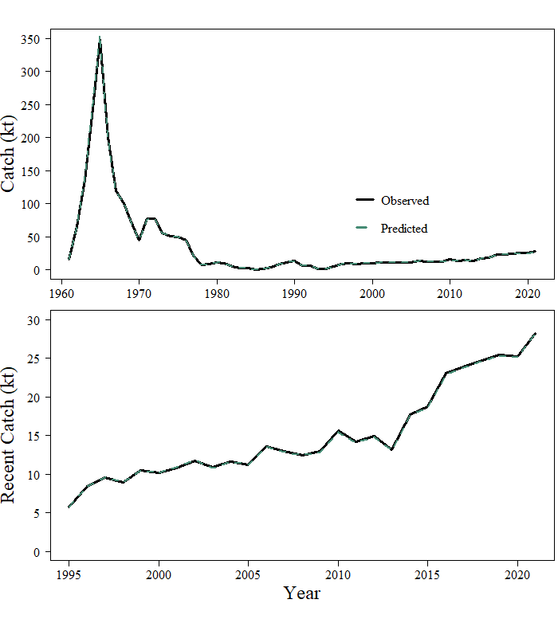

###### Figure 9-1. Estimated and observed long-term (top figure) and short-term (bottom figure) catch history for GOA POP.

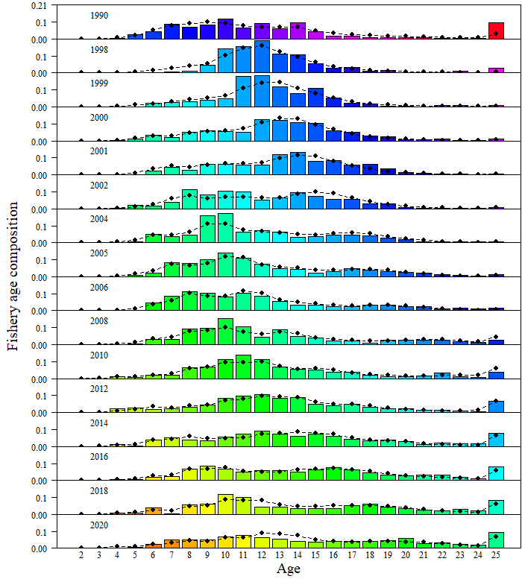

###### Figure 9-2. Fishery age compositions for GOA POP. Observed = bars, predicted from author recommended model = line with circles. Colors follow cohorts.

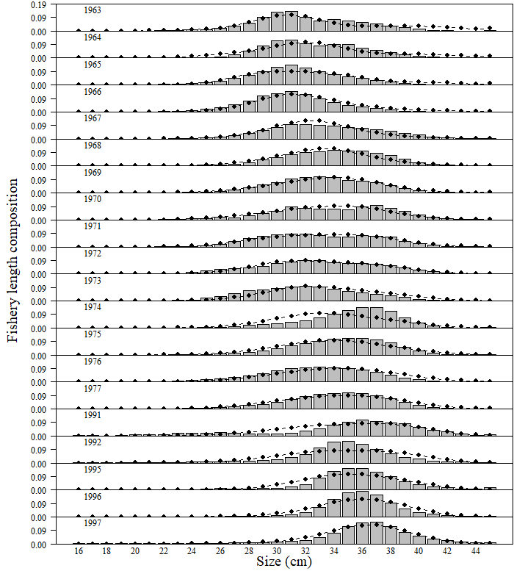

###### Figure 9-3. Fishery length (cm) compositions for GOA POP. Observed = bars, predicted from author recommended model = line with circles.

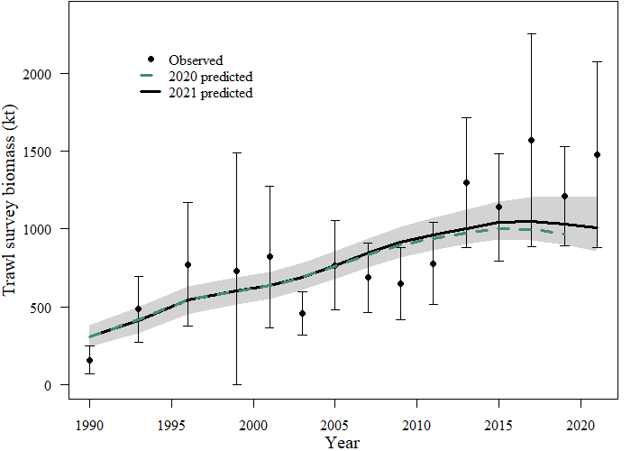

###### Figure 9-4. NMFS Groundfish Survey observed biomass estimates (open circles) with 95% sampling error confidence intervals for GOA POP. Predicted estimates from the recommended model (black line, with 95% confidence intervals shown in grey shaded region) compared with last year’s model fit (green dotted line).

###### Figure 9-5. Distribution of GOA POP catch per unit effort (CPUE) in the 2017-2021 GOA groundfish surveys.

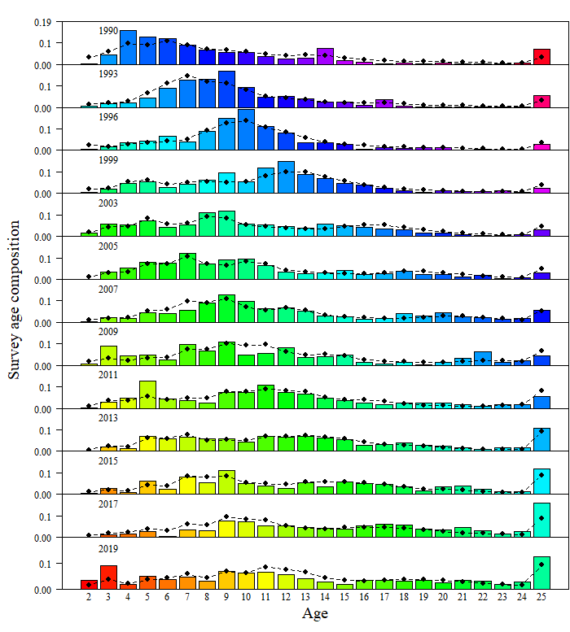

###### Figure 9-6. Groundfish survey age compositions for GOA POP. Observed = bars, predicted from author recommended model = line with circles.

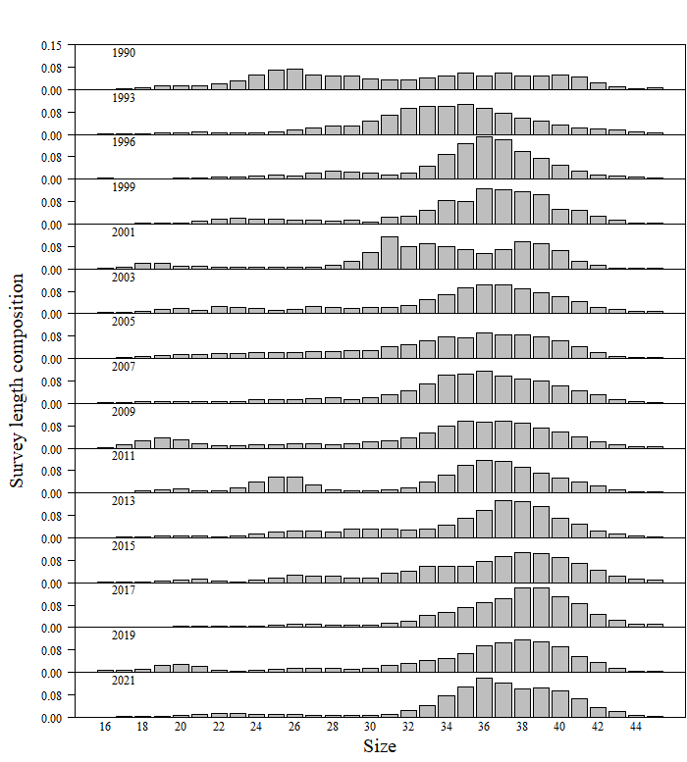

###### Figure 9-7. Groundfish survey length compositions for GOA POP. Observed = bars. Survey size not used in POP model because survey ages are available for these years.

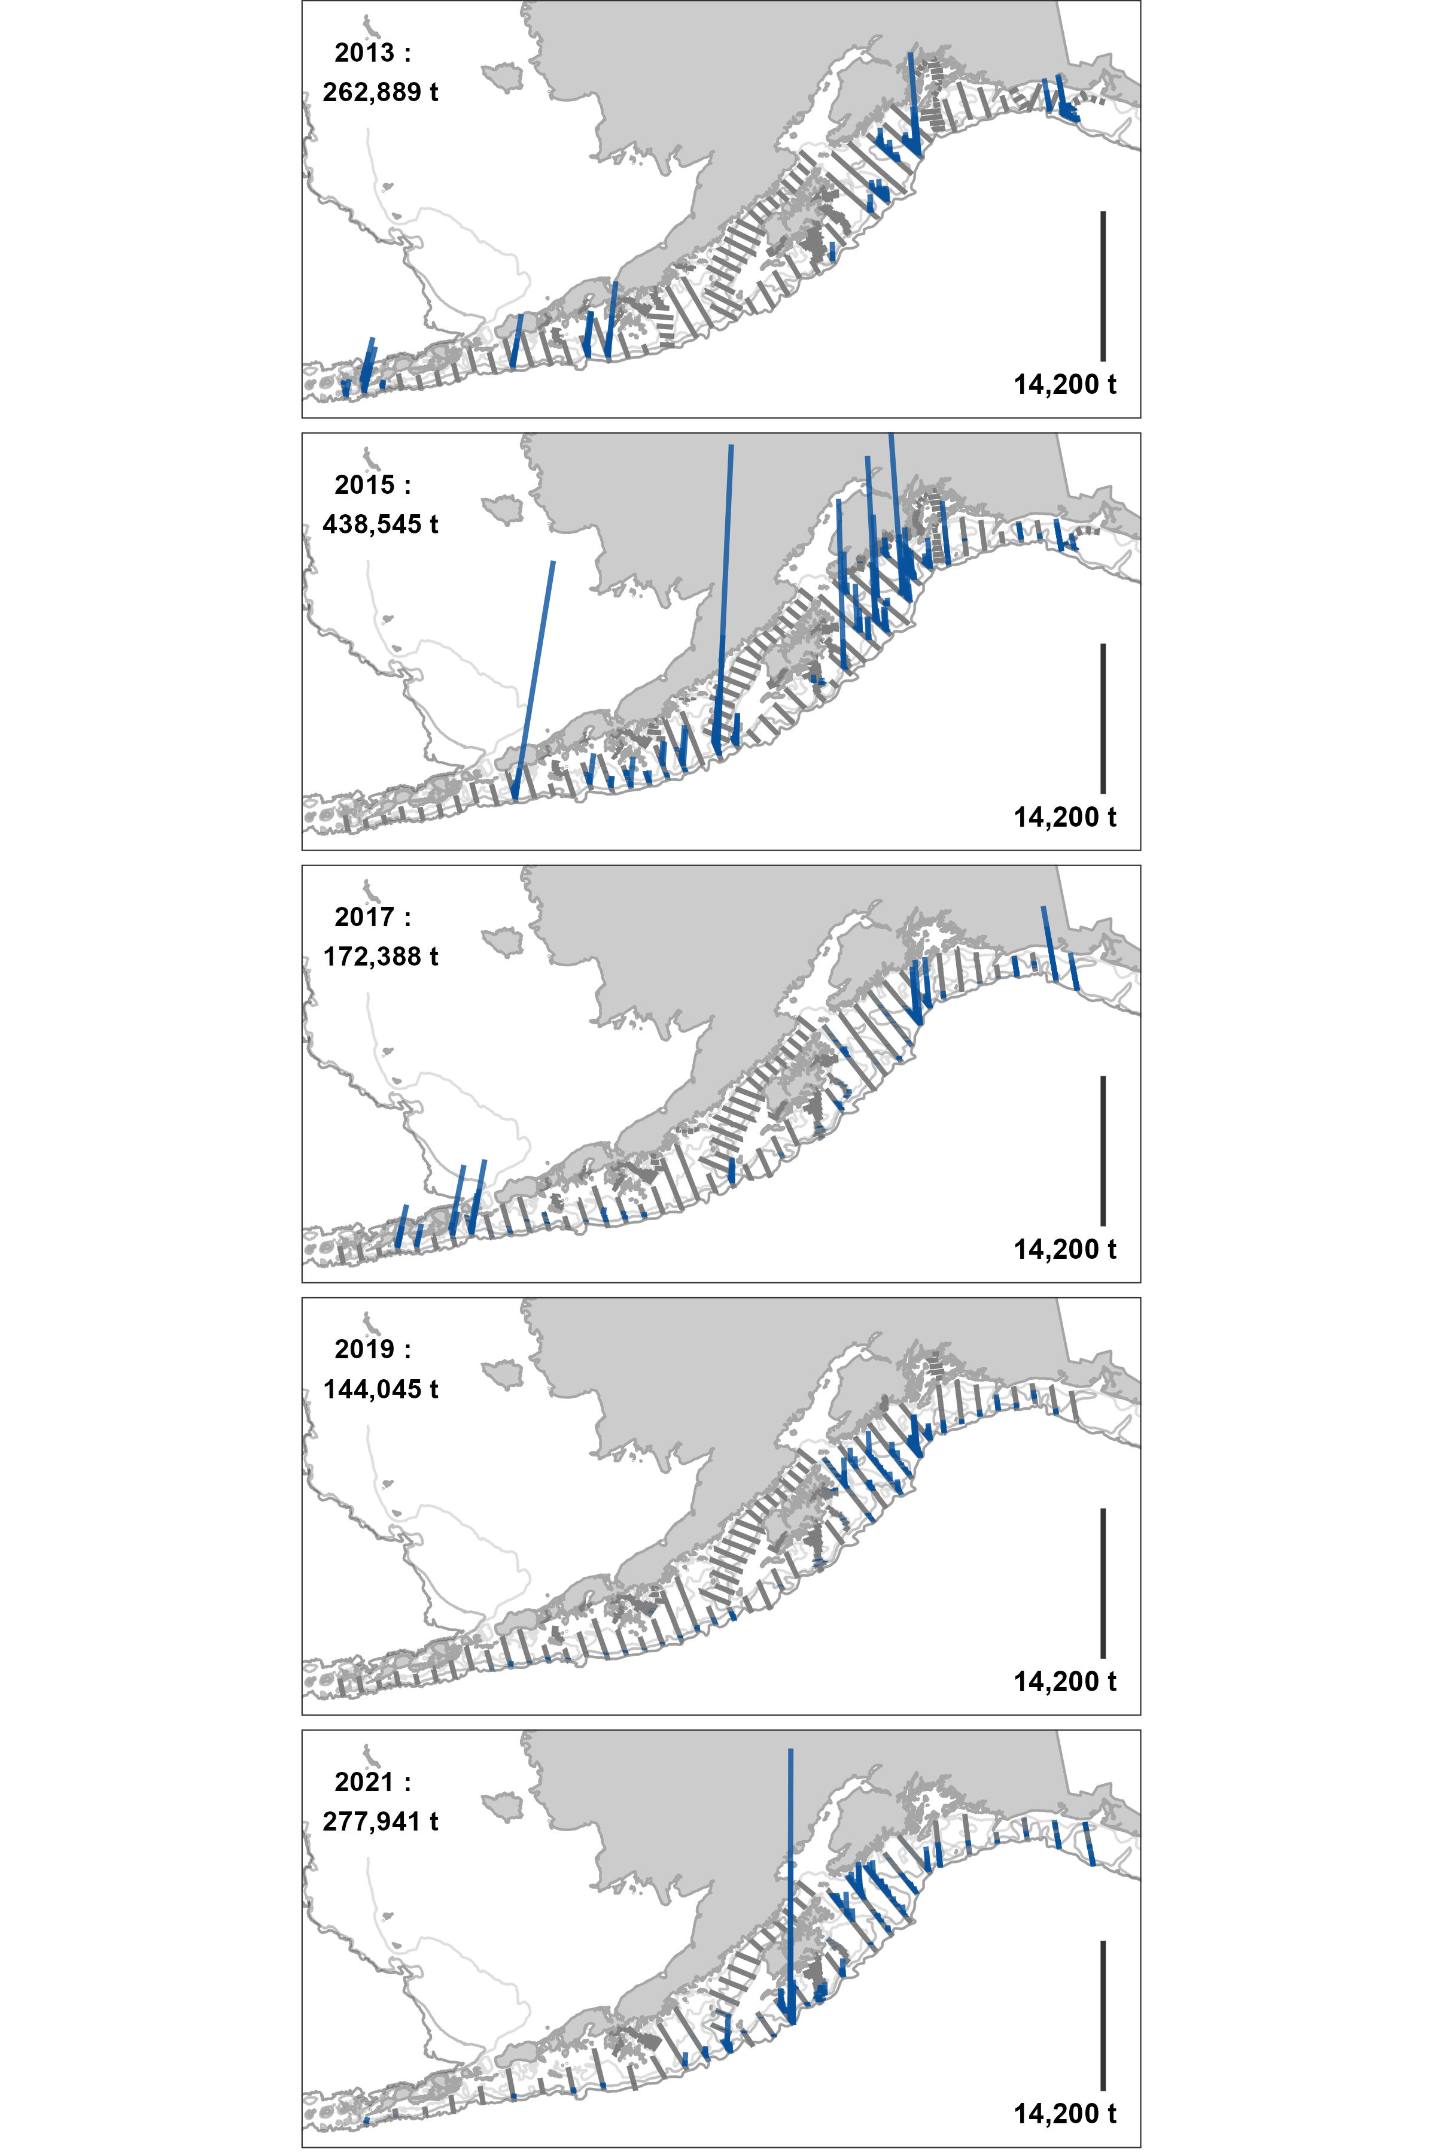

###### Figure 9-8. Density (t/nmi2) of POP observed during the previous three GOA acoustic-trawl surveys.

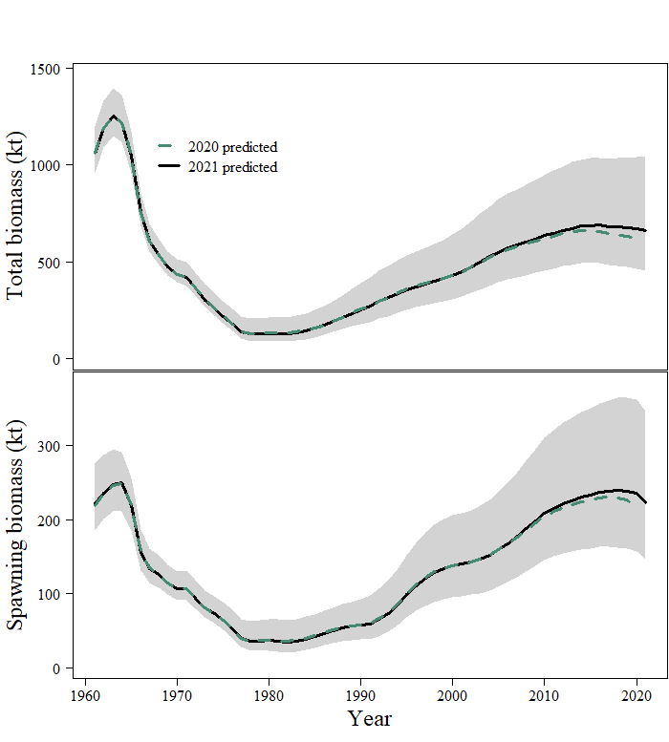

###### Figure 9-9. Model estimated total biomass (top panel, solid black line) and spawning biomass (bottom panel) with 95% credible intervals determined by MCMC (light grey region) for GOA POP. Last year’s model estimates included for comparison (dashed line).

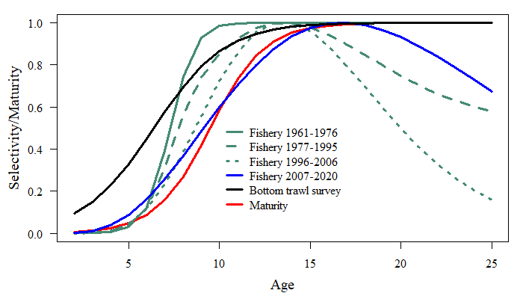

###### Figure 9-10. Estimated selectivities for the fishery and groundfish survey with maturity for GOA POP.

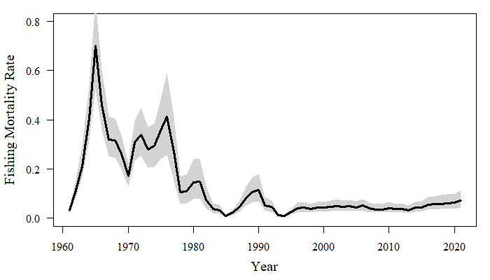

###### Figure 9-11. Estimated fully selected fishing mortality over time with 95% credible intervals determined by MCMC (light grey region) for GOA POP.

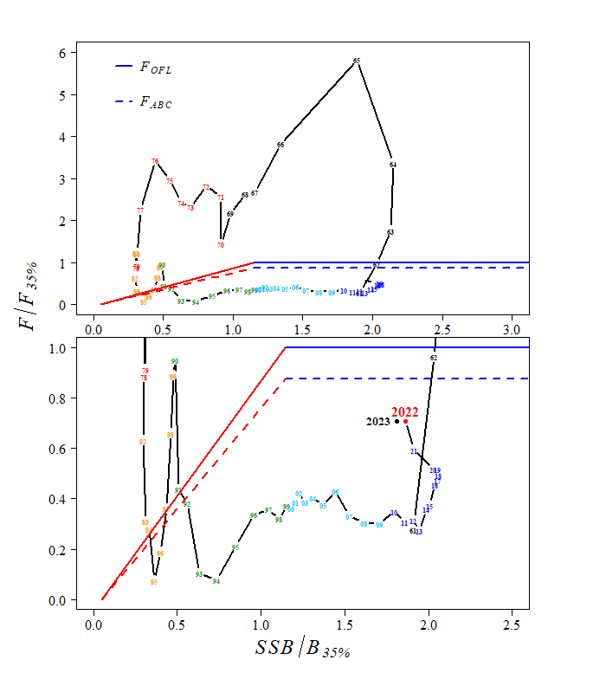

###### Figure 9-12. Time series of POP estimated spawning biomass relative to the target level B35% level and fishing mortality relative to F35% for author recommended model. Top shows whole time series. Bottom shows close up on more recent management path.

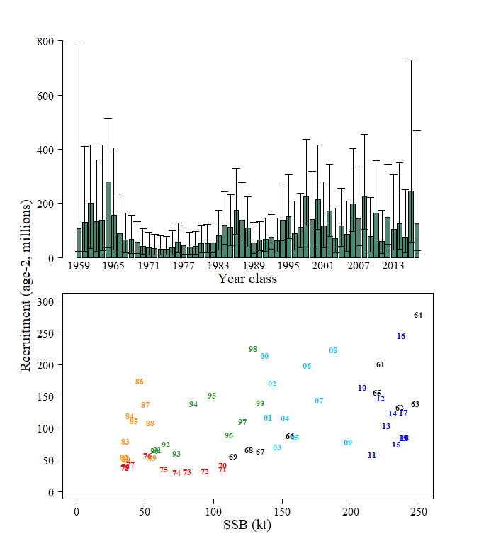

###### Figure 9-13. Estimated recruitment of GOA POP (age 2) by year class with 95% credible intervals derived from MCMC (top). Estimated recruits per spawning stock biomass (bottom). Red circles in top graph are last year’s estimates for comparison.

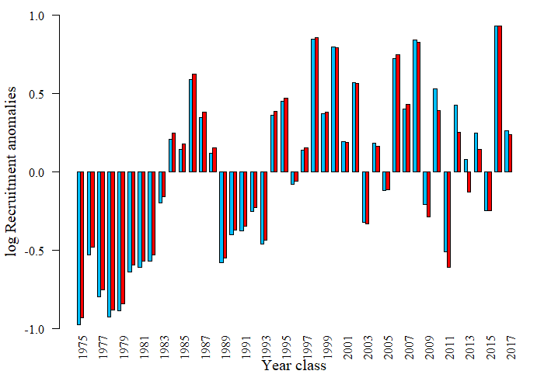

###### Figure 9-14. Recruitment deviations from average on the log-scale comparing last cycle’s model (red) to current year recommended model (blue) for GOA POP.

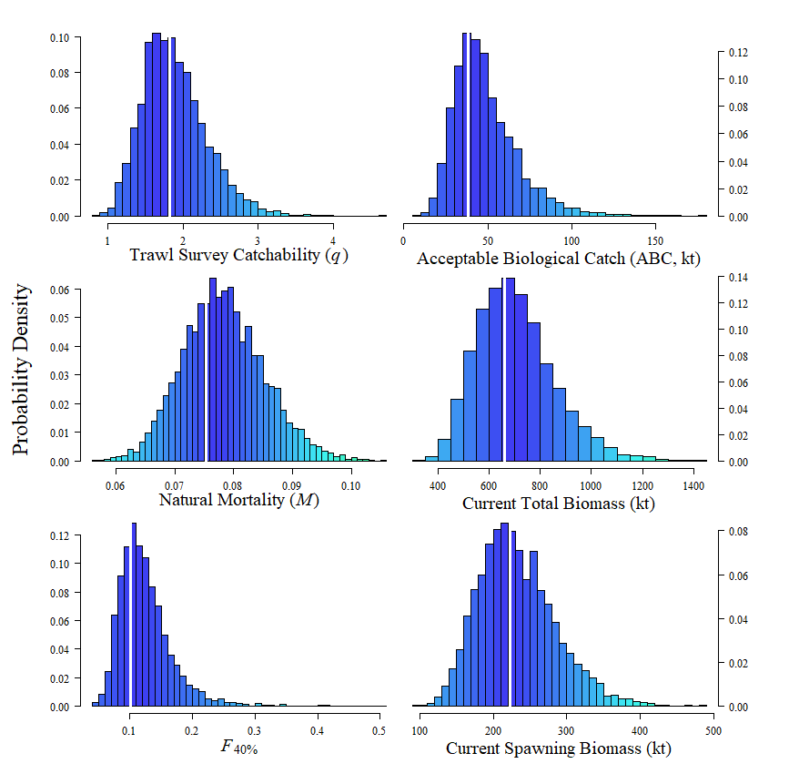

###### Figure 9-15. Histograms of estimated posterior distributions of key parameters derived from MCMC for GOA POP. The vertical white lines are the recommended model estimates.

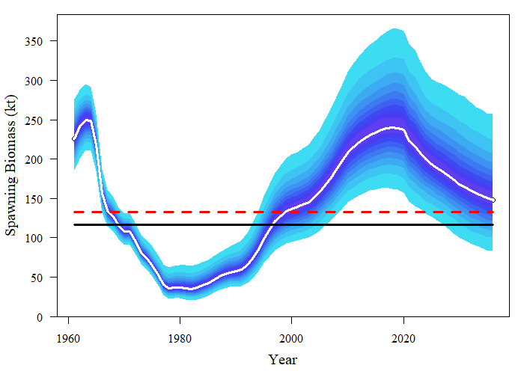

###### Figure 9-16. Bayesian credible intervals for entire spawning stock biomass series including projections through 2030. Red dashed line is *B40%* and black solid line is *B35%* based on recruitments from 1979-2015. The white line is the median of MCMC simulations. Each shade is 5% of the posterior distribution.

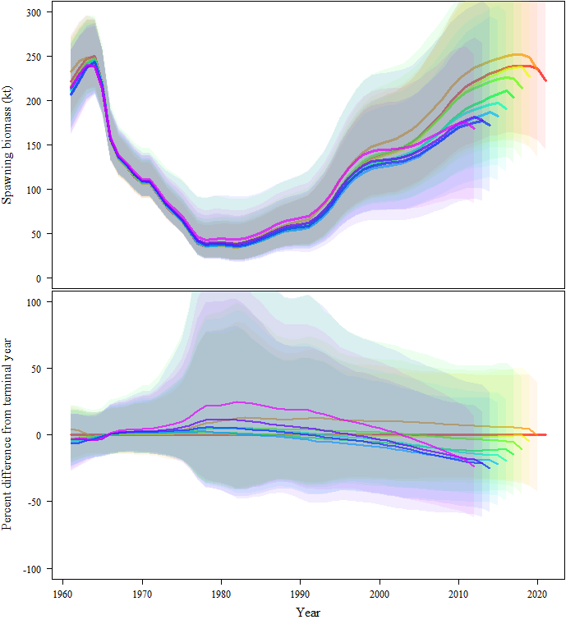

###### Figure 9-17. Retrospective peels of estimated female spawning biomass for the past 10 years from the recommended model with 95% credible intervals derived from MCMC (top), and the percent difference in female spawning biomass from the recommended model in the terminal year with 95% credible intervals from MCMC.

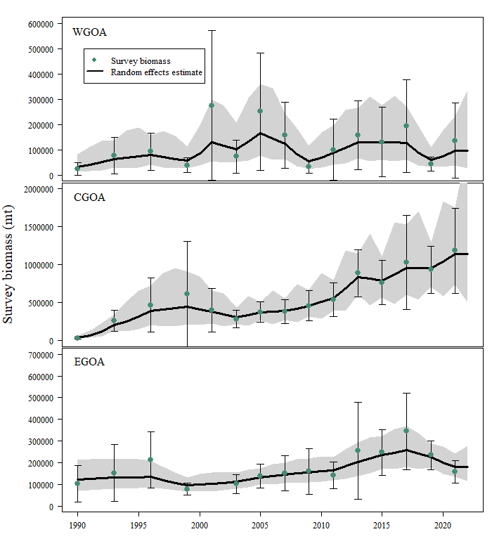

###### Figure 9-18. Random effects model fit (black line with 95% confidence intervals in light grey region) to regional bottom trawl survey biomass (green points with 95% sampling error confidence intervals).

## Appendix 9A.—Supplemental catch data

In order to comply with the Annual Catch Limit (ACL) requirements, non-commercial removals and estimates total removals that do not occur during directed groundfish fishing activities are presented. This includes removals incurred during research, subsistence, personal use, recreational, and exempted fishing permit activities, but does not include removals taken in fisheries other than those managed under the groundfish FMP. These estimates represent additional sources of removals to the existing Catch Accounting System estimates. For GOA POP, removals are minimal relative to the fishery catch and compared to the research removals for many other species. The majority of removals are taken by the Alaska Fisheries Science Center’s biennial bottom trawl survey which is the primary research survey used for assessing the population status of POP in the GOA. Other research conducted using trawl gear catch minimal amounts of POP. No reported recreational or subsistence catch of POP occurs in the GOA. Total removals from activities other than directed fishery are such that they represent a very low risk to the POP stock. The increase in removals in odd years (e.g., 2013 and 2015) are due to the biennial cycle of the bottom trawl survey in the GOA. However, since 2000 removals have been less than 150 t, and do not pose significant risk to the stock.

Table 9A-1. Total removals of GOA POP (t) from activities not related to directed fishing, since 1977. Trawl survey sources are a combination of the NMFS echo-integration, small-mesh, and GOA bottom trawl surveys, and occasional short-term research projects. Other is recreational, personal use, and subsistence harvest.

|  |  |  |  |  |
| --- | --- | --- | --- | --- |
| Year | Source | Trawl | Other | Total |
| 1977 | **Assessment of POP in the GOA (Hanselman et al. 2010)** | 13 |  | 13 |
| 1978 | 6 |  | 6 |
| 1979 | 12 |  | 12 |
| 1980 | 13 |  | 13 |
| 1981 | 57 |  | 57 |
| 1982 | 15 |  | 15 |
| 1983 | 2 |  | 2 |
| 1984 | 77 |  | 77 |
| 1985 | 35 |  | 35 |
| 1986 | 14 |  | 14 |
| 1987 | 69 |  | 69 |
| 1988 | 0 |  | 0 |
| 1989 | 1 |  | 1 |
| 1990 | 26 |  | 26 |
| 1991 | 0 |  | 0 |
| 1992 | 0 |  | 0 |
| 1993 | 59 |  | 59 |
| 1994 | 0 |  | 0 |
| 1995 | 0 |  | 0 |
| 1996 | 81 |  | 81 |
| 1997 | 1 |  | 1 |
| 1998 | 305 |  | 305 |
| 1999 | 330 |  | 330 |
| 2000 | 0 |  | 0 |
| 2001 | 43 |  | 43 |
| 2002 | 60 |  | 60 |
| 2003 | 43 |  | 43 |
| 2004 | 0 |  | 0 |
| 2005 | 84 |  | 84 |
| 2006 | 0 |  | 0 |
| 2007 | 93 |  | 93 |
| 2008 | 0 |  | 0 |
| 2009 | 69 |  | 69 |
| 2010 | **AKRO** | <1 | 3 | 3 |
| 2011 | 64 | <1 | 64 |
| 2012 | <1 | <1 | 1 |
| 2013 | 87 | <1 | 87 |
| 2014 | 4 | <1 | 5 |
| 2015 | 124 | <1 | 125 |
| 2016 | <1 | <1 | 1 |
| 2017 | 99 | <1 | 99 |
| 2018 | 1 | <1 | 1 |
| 2019 | 87 | <1 | 87 |
| 2020 | 13 | <1 | 13 |

## Appendix 9B.—Summary of the 2021 CIE review of Gulf of Alaska Pacific Ocean perch

The Center for Independent Expert (CIE) review for Gulf of Alaska Pacific ocean perch was conducted virtually from March 30 to April 1, 2021. The panel of experts consisted of Drs Noel Cadigan, Saang-Yoon Hyun, and Geoff Tingley. Overall, the review was productive, resulting in a number of recommendations for future development and research into the assessment for GOA POP. By the conclusion of the review the experts found the assessment to be of high quality, and the reviews contained statements like, “The overall outcome of this assessment, as reviewed, is that it meets the description of best available science and exceeds the acceptability quality threshold to be used to inform management.” (Tingley).

Each of the reviewers provided research recommendations that should serve to improve the assessment model for GOA POP. A number of the recommendations focused on a variety of sensitivity analyses, while others involved more in-depth model development. Distilling these comments, the more in-depth recommendations included:

* Investigate data weighting of compositional data
* Develop a state-space model to be run in parallel to the current assessment
* Continue to investigate use of VAST estimates of survey biomass, in particular investigate reasons behind the divergence between design-based and model-based estimates of abundance

As it pertains to the use of VAST estimates of survey biomass, the consensus among the reviewers was that it is still premature to use this index in the assessment until it can be more thoroughly investigated. This was also the consensus with the use of acoustic survey biomass estimates as an additional index to the model. Due to the recommendations that further work be conducted before implementation into the assessment, and in conjunction with the work that the AFSC internal review team performed through 2020 and 2021 (which additionally identified different methods to estimate fishery selectivity as a topic to be considered in the assessment model development), the GOA POP assessment will not incorporate any substantial model changes for the 2021 assessment cycle, but will investigate and continue to develop these various recommendations to be potentially implemented in the next full assessment that will be conducted in 2023.

The following tables compile the main recommendations suggested by the reviewers and are organized by the terms of reference (TOR) of the review.

**TOR 1: *Evaluate the data used in the assessments, specifically trawl survey estimates of biomass, and recommend how data should be treated within the assessment model***

|  |  |  |
| --- | --- | --- |
| Reviewer | Recommendation | Response |
| Tingley | Sensitivities to plausible alternative catch histories, particularly for the early years of the fishery, should be run, but only when there are substantive changes to the assessment model structure or major assumptions. | We plan to investigate this sensitivity in the summer of 2023 |
| Tingley | Continue to explore different approaches to the appropriate weighting of the composition data, by using different statistical approaches but possibly also by careful quality control of these data, excluding data of known poorer quality. | This has been continually evaluated since 2017, and the results are very sensitive to the biomass index used. We will present updated results in September 2022 |
| Tingley | At a future assessment, it is recommended to try and incorporate all of the high-quality length composition data from both the survey and the commercial fishery, at least in a sensitivity. | We plan to investigate this sensitivity in the summer of 2023 |
| Tingley | Prior to or as part of the next assessment, explore whether the plus group should continue to start at age 25 or whether an older plus group starting age is more appropriate. | We have explored this in previous assessments, but will update this analysis in the summer of 2022. |
| Cadigan | Investigate if stock weights-at-age from the survey are significantly (i.e., in the statistical sense) different than fishery weights-at-age. Also, investigate if there is significant temporal variation in both stock and fishery weights-at-age. Provide figures of how mean weight-at-age changes over time, with different panels for groups of ages (i.e., 1-5, 6-10, 10+). Consider using more efficient and less bias methods for analyzing size-at-age from length-stratified age samples (e.g., Perreault et al., 2019). Investigate spatiotemporal variation in weight as a function of length. | We have previously evaluated time-dependent and have compared between the survey and fishery. We will update this analysis in the spring of 2023, in particular with the different groups of ages, as well as new methods of length-stratified sampling |
| Cadigan | Consider new sampling programs to collect information on POP maturity. | TBD, dependent on funding |
| Cadigan | Investigate a bootstrap re-sampling procedure (e.g., Jourdain et al., 2020) to estimate uncertainty (i.e., covariance) in survey age compositions. This could also be considered for fishery compositions, although I recognize that it may be less straight-forward if there is data-borrowing for unsampled fishery “strata” (i.e., gears, areas, seasons, etc.). | Currently being investigated by Sisky et al. results for POP will be presented in September 2022 |
| Hyun | If the survey for the POP stock assessment continues to rely on a bottom trawl survey, they should consider increasing the current trawlable area. | The current method for selecting trawl sites will continue to expand our understanding of trawlable and untrawlable grid cells |
| Hyun | They should revise the calculation of the CV of annual bottom trawl survey indices (annual relative population sizes) because they failed to consider the covariances of survey indices from neighboring strata when calculating the variance of the annual survey index. | We will discuss the potential for this calculation with GAP in the spring of 2022. |

**TOR2: *Evaluate the stock assessment model for GOA Pacific ocean perch in general and comment on appropriateness of parameter estimates to assess stock status determinations***

|  |  |  |
| --- | --- | --- |
| Reviewer | Recommendation | Response |
| Tingley | Exploration of additional information to better define the realistic range of M for Pacific ocean perch is recommended. This should consider data available for Pacific ocean perch and for other long-lived rockfish species. | In the 2020 assessment we used Hamel (2015) as the prior for M. We will be performing sensitivities to M in the summer of 2022, as per the SSC request. |
| Cadigan | Investigate a sensitivity model run with an initial age-structure derived using the assumed M and a few years of F like that estimated for 1961. For example, initial cumulative Z = a*M + min(a,3)*Finit will be appropriate if the stock experienced Finit fishing mortality for three years prior to the start of the assessment model. | Within the internal review team we investigated alternative methods to estimate initial age-structure. We will revisit this with this recommendation in the spring of 2023. |
| Cadigan | Consider including a stock-recruit model with autocorrelated errors to improve the fit of the POP assessment model. Investigate possible drivers of patterns in recruitment deviations. | We have been investigating time-dependent mean recruitment, and will revisit this analysis with this suggestion in the summer of 2022. |
| Cadigan | Consider removing priors for F Regularity and σR. | We will investigate this sensitivity in the summer of 2023. |
| Cadigan, Hyun | A research (i.e., exploratory) state-space stock assessment model, run in tandem with the current stock assessment model, should be developed. | We will begin to develop a state-space model after some of the higher priority suggestions have been addressed. |
| Cadigan | Consider including fishery length composition information in off-years when ages are not measured. However, this may not provide much additional information about recent recruitment trends because of the low selectivity of the fishery for ages less than seven. | We will perform this request as a sensitivity run in the summer of 2023. |
| Cadigan | Evaluate the quality of fishery and survey age compositions for tracking cohorts. | This is a common evaluation in our standard assessments. We feel that given the amount of funding and realistic level of sampling, that our age composition data is adequate to track cohorts. |
| Cadigan | Provide a retrospective analysis of current status evaluations. This will provide additional information on the reliability of the status evaluations. | We will perform this sensitivity analysis in the summer of 2023. |
| Cadigan | Provide convergence diagnostics, including the maximum absolute gradient and the results of a jitter test. | This is potentially a broader topic, but we can fairly easily provide these diagnostics in the 2023 SAFE document. |

**TOR3: *Evaluate the strengths and weaknesses in the stock assessment model for GOA Pacific ocean perch, and recommend any improvements to the assessment model***

|  |  |  |
| --- | --- | --- |
| Reviewer | Recommendation | response |
| Tingley | In the absence of better information about the likely magnitude of M, sensitivities using values of fixed M that bracket the estimated value M should be run in future stock assessments to inform on the level of risk inherent in the current assumptions about M. | We will perform this sensitivity analysis in the summer of 2022 and present the results of this in September 2022 Plan Team meeting. |
| Hyun | They should incorporate the annual fishery cpue’s into the assessment model framework. | Historically, the fishery CPUE data for POP has been highly variable and questionable, which has caused doubt as to its usefulness in the model. |
| Hyun | They should improve the model fit to the survey indices. One of the efficient ways to improve the goodness-of-fit might be to consider process errors in state variables (random effects). | We intend to develop a state-spaced model once more higher priority model developments are completed. |
| Hyun | The penalized likelihood form as the prior of M, q, and  must be revised (beyond the typo). The revised form, which I suggest above, might improve the model performance. | We will investigate this in the summer of 2023 |
| Hyun | They should do formal model validation, setting true values of free parameters, generating pseudo data, feeding those simulated data into the assessment model, estimating parameters, and comparing estimates of free parameters with the corresponding true values. Such model validation would help us to judge the reliability of parameter estimates and the resultant derived quantities made by the model. | Similar to the model convergence and jitter test diagnostics recommended in the previous TOR, this may be a broader diagnostic to consider in AFSC assessments, however, this model validation will be investigated in the summer of 2023. |
| Hyun | For the retrospective error analysis, they should also examine estimates of annual fishing mortality. | We will perform this sensitivity analysis in the summer of 2023. |

**TOR4: *Evaluate and recommend how survey data are used for biomass indices within the assessment. Specifically, advise on trawl survey indices arising from design-based methods versus model-based approaches.***

|  |  |  |
| --- | --- | --- |
| Reviewer | Recommendation | REsponse |
| Tingley | Continue to exclude the 1984 and 1987 survey biomass estimates and survey composition data from all future assessments as these are clearly not part of the longer survey timeseries due to the use of differences in vessels, trawl gear, tow duration and survey timing. | We will no longer be including these surveys in the POP assessment. |
| Tingley, Cadigan | Exclude the 1990 and 1993 Gulf of Alaska Bottom Trawl Survey biomass estimates and the survey composition data from all future Pacific ocean perch (and other species) assessments (or include them only in sensitivities, possibly including them as a separate timeseries). These two years do not appear to be part of the longer survey timeseries due to different timing, tow duration and survey structure. | We will investigate the model sensitivity to these surveys in the summer of 2022. |
| Tingley | It is recommended that the current approach of estimating the missing eastern data from the 2001 Gulf of Alaska Bottom Trawl Survey is discontinued for all future assessments of Pacific ocean perch and that one of the proposed approaches, or an alternative approach, is used so as to reduce uncertainty in the next assessment. | We will investigate one of the alternatives in the summer of 2022. |
| Tingley | Continue to support the development and application of spatio-temporal models (such as VAST) for use in stock assessments. In order to make this effective, there need to be a rapid development of a suite of informative diagnostics for spatio-temporal models in a fisheries stock assessment context. Until such time as suitable diagnostics are available, it is recommended that these spatio-temporal models are only used in sensitivity model runs and not in the base case from which management advice is developed. | We will be working with GAP to evaluate the VAST model for POP in the spring of 2022. |
| Cadigan | It was premature to use VAST biomass indices in the POP stock assessment. There are several diagnostic analyses that need to be explored. | We will be working with GAP to evaluate the VAST model for POP in the spring of 2022. |
| Cadigan | Provide the stratum size-weighted averages of the VAST ordinary raw residuals. | We will be working with GAP to evaluate the VAST model for POP in the spring of 2022. |
| Cadigan | Provide trawlable biomass values aggregated over survey strata. This should include time-series of maps indicating strata, where each stratum is colored to indicate the area-expanded VAST biomass. Also useful are time-series plots of VAST biomass aggregated over sets of strata for standard depth ranges shown in Table 2. It will also be informative if this could be further divided into trawlable and untrawlable grounds. | We will be working with GAP to evaluate the VAST model for POP in the spring of 2022. |
| Cadigan | Account for potential vessel and tow time effects in a VAST model. Examine the statistical significance of vessel and tow duration effects. Consider including vessel as a random effect. | We will be working with GAP to evaluate the VAST model for POP in the spring of 2022. |
| Cadigan | Consider including the 1984 and 1987 survey catches in the VAST model, to extend the survey biomass indices back to those years. This VAST model should include those effects that were different or less standardized in the 1984 and 1987 surveys. Consider the potential confounding of year effects with other effects. | We will be working with GAP to evaluate the VAST model for POP in the spring of 2022. |
| Cadigan | Investigate methods to produce length and size compositions that are weighted by VAST spatial density estimates. | We will be working with GAP to evaluate the VAST model for POP in the spring of 2022. |

**TOR5: *Evaluate abundance estimates from summer acoustic-trawl data, and recommend how it may be used within the assessment.***

|  |  |  |
| --- | --- | --- |
| Reviewer | Recommendation | response |
| Tingley | It is recommended that attempts to develop an acoustic abundance index for Pacific ocean perch from the MACE Acoustic Survey data for use in assessments should be discontinued until the evidence base supports a substantially increased likelihood that the processed acoustic backscatter represents a reliable abundance index for Pacific ocean perch. | We will be continuing to work with MACE in 2022 and 2023 to investigate the utility of this survey in the POP assessment. |
| Tingley | It is, however, also recommended that the existing MACE acoustic and trawl data are further explored in detail to ascertain whether the backscatter data can be reliably and robustly be decomposed into Pacific ocean perch and other species or not. | We will be continuing to work with MACE in 2022 and 2023 to investigate the utility of this survey in the POP assessment. |
| Cadigan | More years of acoustic survey data are needed before deciding how it could be included in the POP assessment. However, having an additional fishery-independent abundance index, and in particular an acoustic survey of the off-bottom (i.e., 0.5m) water column, can be quite valuable for detecting changes in availability of POP to the bottom-trawl survey. | We will be continuing to work with MACE in 2022 and 2023 to investigate the utility of this survey in the POP assessment. |
| Cadigan | Continue and improve research on the sources of uncertainty and possibly bias listed above. This should include quantification and incorporation of these sources of uncertainty into acoustic biomass and age/size compositions. | We will be continuing to work with MACE in 2022 and 2023 to investigate the utility of this survey in the POP assessment. |

## Appendix 9C.—Update of Science-Industry Rockfish Research Collaboration in Alaska (SIRRCA)

Over time, the Gulf of Alaska (GOA) bottom trawl survey has systematically identified certain habitats as untrawlable and subsequently eliminated these habitats from survey sampling. The label of “untrawlable” is a functional definition describing habitats that are unavailable to sample using survey gear while maintaining constant bottom contact. Previous work indicates untrawlable habitats are more likely to have greater depths and slopes (means, ranges, and maxima), higher rugosity, higher substrate hardness, and more rock/reef structures than trawlable habitats (Baker et al. 2019). Rockfish can be found in both trawlable and untrawlable habitats (Zimmermann 2003), but Jones et al. (2021) found increased densities for several rockfish species (*Sebastes* spp.) in untrawlable habitats. There has been speculation that estimates of abundance for rockfish species in the GOA are both imprecise and inaccurate because the trawl survey is generally unable to sample in areas where many of these species are most abundant, and habitats are thus not being sampled in proportion to their importance (Rooper and Martin 2012). One potential solution to this problem is to cooperatively collect data in untrawlable habitats with partners in the fishing industry, as industry boats successfully fish many areas that are unavailable to the bottom trawl survey.

Beginning in 2020, the Alaska Fisheries Science Center began pursuing cooperative work with the Gulf of Alaska fishing industry via the Science-Industry Rockfish Research Collaboration in Alaska (SIRRCA). Multi-stakeholder cooperative research programs like SIRRCA are valuable for fishery science; they can improve scientific surveys by sharing knowledge, building public engagement in the scientific process, and laying a foundation of mutual trust between managers and industry (Hartley and Robinson 2006). The first year of SIRRCA has laid a strong foundation based on close involvement of species assessors and continuous maintenance of relationships between scientists and stakeholders, which are important components of successful research collaborations (Steins et al. 2019).

Currently, Alaska commercial catch data are included as gross removals in stock assessments, along with some information about fish length, weight, age and sex, as reported by observers and industry participants. However, commercial fishing effort metrics (e.g., catch-per-unit-effort or regional biomass estimates) are rarely included in stock assessments because it is difficult to extract information about trends in abundance from non-standardized commercial fishery effort data (Maunder 2006), even though this effort may occur in areas not covered by a fishery-independent survey. SIRRCA aims to develop a solution for quantifying commercial fishery catch and effort data for several rockfish species, including POP. This work is focused on adding information from untrawlable habitats, aiming to supply valuable data to the stock assessment from areas not sampled in the survey. This cooperatively collected data will serve as a supplemental source of population abundance information and aid in understanding differences in catchability between different habitat types. Additionally, this work can inform how estimates of abundance are impacted by gear implementation in trawlable vs. untrawlable habitats.

Two SIRRCA scientists began cooperative data collection in summer 2021; sampling was conducted using many, but not all, aspects of GOA bottom trawl survey tows. Aspects of sampling design that were maintained in SIRRCA tows included duration (15 minutes), speed (2.8 – 3.2 knots), and contact with the seafloor (constant bottom contact maintained fur duration of the tow). Gear constituted the major sampling design difference between SIRRCA tows and GOA bottom trawl survey tows, as cooperative research tows were conducted using industry-owned and maintained nets that differ substantially from the government owned and maintained nets used in the survey. To account for these differences, SIRRCA conducted 28 tows to calibrate the fishing power and selectivity of the industry gear to the survey gear. Calibration tows were completed as close in time and space to survey tows as possible, with help from field party chiefs and captains conducting the 2021 bottom trawl survey. Additionally, SIRRCA completed tows in 2 untrawlable habitat stations as a proof-of-concept. While adding information on biomass in untrawlable habitats is a main goal of SIRRCA, calibrating industry gear to survey gear was prioritized in 2021. The underlying reasoning for this strategy is that GOA bottom trawl survey is on a biennial cycle, and thus the opportunity to calibrate industry and survey gear would not have occurred again until the 2023 survey.

Sampling of SIRRCA hauls was conducted in the factory of the catcher-processor vessels. Each cooperative research haul was whole-hauled for POP, northern and dusky rockfish; this means that each haul resulted in precise counts and weights for these 3 species. Length data was also collected; the sampling strategy was adjusted for the size of each tow where every fish was sampled for length if there was estimated to be less than 2000 of our target rockfish in a haul, and fish were subsampled at a rate of 1:10 if there were estimated to be over 2000 individuals (Table 1). Data collection was performed by the SIRRCA scientists (counts, lengths) and factory crew (weights). SIRRCA 2021 hauls totaled >78mt, including >38mt of POP.

We plan to conduct sampling focusing on experimental tows in untrawlable areas in 2022, and to conduct sampling in both trawlable and untrawlable areas concurrent with the GOA bottom trawl survey in 2023 and 2025. In the short term, we hope the data we collect will be useful in the assessment process by informing a prior on catchability. In the longer term, we hope the length and biomass data collected will be useful in the assessment process by facilitating the development of a separate index of relative rockfish abundance from untrawlable habitats, or by building a blended index of abundance using SIRRCA data and GOA bottom trawl survey data. We hope that our project will add to the recent efforts on behalf of scientists at the AFSC to understand differences in seafloor characteristics and fish densities between trawlable and untrawlable habitats (Baker et al. 2019, Jones et al. 2021, Steinessen et al. 2021) and that the continuation of cooperatively collected data will improve the accuracy and precision of future POP assessments.

Table 9C-1. Preliminary data for Pacific Ocean perch from 2021 SIRRCA cooperative survey hauls.

|  |  |  |  |  |  |
| --- | --- | --- | --- | --- | --- |
| Station sampled | Haul type | SIRRCA  haul date | POP (kg) | POP (n) | Length sampling scheme |
| 166-73 | Calibration | 6/5/2021 | 2494.4 | 3640 | 1:10 |
| 171-96 | Calibration | 6/7/2021 | 2658.66 | 3159 | 1:10 |
| 192-94 | Calibration | 6/13/2021 | 323.14 | 436 | 1:1 |
| 196-88 | Calibration | 6/13/2021 | 146.2 | 187 | 1:1 |
| 194-89 | Calibration | 6/13/2021 | 19.56 | 25 | 1:1 |
| 191-86 | Calibration | 6/13/2021 | 349.65 | 549 | 1:1 |
| 175-79 | Calibration | 6/14/2021 | 1300.6 | 3027 | 1:10 |
| 174-77 | Calibration | 6/14/2021 | 1975.75 | 3889 | 1:10 |
| 174-78 | Calibration | 6/14/2021 | 2786.93 | 4685 | 1:10 |
| 158-69 | Calibration | 6/17/2021 | 538.17 | 692 | 1:1 |
| 142-58 | Calibration | 6/18/2021 | 235.6 | 420 | 1:1 |
| 144-58 | Calibration | 6/18/2021 | 5259.75 | 7931 | 1:10 |
| 134-57 | Calibration | 6/19/2021 | 318.78 | 679 | 1:1 |
| 136-55 | Calibration | 6/19/2021 | 265.54 | 379 | 1:1 |
| 235-149 | Calibration | 7/1/2021 | 392.98 | 433 | 1:1 |
| 237-150 | Calibration | 7/1/2021 | 7930.61 | 8805 | 1:10 |
| 239-145 | Calibration | 7/1/2021 | 3264.21 | 3848 | 1:10 |
| 243-147 | Calibration | 7/2/2021 | 1073.82 | 1307 | 1:10 |
| 245-146 | Calibration | 7/2/2021 | 64.64 | 84 | 1:1 |
| 249-147 | Calibration | 7/2/2021 | 1789.77 | 2274 | 1:10 |
| 239-132 | Calibration | 7/4/2021 | 1996.69 | 2832 | 1:10 |
| 131-55 | Experimental | 7/21/2021 | 2.8 | 5 | 1:1 |
| 131-55 | Experimental | 7/21/2021 | 646.82 | 2368 | 1:1 |
| 111-62 | Calibration | 7/22/2021 | 2.96 | 9 | 1:1 |
| 104-55 | Calibration | 7/22/2021 | 0 | 0 | N/A |
| 102-44 | Calibration | 7/22/2021 | 0.27 | 1 | 1:1 |
| 97-44 | Experimental | 7/22/2021 | 0 | 0 | N/A |
| 64-36 | Calibration | 7/23/2021 | 1.6 | 4 | 1:1 |
| 55-32 | Calibration | 7/23/2021 | 49.39 | 87 | 1:1 |
| 54-32 | Calibration | 7/23/2021 | 7.38 | 14 | 1:1 |
| 53-33 | Calibration | 7/23/2021 | 48.39 | 161 | 1:1 |
| 4-4 | Calibration | 7/24/2021 | 2565.09 | 3002 | 1:10 |